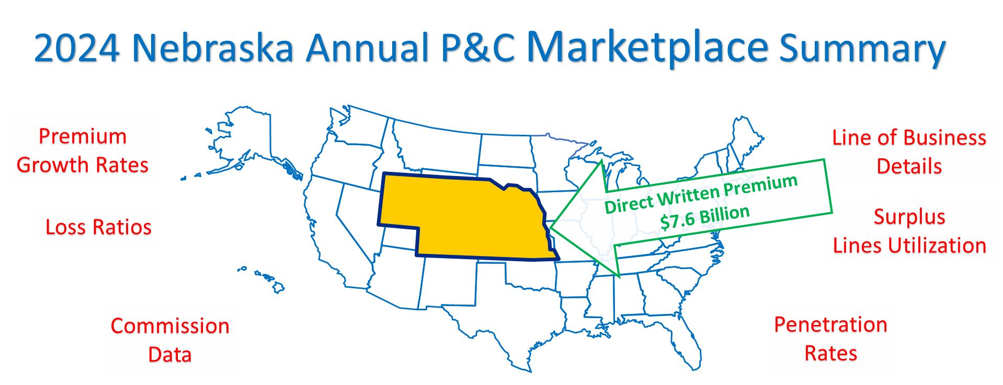

Source: © A.M. Best Company — Used by Permission

You are being provided this *2024 Nebraska Annual P&C Marketplace Summary* covering the Nebraska property and casualty (P&C) insurance marketplace as a benefit of your membership in the **Independent Insurance Agents of Nebraska.**

What follows is a graphic and numeric presentation of the Nebraska P&C industry data from an Independent Agent’s perspective. The 2023 data used is the most recently available from A.M. Best Company and includes all 50 states and the District of Columbia (equaling the 51 entities referred to in the data in this report). The *2024 United States Annual P&C Marketplace Summary* is also available to you as members of the **Independent Insurance Agents of Nebraska** at www.independentagent.com.

This *Summary* emphasizes direct premiums, direct losses, and the associated direct underwriting results before reinsurance. Also included is data from nearly 3,000 insurers that are domiciled in the United States, and if they have written premiums in Nebraska then their data is incorporated. As Independent Agents, this is the marketplace experience for the business we place (or compete against) for our clients in Nebraska.

This *2024 Nebraska Annual P&C Marketplace Summary* provides you with the following important information on the Nebraska P&C marketplace:

* Premiums for all 32 P&C lines of business in Nebraska
* The Top 10 lines of business for Independent Agents
* Premium Growth Rates
* Loss Ratios
* Distribution Style penetration rates and trends
* Commission rates
* Surplus Lines utilization rates
* Lists of the largest insurers for each of the top Lines of Business
* Largest/highest and smallest/lowest state specific data

To enhance your understanding, this *Summary* includes four instructive Appendices: Distribution Style Classifications, NAIC Line of Business Definitions, Line of Business Facts-A Visual Reference, and a Nebraska All Active Insurers List. This last appendix is a new and valuable resource this year, as it allows you to quickly see basic information on any insurer operating in the Nebraska P&C marketplace.

Table of Contents

Nebraska P&C Marketplace Executive Summary 3

Nebraska Premiums: All 32 P&C Lines of Business 5

Nebraska Top 10 Independent Agent Lines of Business 8

Nebraska Loss Ratios 10

Nebraska Premium Change 12

Nebraska Independent Agent Penetration Rates 14

Nebraska Commission Rates 17

Nebraska Surplus Lines 19

Nebraska Line of Business In-Depth Detail Pages 21

Total All P&C Lines of Business 22

Aircraft (all perils) 23

All Commercial Auto 24

All Private Passenger Auto 25

Allied Perils Only 26

Boiler & Machinery 27

Burglary & Theft 28

Commercial Multi-Peril 29

Earthquake 30

Excess Workers’ Comp 31

Farmowners Multi-Peril 32

Federal Flood 33

Fidelity 34

Fire Peril Only 35

Homeowners 36

Inland Marine 37

International 38

Medical Malpractice 39

Multi-Peril Crop 40

Ocean Marine 41

Other Liability (Claims-made) 42

Other Liability (Occurrence) 43

Private Crop 44

Private Flood 45

Products Liability 46

Surety 47

Workers' Compensation 48

Appendix #1: Distribution Style Classifications 49

Appendix #2: NAIC Line of Business Definitions 53

Appendix #3: Line of Business Facts—A Visual Reference 56

Appendix #4: Nebraska All Active Insurers List 57

# Nebraska P&C Marketplace Executive Summary

Premiums Overall

In 2023, Nebraska P&C premiums reached $7.6 billion, ranking Nebraska 35 of 51 in total premiums in the United States. That is 0.8% out of $952 Billion in premiums nationwide. On a relative comparative basis, per capita premiums rank Nebraska 5 of 51 for all P&C premiums combined, 12 of 51 for Personal Lines, 16 of 51 for Commercial Lines, and 3 of 51 for Agricultural Lines.

Lines of Business

In Nebraska the largest Line of Business for independent agents was Multi-Peril Crop (as determined by direct written premium). The second largest Line of Business in Nebraska was All Private Passenger Auto, and the third was Homeowners Multi-Peril. For comparison, in the United States those Top 3 Lines of Business are: All Private Passenger Auto, Homeowners Multi-Peril, and Other Liability (Occurrence).

Loss Ratios

Nebraska's average loss ratio across all P&C Lines of Business was 74.3%, with the highest loss ratios experienced in Private Crop (142.0%), Multi-Peril Crop (141.8%), and All Private Passenger Auto (69.4%). Comparatively, the United States average loss ratio was 66.0%, with the highest loss ratio in Hawaii (140.5%), and the lowest in District of Columbia (43.4%). In the United States, the Lines of Business with the highest loss ratios are Multi-Peril Crop (102.2%), Private Crop (98.8%), and Farmowners Multi-Peril (79.0%).

Premium Change Rates

Premiums grew 9.6% in Nebraska from 2022 to 2023 for all P&C Lines of Business combined, placing it 24 of 51 in the United States and District of Columbia. The fastest growing Lines of Business in Nebraska are Fire Peril Only (55.5%), Boiler & Machinery (31.6%), and Medical Malpractice (30.8%). By comparison the United States grew by 10.4%, with the fastest growing state being Florida (16.1%), and the slowest being District of Columbia (3.4%). The United States fastest growing Lines of Business are Fire Peril Only (28.9%), Allied Perils Only (24.5%), and Earthquake (16.5%).

Independent Agent Penetration of Marketplace

Independent Agents control 66.8% of the Nebraska P&C marketplace. This compares to the United States average of 62.2%, with the highest penetration in Massachusetts (79.6%), and the lowest in Alabama (51.7%). In Nebraska, the top penetration rates by Lines of Business for Independent Agents are: International (100.0%), Ocean Marine (99.6%), and Private Crop (98.8%). In the United States, top penetration rates by Lines of Business for Independent Agents are: International (100.0%), Ocean Marine (96.5%), and Burglary & Theft (96.3%).

Commissions

The average commission rate in Nebraska was 11.8% for all P&C Lines of Business combined. By contrast, the average commission rate in the United States was 11.4%. The highest average commission was in the District of Columbia (13.8%) with the lowest in Virginia (10.2%).

Surplus Lines

Surplus Lines utilization is on the rise across all states. In Nebraska, the average percentage of premiums going to UNLICENSED insurers (that is, Surplus Lines) was 4.9%. That percentage was 3.9% one year ago, and 2.6% five years ago. In the United States the corresponding figures are 9.3%, 9.0%, and 6.2%, respectively. In Nebraska, the top 3 Lines of Business with premiums going to Surplus Lines insurers are: Fire Peril Only (47.7%), Other Liability (Claims-made) (42.2%), and Private Flood (30.7%). In United States, the top 3 Lines of Business with premiums going to Surplus Lines insurers are: Earthquake (50.8%), Private Flood (46.2%), and Products Liability (42.1%).

Largest Insurers

State Farm Group (G) was the largest insurer group in Nebraska, and it writes 9.7% of all P&C premiums. Farmers Mutual Insurance Co of Nebraska emerges as the largest pure Independent Agent policy-issuing insurer, State Farm Fire and Casualty Company as the largest Exclusive-Captive policy-issuing insurer, and Progressive Universal Insurance Company as the largest Direct policy-issuing insurer.

.

# Nebraska Premiums: All 32 P&C Lines of Business

The below chart, *Nebraska* *Premiums: By Line of Business*, lists the Line of Business and then shows 2023 total premiums for all 32 P&C Lines of Business that P&C insurers are required to report on in their annual statement to regulators. The Lines of Business are listed in alphabetical order, both below and in most of the subsequent tables, charts, and graphs in this *Summary*. Of the 32 lines, 26 Lines of Business are primarily focused on by Independent Agents, emphasized below with an asterisk (*). As Independent Agents are the target audience of this *Summary*, the 26 Lines of Business are emphasized throughout the remainder of it.

Nebraska Premiums: By Line of Business

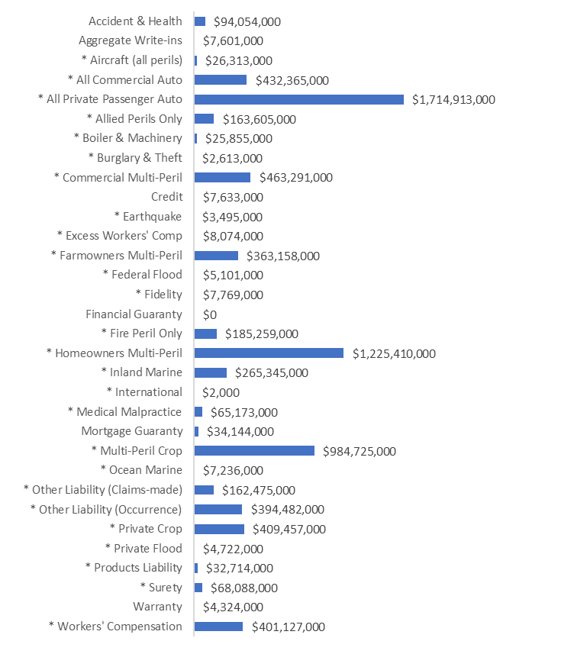

Source: © A.M. Best Company — used by permission. (Note: Independent Agent-focused Lines of Business are designated by an asterisk (*)).

The below table, *Nebraska: All Lines of Business Additional Details,* provides further data on Nebraska Premiums, Loss Ratios, Premium Growth rates, and Penetration rates by Independent Agents for these 32 P&C lines of business.

Nebraska: All Lines of Business Additional Details

|  |  |  |  |  |  |  |  |
| --- | --- | --- | --- | --- | --- | --- | --- |
| **All P-C Lines of Business** | **All Direct Written Premium** | **1-Year Loss Ratio** | **5-Year Loss Ratio** | **1-Year Growth** | **5-Year Growth** | **1-Year Penetration** | **5-Year Penetration** |
| Accident & Health | 94,054,000 | 72% | 56% | 0% | -4% | 81% | 78% |
| Aggregate Write-ins | 7,601,000 | 82% | 143% | 22% | 8% | 70% | 55% |
| **Aircraft (all perils)** | 26,313,000 | 37% | 41% | 11% | 15% | 99% | 98% |
| **All Commercial Auto** | 432,365,000 | 57% | 60% | 7% | 8% | 84% | 83% |
| **All Private Passenger Auto** | 1,714,913,000 | 69% | 68% | 14% | 6% | 35% | 35% |
| **Allied Perils Only** | 163,605,000 | 60% | 94% | 16% | 13% | 87% | 87% |
| **Boiler & Machinery** | 25,855,000 | 11% | 47% | 32% | 17% | 89% | 89% |
| **Burglary & Theft** | 2,613,000 | 26% | 29% | -5% | 4% | 97% | 96% |
| **Commercial Multi-Peril** | 463,291,000 | 49% | 74% | 17% | 11% | 74% | 74% |
| Credit | 7,633,000 | 52% | 56% | -1% | 8% | 84% | 75% |
| **Earthquake** | 3,495,000 | 1% | 3% | 17% | 11% | 81% | 76% |
| **Excess Workers' Comp** | 8,074,000 | -20% | 52% | 3% | 1% | 96% | 98% |
| **Farmowners Multi-Peril** | 363,158,000 | 62% | 81% | 18% | 10% | 56% | 57% |
| **Federal Flood** | 5,101,000 | 3% | 129% | -2% | -7% | 83% | 80% |
| **Fidelity** | 7,769,000 | 31% | 23% | -10% | -3% | 92% | 92% |
| Financial Guaranty | 0 | N/A | 0% | -100% | N/A | #DIV/0! | 0% |
| **Fire Peril Only** | 185,259,000 | 17% | 64% | 55% | 25% | 95% | 93% |
| **Homeowners Multi-Peril** | 1,225,410,000 | 57% | 78% | 14% | 10% | 40% | 39% |
| **Inland Marine** | 265,345,000 | 39% | 53% | 10% | 10% | 76% | 73% |
| **International** | 2,000 | 50% | -200% | 100% | N/A | 100% | 100% |
| **Medical Malpractice** | 65,173,000 | 29% | 46% | 31% | 18% | 97% | 93% |
| Mortgage Guaranty | 34,144,000 | 3% | 4% | 1% | 0% | 11% | 11% |
| **Multi-Peril Crop** | 984,725,000 | 142% | 86% | -6% | 17% | 98% | 98% |
| **Ocean Marine** | 7,236,000 | 36% | 36% | 8% | 8% | 100% | 99% |
| **Other Liability (Claims-made)** | 162,475,000 | 58% | 50% | 1% | 9% | 93% | 92% |
| **Other Liability (Occurrence)** | 394,482,000 | 69% | 62% | 7% | 10% | 81% | 79% |
| **Private Crop** | 409,457,000 | 142% | 125% | 4% | 14% | 99% | 99% |
| **Private Flood** | 4,722,000 | 4% | 86% | 7% | 19% | 91% | 86% |
| **Products Liability** | 32,714,000 | 13% | 38% | 24% | 11% | 62% | 71% |
| **Surety** | 68,088,000 | 6% | 5% | 29% | 12% | 92% | 91% |
| Warranty | 4,324,000 | 76% | 68% | 0% | -10% | 43% | 71% |
| **Workers' Compensation** | 401,127,000 | 62% | 58% | 3% | 2% | 88% | 87% |
| Total (All Lines) | 7,570,545,000 | 74% | 72% | 10% | 10% | 67% | 65% |

Source: © A.M. Best Company — used by permission. (Note: Independent Agent-focused Lines of Business are bold and underlined)

Nebraska All Lines of Business Total Premium Comparisons

The table below, *Total and Per Capita Premiums*, compares Nebraska P&C premiums to the United States both in total, and on a per capita basis. Per capita premiums are provided to give a relative sense of the cost of premiums, but also allows comparing premiums state to state. For insights, per capita premiums are provided for the following groupings of Lines of Business: Total (All Lines of Business Combined), Personal Lines of Business, Commercial Lines of Business, and Agricultural Lines of Business.

The definition of Total, Personal, Commercial, and Agricultural Lines of Business are as follows:

* **Total (All Lines of Business Combined)** includes premiums for all 32 P&C Lines of Business.
* **Personal Lines** includes All Private Passenger Auto, and Homeowners Multi-Peril.
* **Commercial Lines** includes All Commercial Auto, Commercial Multi-Peril, Other Liability (Claims-Made), Other Liability (Occurrence), Products Liability, and Workers’ Compensation.
* **Agricultural Lines** include Farmowners Multi-Peril, Multi-Peril Crop, and Private Crop.

In this table, total and per capita premiums are provided for each Line of Business grouping. Also provided is the largest/highest state and the smallest/lowest state for either total premiums, or per capita premiums.

Note: The most recent population estimate from the United Census Bureau is the basis for the per capita comparative premium figures.

Total and Per Capita Premiums

|  |  |  |  |  |
| --- | --- | --- | --- | --- |
| **Groupings of Premiums** | **Nebraska (Rank)** | **United States (Average State)** | **Largest/Highest State** | **Smallest/Lowest State** |
| Total (All Lines) Premiums | $7.6 billion | $951,751,484,000  ($18.7 billion) | California ($112.3 billion) | Vermont ($1.6 billion) |
| Total (All Lines) Per Capita Premium | $3,827  (Rank is 5 of 51) | $2,842 | North Dakota ($4,877) | Ohio ($1,985) |
| Personal Lines Per Capita Premium | $1486  (Rank is 12 of 51) | $1,403 | Florida ($2,111) | District of Columbia ($964) |
| Commercial Lines Per Capita Premium | $954  (Rank is 16 of 51) | $898 | District of Columbia ($1,756) | Ohio ($543) |
| Agricultural Lines Per Capita Premium | $888  (Rank is 3 of 51) | $77 | North Dakota ($2,278) | District of Columbia ($0) |

*Source: © A.M. Best Company — used by permission, and United States Census Bureau, Population Division and Annual Estimates of Resident Population (Release Date: December 2023)*

# Nebraska Top 10 Independent Agent Lines of Business

The below pie charts show the top ten Lines of Business written by Independent Agents in Nebraska and the United States. This is based on direct written premiums for each Line of Business. Premiums for Lines of Business that fall below the Top 10 are combined in the “All Other” pie section. The pie charts are organized by the rank-order of premiums of each of these Lines of Business. Each section of the left pie chart includes premiums only through Independent Agents. Each section of the right pie chart uses all premiums from all insurer Distribution Styles.

For further information on the classification of insurers into Distribution Styles, based on A.M. Best’s reported Marketing Types see *Appendix #1: Distribution Style Classifications*. Also included in *Appendix #1* is additional data on premiums by Line of Business for each Distribution Style, as well as the Top ten insurers for each Distribution Style.

Nebraska Top 10 Lines of Business

|  |  |
| --- | --- |
|  |  |

United States Top 10 Lines of Business

|  |  |
| --- | --- |
|  |  |

Source: © A.M. Best Company — used by permission.

Top 10 Independent Agent Lines of Business Premium Comparison

The table below, *Top 10 Lines of Business Premium Rankings*, compares annual premium rankings for all 32 P&C Lines of Business (LOB). Shown under the column heading “Nebraska LOB Ranking” are the top 10 Lines of Business in terms of premiums for Nebraska in 2023. Shown under the column heading “United States LOB Ranking” are the top 10 Lines of Business in terms of premiums nationwide in 2023. The column heading “Percent of Time #1 LOB (All States),” shows that the #1 Line of Business for the United States in 2023 was also the top Line of Business in most individual states. Specifically, Private Passenger Auto was the number one Line of Business in 67% of all states, meaning it was #1 in 34 of the 51 states and District of Columbia.

The last column, “Percent of Time in Top 10 LOB (All States),” shows the frequency of each Line of Business in any state’s Top 10 Lines of Business. For example, Private Passenger Auto, Commercial Multi-Peril, and Homeowners Multi-Peril were in every state’s Top 10 Lines of Business (100%), but Aircraft was in the Top 10 only once (2%), Medical Malpractice was in the Top 10 three-times (6%), and so on.

Top 10 Lines of Business Premium Rankings

|  |  |  |  |  |
| --- | --- | --- | --- | --- |
| **Lines of Business** | **Nebraska LOB Ranking** | **United States LOB Ranking** | **Percent of Time #1 LOB (All States)** | **Percent of Time in Top 10 LOB  (All States)** |
| Accident & Health |  |  |  | 4% |
| Aggregate Write-ins |  |  |  |  |
| Aircraft (all perils) |  |  |  | 2% |
| All Commercial Auto | #5-LOB | #4-LOB |  | 98% |
| All Private Passenger Auto | #2-LOB | #1-LOB | 67% | 100% |
| Allied Perils Only |  | #10-LOB |  | 55% |
| Boiler & Machinery |  |  |  |  |
| Burglary & Theft |  |  |  |  |
| Commercial Multi-Peril | #7-LOB | #6-LOB |  | 100% |
| Credit |  |  |  |  |
| Earthquake |  |  |  | 6% |
| Excess Workers' Comp |  |  |  |  |
| Farmowners Multi-Peril | #9-LOB |  |  | 6% |
| Federal Flood |  |  |  |  |
| Fidelity |  |  |  |  |
| Financial Guaranty |  |  |  |  |
| Fire Peril Only |  | #9-LOB |  | 94% |
| Homeowners Multi-Peril | #3-LOB | #2-LOB | 6% | 100% |
| Inland Marine | #10-LOB | #8-LOB |  | 100% |
| International |  |  |  |  |
| Medical Malpractice |  |  |  | 6% |
| Mortgage Guaranty |  |  |  |  |
| Multi-Peril Crop | #1-LOB |  | 12% | 43% |
| Ocean Marine |  |  |  |  |
| Other Liability (Claims-made) |  | #7-LOB | 2% | 86% |
| Other Liability (Occurrence) | #8-LOB | #3-LOB | 8% | 100% |
| Private Crop | #4-LOB |  |  | 4% |
| Private Flood |  |  |  |  |
| Products Liability |  |  |  |  |
| Surety |  |  |  | 4% |
| Warranty |  |  |  |  |
| Workers' Compensation | #6-LOB | #5-LOB | 6% | 92% |

*Source: © A.M. Best Company — used by permission.*

# Nebraska Loss Ratios

The below bar chart, *Nebraska* *1-Year and 5-Year Average Loss Ratios by Line of Business,* shows Loss Ratios for the 26 P&C Lines of Business focused on by Independent Agents. These 26 Lines of Business were previously highlighted earlier in this *Summary*. The 1-Year Loss Ratio is for 2023. The 5-Year Loss Ratio is the average Loss Ratio for 2019 to 2023.

Notes: International and Excess Workers’ Compensation are not shown due to extreme values and low premiums (that data is available in the Nebraska Line of Business Data In-Depth Details Pages. And, after the bar chart is a definition of “Loss Ratios,” and the formula for how loss ratios are calculated.

Nebraska 1-Year and 5-Year Average Loss Ratios by Line of Business

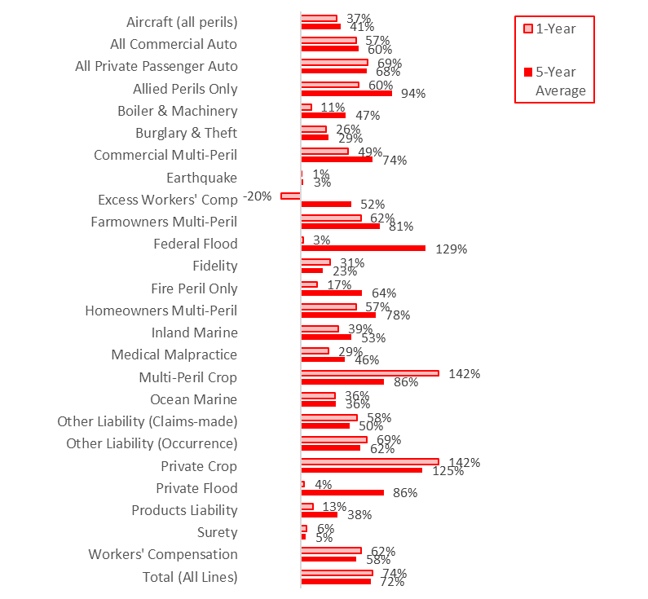

Source: © A.M. Best Company — used by permission.

Loss Ratios Defined

Loss Ratios are calculated as “adjusted calendar year loss ratios.” The losses used in the ratio of losses to earned premiums equals the paid losses that year, plus any estimates of future losses that will be paid from claims that year (new reserves), plus any changes in reserves from previous years made that year (prior reserves). The "adjusted" part is if dividends are paid out under a Line of Business, then the Loss Ratio is adjusted for that cost. Where dividends are a factor (for example, workers’ compensation), it is important to include them whenever Loss Ratios of different Lines of Business are compared.

$$Adjusted Calendar Year Loss Ratio=\frac{Paid Losses+New Reserves±Changes in Prior Reserves}{Earned Premiums-Policy Dividends}$$

Loss Ratio Comparisons

The table below, *Lines of Business Loss Ratios*, compares the 1-year and 5-year average Loss Ratios in Nebraska, and then the United States, by Line of Business, and for all lines combined, to the range in loss ratios for the 50 states and the District of Columbia. The Lines of Business are those 26 focused Lines of Business focused on by Independent Agents.

Note: individual state loss ratios can and do vary considerably, especially with low premiums in a state, and/or an individual Line of Business. Also, negative loss ratios are possible if there are prior year claim reserve reductions impacting loss ratios.

Lines of Business Loss Ratios

|  |  |  |  |  |
| --- | --- | --- | --- | --- |
| **Line of Business Loss Ratios** | **Nebraska  1-Yr | 5-Yr** | **United States  1-Yr | 5-Yr** | **Highest State (1-Yr)** | **Lowest State (1-Yr)** |
| All Lines of Business | 74.3% | 72.2% | 66.0% | 63.7% | 140.5% (Hawaii) | 43.4% (District of Columbia) |
| Aircraft (all perils) | 37.2% | 41.1% | 48.1% | 57.0% | 291.8% (New Jersey) | -17.9% (Connecticut) |
| All Commercial Auto | 57.0% | 59.5% | 74.2% | 68.9% | 93.5% (Nevada) | 47.2% (Hawaii) |
| All Private Passenger Auto | 69.4% | 68.0% | 75.7% | 69.9% | 88.2% (Nevada) | 61.5% (Montana) |
| Allied Perils Only | 60.3% | 93.9% | 51.1% | 69.8% | 183.8% (Arkansas) | 2.7% (District of Columbia) |
| Boiler & Machinery | 11.1% | 46.7% | 35.2% | 39.6% | 157.6% (Alabama) | -48.4% (Tennessee) |
| Burglary & Theft | 26.3% | 29.2% | 31.3% | 45.5% | 82.7% (Indiana) | -17.2% (Kentucky) |
| Commercial Multi-Peril | 49.0% | 74.3% | 61.8% | 60.1% | 276.4% (Hawaii) | 37.0% (Vermont) |
| Earthquake | 1.4% | 3.0% | 0.3% | 1.6% | 8.6% (Hawaii) | -9.3% (New Jersey) |
| Excess Workers' Comp | -20.1% | 51.9% | 14.9% | 44.2% | 140.0% (Wyoming) | -500.0% (North Dakota) |
| Farmowners Multi-Peril | 62.0% | 81.3% | 79.0% | 70.3% | 171.0% (Kentucky) | 15.5% (Rhode Island) |
| Federal Flood | 2.5% | 128.9% | 59.6% | 58.4% | 930.0% (Vermont) | 1.0% (Louisiana) |
| Fidelity | 30.8% | 23.4% | 34.4% | 34.1% | 124.3% (Minnesota) | -14.4% (Vermont) |
| Fire Peril Only | 17.0% | 63.5% | 45.8% | 58.2% | 401.9% (Hawaii) | 11.9% (Wyoming) |
| Homeowners Multi-Peril | 57.0% | 77.6% | 70.8% | 67.8% | 390.9% (Hawaii) | 40.0% (Florida) |
| Inland Marine | 39.1% | 52.7% | 44.2% | 50.3% | 59.7% (Alabama) | 20.1% (District of Columbia) |
| International | 50.0% | -200.0% | 146.3% | 93.8% | 635.4% (Massachusetts) | -800.0% (Nevada) |
| Medical Malpractice | 29.1% | 46.0% | 55.7% | 56.2% | 195.5% (New Mexico) | 14.1% (Wyoming) |
| Multi-Peril Crop | 141.8% | 86.1% | 102.2% | 92.2% | 200.2% (New Hampshire) | 19.9% (Indiana) |
| Ocean Marine | 35.8% | 36.5% | 48.1% | 56.1% | 113.2% (Arkansas) | 5.8% (West Virginia) |
| Other Liability (Claims-made) | 58.1% | 50.4% | 50.7% | 53.2% | 79.0% (Vermont) | 23.2% (Wyoming) |
| Other Liability (Occurrence) | 68.6% | 61.9% | 71.3% | 67.5% | 139.3% (Delaware) | 26.9% (Montana) |
| Private Crop | 142.0% | 125.2% | 98.8% | 97.1% | 272.6% (Louisiana) | -7.5% (Oregon) |
| Private Flood | 3.9% | 85.6% | 6.3% | 35.7% | 1317.7% (Vermont) | -31.8% (New Jersey) |
| Products Liability | 12.8% | 38.3% | 57.5% | 50.9% | 147.2% (Pennsylvania) | -4.5% (Delaware) |
| Surety | 6.4% | 5.3% | 23.1% | 18.9% | 57.9% (New York) | -11.0% (Maine) |
| Workers' Compensation | 62.2% | 57.7% | 46.1% | 47.9% | 78.3% (Oregon) | 16.7% (Washington) |

Source: © A.M. Best Company — used by permission.

# Nebraska Premium Change

The below bar chart, *Nebraska 1-Year and 5-Year Premium Changes*, shows the percentage change in direct written premiums for the 26 different P&C Lines of Business focused on by Independent Agents. The 1-Year growth rate is the percentage change in premiums from 2022 to 2023. The 5-Year growth rate is the percentage that results when the premiums from the first year equal the most recent year, when the percentage is applied annually.

Note: International is not shown as there is less than 5 years data available.

Nebraska 1-Year and 5-Year Premium Changes

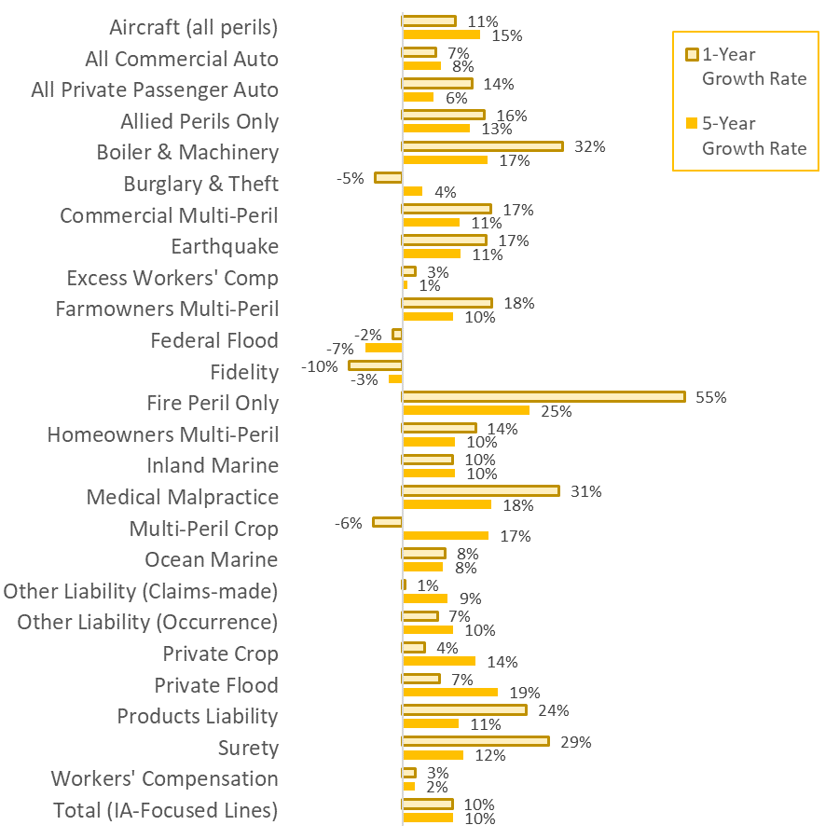

Source: © A.M. Best Company — used by permission. (International not shown, as less than 5 years data is available)

Average Premium Change Comparisons

The table below, *Line of Business Premium Change* compares the 1-year and 5-year average premium change in Nebraska to the range of premium changes in the United States and across the 50 states and the District of Columbia.

Line of Business Premium Change

|  |  |  |  |  |
| --- | --- | --- | --- | --- |
| **Line of Business Premium Change** | **Nebraska  1-Yr | 5-Yr** | **United States  1-Yr | 5-Yr** | **Highest State (1-Yr)** | **Lowest State (1-Yr)** |
| Total (All Lines) | 9.6% | 9.6% | 10.4% | 7.9% | 16.1% (Florida) | 3.4% (District of Columbia) |
| Aircraft (all perils) | 10.5% | 15.3% | 7.8% | 12.4% | 42.7% (District of Columbia) | -32.1% (Massachusetts) |
| All Commercial Auto | 6.6% | 7.6% | 7.2% | 9.1% | 17.4% (Florida) | -11.3% (District of Columbia) |
| All Private Passenger Auto | 13.7% | 6.2% | 14.5% | 5.8% | 20.6% (Texas) | 5.8% (Hawaii) |
| Allied Perils Only | 16.2% | 13.2% | 24.5% | 18.0% | 40.4% (Florida) | -13.7% (Louisiana) |
| Boiler & Machinery | 31.6% | 16.8% | 13.4% | 11.4% | 32.1% (Tennessee) | -9.7% (Alaska) |
| Burglary & Theft | -5.3% | 4.0% | 5.1% | 7.7% | 56.0% (Louisiana) | -18.5% (South Dakota) |
| Commercial Multi-Peril | 17.4% | 11.3% | 12.0% | 8.8% | 34.3% (Florida) | -47.6% (Delaware) |
| Earthquake | 16.5% | 11.4% | 16.5% | 13.7% | 87.6% (New Hampshire) | -14.9% (New Jersey) |
| Excess Workers' Comp | 2.6% | 1.0% | 3.3% | 3.2% | 40.0% (North Dakota) | -255.4% (Wyoming) |
| Farmowners Multi-Peril | 17.6% | 9.9% | 9.7% | 6.4% | 36.0% (Mississippi) | 0.6% (California) |
| Federal Flood | -1.8% | -7.3% | 13.0% | 1.4% | 120.7% (Utah) | -5.5% (Alaska) |
| Fidelity | -10.5% | -2.7% | -0.2% | 3.5% | 18.5% (South Dakota) | -10.5% (Nebraska) |
| Fire Peril Only | 55.5% | 25.0% | 28.9% | 18.4% | 55.5% (Nebraska) | 9.2% (North Dakota) |
| Homeowners Multi-Peril | 14.4% | 10.3% | 14.0% | 10.0% | 22.0% (Utah) | 7.0% (West Virginia) |
| Inland Marine | 9.9% | 10.3% | 6.9% | 8.3% | 18.6% (Florida) | 1.0% (Washington) |
| International | 100.0% | N/A | -204.5% | N/A | 436.4% (New Jersey) | 0.0% (Alaska) |
| Medical Malpractice | 30.8% | 17.5% | 1.9% | 5.5% | 30.8% (Nebraska) | -20.8% (North Dakota) |
| Multi-Peril Crop | -5.6% | 17.0% | -3.4% | 16.9% | 126.7% (Nevada) | -33.8% (Alaska) |
| Ocean Marine | 8.4% | 8.0% | 10.6% | 10.9% | 45.9% (Washington) | -19.8% (Mississippi) |
| Other Liability (Claims-made) | 0.5% | 8.9% | -6.2% | 11.5% | 22.6% (Vermont) | -18.1% (District of Columbia) |
| Other Liability (Occurrence) | 6.9% | 10.0% | 5.8% | 10.6% | 26.9% (Delaware) | -20.4% (Florida) |
| Private Crop | 4.4% | 14.3% | 4.4% | 8.6% | 800.0% (Connecticut) | -72.0% (Nevada) |
| Private Flood | 7.4% | 18.7% | 10.5% | 27.3% | 61.7% (Utah) | -16.5% (New Mexico) |
| Products Liability | 24.4% | 11.0% | 6.5% | 6.1% | 35.1% (New Mexico) | -11.1% (District of Columbia) |
| Surety | 28.8% | 12.0% | 10.7% | 7.9% | 41.7% (Delaware) | -14.5% (South Dakota) |
| Workers' Compensation | 2.6% | 2.5% | 2.4% | 1.1% | 17.7% (North Dakota) | -15.1% (Idaho) |

Source: © A.M. Best Company — used by permission.

# Nebraska Independent Agent Penetration Rates

The clustered bar chart below, *Nebraska Top 10 Lines of Business and 5-Year Penetration Rates*, shows 5 years of penetration rates, from 2019 to 2023, for the top 10 Lines of Business written through Independent Agents in Nebraska. The clustered bars are organized by the rank-order of premiums of each Line of Business. The final cluster of bars labeled *Total (IA-Focused Lines)* is the trend for the 26 P&C Lines of Business focused on by Independent Agents.

Note: After the bar chart is a definition of “Independent Agent Penetration Rates,” and the formula for how penetration rates are calculated.

Nebraska Top 10 Lines of Business and 5-Year Penetration Rates

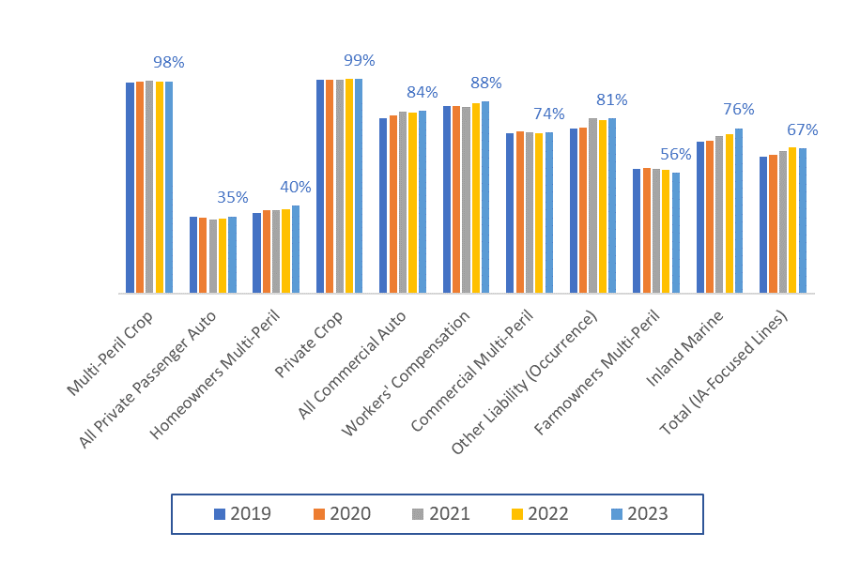

Source: © A.M. Best Company — used by permission.

Independent Agent Penetration Rates Defined

Independent Agent penetrations are estimated based on premiums of insurers using Independent Agents either directly, or in combination with other Distribution Styles (like Managing General Agents). For further information *Appendix #1: Distribution Style Classifications* gives a detailed explanation of the classification of insurers into Distribution Styles, based on insurer reported Marketing Types.

$$Independent Agent Penetration=\frac{Independent Agent Written Premium by Line of Business}{All Written Premium by Line of Business}$$

Independent Agent Penetration Comparisons by Line of Business

The table below, *Line of Business Penetration Rates*, shows the 1-year and 5-year average Independent Agent penetration rates for Nebraska, as compared to the range of Independent Agent penetration rates across the 50 states and the District of Columbia.

Line of Business Penetration Rates

|  |  |  |  |  |
| --- | --- | --- | --- | --- |
| **Line of Business Penetration Rates** | **Nebraska  1-Yr | 5-Yr** | **United States  1-Yr | 5-Yr** | **Highest State (1-Yr)** | **Lowest State (1-Yr)** |
| Total (IA-Focused Lines) | 66.8% | 65.5% | 62.2% | 60.9% | 79.6% (Massachusetts) | 51.7% (Alabama) |
| Aircraft (all perils) | 98.5% | 97.5% | 95.5% | 94.5% | 99.4% (Delaware) | 86.4% (Maine) |
| All Commercial Auto | 84.2% | 82.9% | 85.1% | 84.5% | 92.7% (Massachusetts) | 63.8% (District of Columbia) |
| All Private Passenger Auto | 35.5% | 34.9% | 32.8% | 31.8% | 61.8% (Massachusetts) | 10.2% (Alaska) |
| Allied Perils Only | 86.8% | 86.8% | 87.3% | 85.1% | 95.4% (Hawaii) | 70.8% (Arkansas) |
| Boiler & Machinery | 89.2% | 89.2% | 94.0% | 93.5% | 99.9% (Maine) | 80.4% (Michigan) |
| Burglary & Theft | 96.7% | 96.0% | 96.3% | 95.8% | 99.8% (Massachusetts) | 73.9% (Mississippi) |
| Commercial Multi-Peril | 74.2% | 74.1% | 84.8% | 83.7% | 97.9% (Massachusetts) | 62.5% (Idaho) |
| Earthquake | 81.3% | 76.4% | 87.4% | 85.8% | 97.9% (Florida) | 40.1% (Oklahoma) |
| Excess Workers' Comp | 95.7% | 98.1% | 92.9% | 93.9% | 101.7% (Minnesota) | 28.6% (North Dakota) |
| Farmowners Multi-Peril | 55.7% | 57.0% | 39.8% | 39.8% | 99.7% (New Jersey) | 12.1% (Missouri) |
| Federal Flood | 82.8% | 80.1% | 79.4% | 77.4% | 92.7% (Massachusetts) | 49.3% (Utah) |
| Fidelity | 91.6% | 91.6% | 90.5% | 90.5% | 95.1% (Nevada) | 76.1% (West Virginia) |
| Fire Peril Only | 95.1% | 93.4% | 90.1% | 87.7% | 96.3% (Hawaii) | 73.0% (Arkansas) |
| Homeowners Multi-Peril | 40.4% | 38.7% | 50.8% | 47.9% | 81.8% (Florida) | 19.7% (Alaska) |
| Inland Marine | 76.1% | 72.8% | 78.7% | 76.8% | 90.8% (Indiana) | 55.9% (Delaware) |
| International | 100.0% | 100.0% | 100.0% | 100.0% | 100.0% (46 States) | 0.0% (5 States $0 Prem.) |
| Medical Malpractice | 96.8% | 93.0% | 73.7% | 73.8% | 97.7% (Maine) | 43.9% (Connecticut) |
| Multi-Peril Crop | 97.7% | 97.7% | 95.8% | 95.6% | 100.0% (Alaska) | 80.3% (Utah) |
| Ocean Marine | 99.6% | 98.8% | 96.5% | 95.6% | 99.7% (New Mexico) | 91.0% (Alaska) |
| Other Liability (Claims-made) | 92.7% | 91.7% | 90.7% | 90.8% | 95.4% (Louisiana) | 84.9% (District of Columbia) |
| Other Liability (Occurrence) | 80.8% | 78.9% | 85.4% | 85.4% | 91.5% (District of Columbia) | 69.0% (Delaware) |
| Private Crop | 98.8% | 98.6% | 96.2% | 96.4% | 106.7% (Michigan) | 49.1% (California) |
| Private Flood | 90.9% | 86.2% | 88.1% | 83.9% | 99.4% (West Virginia) | 75.1% (Arkansas) |
| Products Liability | 62.2% | 71.3% | 90.9% | 92.2% | 98.2% (Hawaii) | 62.2% (Nebraska) |
| Surety | 91.9% | 91.1% | 85.0% | 85.7% | 93.2% (Mississippi) | 71.8% (Rhode Island) |
| Workers' Compensation | 88.5% | 87.0% | 91.0% | 90.7% | 97.1% (Rhode Island) | 43.3% (Idaho) |

Source: © A.M. Best Company — used by permission.

Nebraska 5-Year Penetration Rate Trends

Below are 5-Year Nebraska penetration rate trends, from 2019 to 2023, broken-down into the Distribution Styles previously presented as 4 groupings of Lines of Business. Refer to the Nebraska All Lines of Business Total Premiums Comparisons section earlier in this Summary for what is included in each grouping.

|  |  |
| --- | --- |
|  |  |
|  |  |

|  |  |
| --- | --- |
|  |  |
|  |  |

*Source: © A.M. Best Company — used by permission*.

# Nebraska Commission Rates

The below bar chart, *Nebraska Commission Rates: Independent Agent Lines of Business*, shows the commission rates paid by all insurers for the 26 different Independent Agent-focused P&C Lines of Business, for the most recent 1-year, and the 5-year average. Shown last in the bar chart, *Total (All Lines),* is the average combined commission paid on all Lines of Business.

Notes: International is not shown as there is less than 5 years data available. And, after the bar chart is a definition of “Commission Rate,” and the formula for how commissions are calculated.

Nebraska Commission Rates:  
Independent Agent Lines of Business

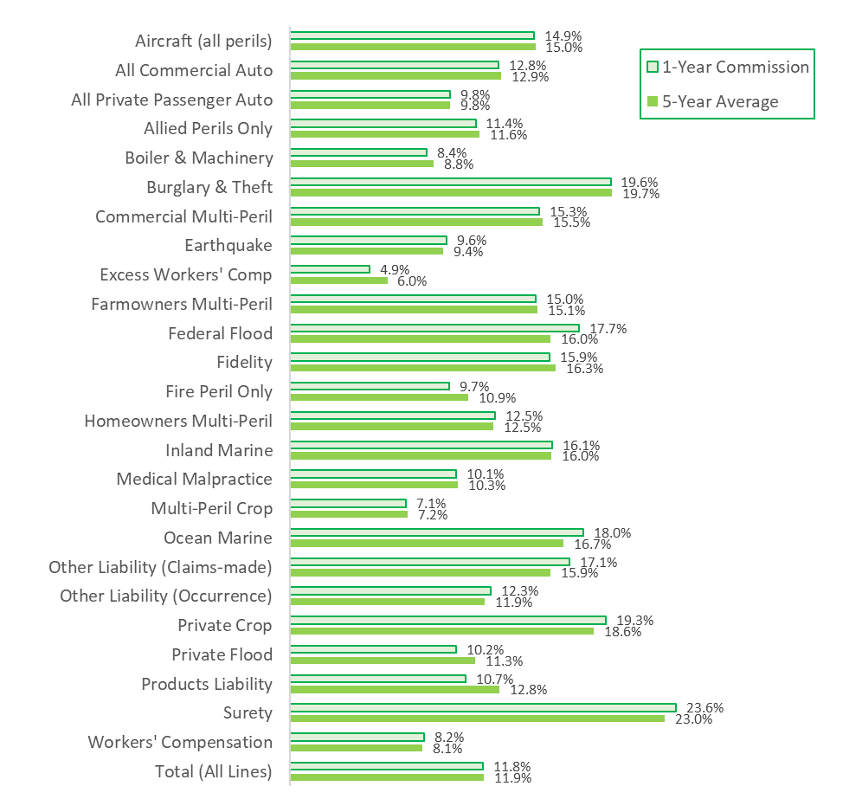

Source: © A.M. Best Company — used by permission.

Commission Rate Defined

The formula below shows how commission percentages are calculated, where the commission % equals the direct and contingent commissions, dividedby the Line of Business written premium.

$$Commission \%=\frac{Line of Business Direct and Contingent Commissions}{Line of Business Written Premium}$$

Average Commission Comparisons

The table below, *Line of Business Commission Rates*, shows the 1-year commission rate, and 5-year average commission rates for Nebraska, and then the United States, compared to the range of commission rates across the 50 states and the District of Columbia.

Note: Where premiums are low in a Line of Business or a state, unusual highest and/or lowest commission rate figures are possible. An example of this is Ohio had the highest commission rate for Workers’ Compensation, as Ohio is a monopolistic fund state with almost no premiums in this Line of Business.

Line of Business Commission Rates

|  |  |  |  |  |
| --- | --- | --- | --- | --- |
| **Line of Business Commission Rates** | **Nebraska  1-Yr | 5-Yr** | **United States  1-Yr | 5-Yr** | **Highest State (1-Yr)** | **Lowest State (1-Yr)** |
| Total (All Lines) | 11.8% | 11.9% | 11.4% | 11.4% | 13.8% (District of Columbia) | 10.2% (Virginia) |
| Aircraft (all perils) | 14.9% | 15.0% | 14.8% | 14.9% | 29.2% (Maine) | 5.3% (Georgia) |
| All Commercial Auto | 12.8% | 12.9% | 12.5% | 13.0% | 15.0% (Alabama) | 9.7% (District of Columbia) |
| All Private Passenger Auto | 9.8% | 9.8% | 7.7% | 7.8% | 10.3% (North Dakota) | 4.4% (District of Columbia) |
| Allied Perils Only | 11.4% | 11.6% | 12.0% | 12.1% | 17.6% (Hawaii) | 9.1% (Idaho) |
| Boiler & Machinery | 8.4% | 8.8% | 9.4% | 9.5% | 13.3% (Montana) | 5.0% (Wyoming) |
| Burglary & Theft | 19.6% | 19.7% | 19.1% | 20.9% | 25.9% (New York) | 13.3% (Louisiana) |
| Commercial Multi-Peril | 15.3% | 15.5% | 16.9% | 17.0% | 20.2% (Maine) | 15.2% (Idaho) |
| Earthquake | 9.6% | 9.4% | 12.9% | 12.6% | 15.8% (Florida) | 4.3% (Wisconsin) |
| Excess Workers' Comp | 4.9% | 6.0% | 7.8% | 8.0% | 17.9% (Delaware) | 0.5% (District of Columbia) |
| Farmowners Multi-Peril | 15.0% | 15.1% | 14.6% | 14.8% | 20.8% (New York) | 9.9% (Alabama) |
| Federal Flood | 17.7% | 16.0% | 17.6% | 17.5% | 20.7% (Ohio) | 12.6% (Vermont) |
| Fidelity | 15.9% | 16.3% | 16.1% | 15.9% | 19.0% (District of Columbia) | 12.3% (Kentucky) |
| Fire Peril Only | 9.7% | 10.9% | 12.7% | 13.0% | 21.6% (South Carolina) | 8.9% (Illinois) |
| Homeowners Multi-Peril | 12.5% | 12.5% | 12.4% | 12.5% | 16.9% (Massachusetts) | 9.9% (Alaska) |
| Inland Marine | 16.1% | 16.0% | 17.9% | 17.2% | 26.9% (Indiana) | 11.6% (District of Columbia) |
| International | 0.0% | 0.0% | -2868.9% | 2472.5% | 20030.5% (New Jersey) | 0.0% (Alaska) |
| Medical Malpractice | 10.1% | 10.3% | 9.3% | 9.1% | 13.2% (New Hampshire) | 5.5% (Connecticut) |
| Multi-Peril Crop | 7.1% | 7.2% | 7.6% | 7.8% | 15.6% (Nevada) | 2.9% (West Virginia) |
| Ocean Marine | 18.0% | 16.7% | 15.8% | 15.5% | 21.8% (Nevada) | 8.9% (Tennessee) |
| Other Liability (Claims-made) | 17.1% | 15.9% | 16.3% | 15.6% | 19.2% (Wyoming) | 12.8% (Rhode Island) |
| Other Liability (Occurrence) | 12.3% | 11.9% | 13.8% | 13.3% | 19.3% (Wyoming) | 8.5% (Delaware) |
| Private Crop | 19.3% | 18.6% | 19.9% | 19.2% | 279.5% (Montana) | 0.0% (Massachusetts) |
| Private Flood | 10.2% | 11.3% | 14.4% | 13.4% | 20.4% (Hawaii) | 7.7% (North Dakota) |
| Products Liability | 10.7% | 12.8% | 14.1% | 14.5% | 16.5% (Montana) | 10.7% (Indiana) |
| Surety | 23.6% | 23.0% | 26.9% | 26.6% | 31.1% (Vermont) | 20.7% (Rhode Island) |
| Workers' Compensation | 8.2% | 8.1% | 9.3% | 9.1% | 48.4% (Ohio) | 6.4% (North Dakota) |

Source: © A.M. Best Company — used by permission.

# Nebraska Surplus Lines

The pie chart below, *Nebraska* *Surplus Lines: Top 10 Lines of Business*, illustrates the Top 10 Lines of Business by percentage of all Surplus Lines premiums in Nebraska for 2023. Also below, the combination line and bar chart, *Nebraska* *Total Premiums and Percentage of All Premiums*, shows (orange bars) the total Surplus Lines premiums, and shows (orange dotted line) the Surplus Lines premium-to-premium percentages for all Lines of Business combined.

Note: Alien insurer data (e.g. Lloyds of London) is not included, as it is not tracked as consistently across states nor in the same time-frame, and if included, would increase Surplus Lines premiums by about 1%.

Nebraska Surplus Lines: Top 10 Lines of Business

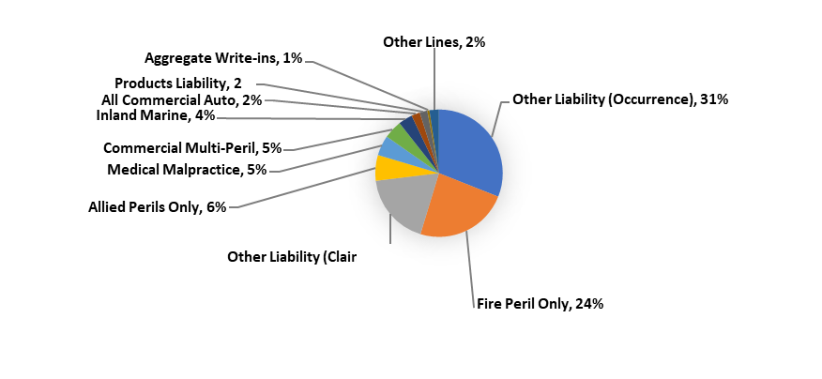

Source: © A.M. Best Company — used by permission

Nebraska Total Premiums and Percentage of All Premiums

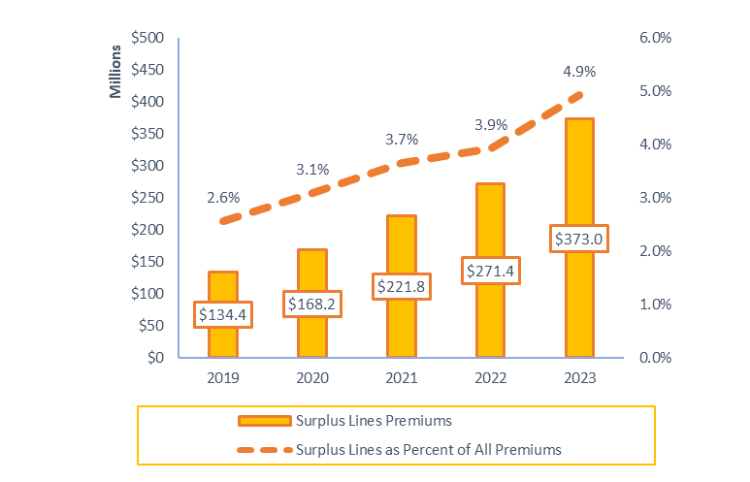

Source: © A.M. Best Company — used by permission

Average Surplus Lines Comparison

The table below, *Line of Business Surplus Lines Utilization,* looks at Surplus Lines utilization for the 26 Lines of Business focused on by Independent Agents. It compares Nebraska 1-year, and 5-year average Surplus Lines utilization rates to the range in Surplus Lines utilization rates for the 50 states and District of Columbia.

Line of Business Surplus Lines Utilization

|  |  |  |  |  |
| --- | --- | --- | --- | --- |
| **All Lines Surplus Lines Utilization Rates** | **Nebraska  1-Yr | 5-Yr** | **United States  1-Yr | 5-Yr** | **Highest State (1-Yr)** | **Lowest State (1-Yr)** |
| Total (All Lines) | 4.9% | 3.7% | 9.3% | 8.1% | 17.6% (Mississippi) | 2.6% (South Dakota) |
| Aircraft (all perils) | 0.0% | 0.0% | 1.6% | 2.5% | 8.9% (Massachusetts) | 0.0% (6 states) |
| All Commercial Auto | 1.9% | 1.6% | 7.3% | 6.5% | 23.6% (California) | 1.6% (New York) |
| All Private Passenger Auto | 0.0% | 0.0% | 0.2% | 0.2% | 11.9% (Mississippi) | 0.0% (36 states) |
| Allied Perils Only | 14.9% | 12.6% | 34.0% | 30.5% | 52.1% (South Carolina) | 11.8% (Minnesota) |
| Boiler & Machinery | 3.9% | 3.0% | 9.0% | 7.6% | 24.2% (Hawaii) | 1.8% (Wyoming) |
| Burglary & Theft | 25.6% | 15.2% | 23.9% | 18.3% | 50.1% (Louisiana) | 5.9% (Alabama) |
| Commercial Multi-Peril | 3.7% | 3.7% | 11.0% | 9.0% | 41.3% (Florida) | 2.8% (Ohio) |
| Earthquake | 30.5% | 29.7% | 50.8% | 47.7% | 86.9% (Florida) | 10.4% (Kentucky) |
| Excess Workers' Comp | 0.0% | 0.0% | 0.5% | 0.7% | 46.2% (District of Columbia) | 0.0% (38 states) |
| Farmowners Multi-Peril | 0.0% | 0.1% | 0.5% | 0.5% | 21.5% (Mississippi) | 0.0% (5 states) |
| Federal Flood | 2.3% | 0.8% | 2.5% | 2.3% | 11.4% (Texas) | 0.1% (Louisiana) |
| Fidelity | 1.0% | 1.2% | 2.1% | 1.9% | 9.2% (Vermont) | 0.2% (West Virginia) |
| Fire Peril Only | 47.7% | 28.7% | 40.3% | 34.4% | 59.7% (South Carolina) | 22.5% (New Hampshire) |
| Homeowners Multi-Peril | 0.1% | 0.1% | 2.1% | 2.2% | 20.3% (Mississippi) | 0.1% (Kentucky) |
| Inland Marine | 5.0% | 5.5% | 7.6% | 6.5% | 17.8% (California) | 1.8% (Delaware) |
| International | 0.0% | 0.0% | 0.7% | 100.5% | 200.0% (Michigan) | 0.0% (44 states) |
| Medical Malpractice | 29.3% | 24.0% | 25.7% | 23.7% | 47.7% (Rhode Island) | 10.0% (New York) |
| Multi-Peril Crop | 0.0% | 0.0% | 0.0% | 0.0% | 0.0% (Alaska) | 0.0% (50 states) |
| Ocean Marine | 3.1% | 1.3% | 6.2% | 3.9% | 20.4% (Oklahoma) | 0.6% (District of Columbia) |
| Other Liability (Claims-made) | 42.2% | 34.5% | 38.0% | 34.6% | 64.2% (Alaska) | 25.1% (South Dakota) |
| Other Liability (Occurrence) | 29.3% | 23.9% | 33.4% | 29.9% | 46.7% (Louisiana) | 13.8% (Delaware) |
| Private Crop | 0.0% | 0.0% | 0.1% | 0.0% | 13.1% (Montana) | 0.0% (33 states) |
| Private Flood | 30.7% | 31.4% | 46.2% | 41.9% | 65.4% (Rhode Island) | 15.6% (Montana) |
| Products Liability | 22.3% | 24.5% | 42.1% | 42.8% | 58.8% (California) | 15.6% (South Dakota) |
| Surety | 0.7% | 0.5% | 0.6% | 0.5% | 28.5% (Rhode Island) | 0.0% (4 states) |
| Workers' Compensation | 0.0% | 0.0% | 0.4% | 0.5% | 2.7% (Florida) | 0.0% (8 states) |

Source: © A.M. Best Company — used by permission.)

# Nebraska Line of Business In-Depth Detail Pages

The following 27 pages of graphs and tables provide in-depth data detail on the 26 P&C Lines of Business focused on by Independent Agents in Nebraska with all Lines of Business combined presented first. The 26 Lines of Business are presented in alphabetical order. The facts and details presented include:

* A bar chart of 5-Years data on premiums for all Distribution Styles (dark blue bars), and premiums written through Independent Agents (light blue bars). Independent Agent classification of premiums is based on the approach explained in *Appendix #1: Distribution Style Classifications.*
* 5-Year line charts, showing the Loss Ratio (dashed red line) and Combined Ratio (solid red line). Additionally, the average commission on each Line of Business is provided below the combination bar and line chart.
* Direct written premium for insurers using Independent Agents, Exclusive-Captive agents, and Direct distribution is provided, as is the percentage of Surplus Lines premiums to all premiums.
* The count of active insurers for Independent Agent, Exclusive-Captive, and Direct insurers is provided, as is the count of active Surplus Lines insurers.
* 1-Year and 5-Year growth rates for all insurers, Independent Agent, Exclusive-Captive, and Direct insurers are provided, as is the percentage of premiums through insurers acting as Surplus Lines.
* The top 5 insurer groups in each Line of Business are provided. This features premiums ("1-yr DPW"), 1-year Loss and Combined Ratio ("1-yr LR | CR"), and 1-year growth and commission percentages ("1-yr Growth | Comm%"). The last column denotes the largest insurer in the group for that Line of Business in Nebraska.
* Listed after the top insurer groups are the top policy-issuing insurers distributing insurance through Independent Agents, Exclusive-Captive agents, Direct, Surplus Lines insurers, with the top risk retention group for that Line of Business shown last. The column headings remain consistent (“1-yr DPW,” “1-yr LR | 1-yr CR,” and “1-yr Growth | Comm%”). Note: The last column changes to the Group that the policy-issuing insurer belongs to (if any). If there is no Group, “N/A” is shown.

As you navigate the Line of Business In-Depth Detail pages, notice if a small pie chart thumbnail is presented at the upper-right corner. If there is a pie chart present, that indicates the product is in the top 10 Lines of Business for Independent Agents in Nebraska. Also at the bottom of each table, after the source citation, is a short narrative of the types of policies that are included in that Line of Business.

For complete definitions of each Line of Business, refer to A*ppendix #2: NAIC Line of Business Definitions*. Lastly, *Appendix #3: Line of Business Facts—Visual Reference* gives the reader another view of the presentation of Line of Business In-Depth Detail Page figures.

|  |  |
| --- | --- |
| Total All P&C Lines of Business |  |

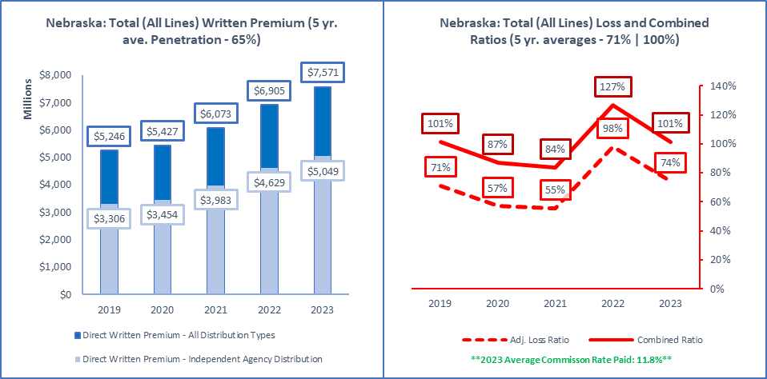

|  |  |  |  |  |
| --- | --- | --- | --- | --- |
| **ALL Direct Written Premium (DPW)** | **Ind Agent DPW** | **Excl.-Captive DPW** | **Direct DPW** | **Surplus Lines DPW** |
| $7,570,545,000 | $5,048,663,000 | $1,841,660,000 | $639,121,000 | $373,011,000 |
|  |  |  |  |  |
| **2019 to 2023 Ave Commission % (All Insurers)** | **Ind Agent Penetration** | **Excl.-Captive Penetration** | **Direct Penetration** | **Surplus Lines Utilization** |
| 11.8% | 12.2% | 11.9% | 11.6% | 11.8% | 67% | 24% | 8% | 4.9% |
|  |  |  |  |  |
| **Active Affiliated and Unaffiliated** | **IA+MGA+IA-Mixed** | **Excl.-Captive** | **Direct** | **Surplus Lines Insurers** |
| 817 | 615 | 52 | 91 | 145 |
|  |  |  |  |  |
| **1-yr | 5-yr Premium Growth: All Premium** | **1-yr | 5-yr: IA+MGA+IA-Mixed** | **1-yr | 5-yr: Excl.-Captive** | **1-yr | 5-yr: Direct** | **1-yr | 5-yr: Surplus Lines** |
| 10% | 10% | 9% | 11% | 11% | 8% | 12% | 6% | 37% | 29% |
|  |  |  |  |  |
| **Top 5 Groups** | **1-yr DPW** | **1-yr LR | CR** | **1-yr Growth | Comm%** | **Largest Insurer in Group or "N/A"** |
| State Farm Group (G) | $733,752,000 | 71% | 96% | 13% | 11% | State Farm Fire and Casualty Company |
| Zurich Insurance US PC Group (G) | $479,360,000 | 112% | 132% | -1% | 9% | Rural Community Insurance Company |
| Farmers Mutual Insurance Co of Nebraska | $472,715,000 | 70% | 99% | 15% | 15% | N/A |
| Chubb INA Group (G) | $376,789,000 | 102% | 122% | 5% | 10% | ACE Property and Casualty Insurance Co |
| Nationwide Property & Casualty Group (G) | $370,751,000 | 61% | 92% | 4% | 14% | Nationwide Mutual Insurance Company |
| Total or Average | $7,544,842,000 | 74% | 101% | 9% | 12% | N/A |
|  |  |  |  |  |
| **Top 5 Pure Independent Agent-Broker Policy-Issuing Insurers** | | | | **Group or "N/A"** |
| Farmers Mutual Insurance Co of Nebraska | $472,715,000 | 70% | 99% | 15% | 15% | N/A |
| NAU Country Insurance Company | $306,524,000 | 138% | 156% | 11% | 13% | QBE North America Insurance Group |
| ACE Property and Casualty Insurance Co | $226,348,000 | 131% | 150% | 3% | 8% | Chubb INA Group |
| Progressive Northern Insurance Company | $221,332,000 | 63% | 85% | 10% | 10% | Progressive Insurance Group |
| Great American Insurance Company | $105,638,000 | 81% | 104% | -7% | 11% | Great American P & C Insurance Group |
| **Top 3 MGA/Wholesale Policy-Issuing Insurers** | | | | **Group or "N/A"** |
| Stratford Insurance Company | $40,122,000 | 175% | 179% | 2% | 6% | American International Group |
| FMH Ag Risk Insurance Company | $12,585,000 | 108% | 117% | -9% | 9% | FMH Insurance Group |
| Gemini Insurance Company | $10,140,000 | 68% | 84% | -5% | 13% | W. R. Berkley Insurance Group |
| **Top 3 Exclusive-Captive Policy-Issuing Insurers** | | | | **Group or "N/A"** |
| State Farm Fire and Casualty Company | $387,858,000 | 68% | 92% | 11% | 11% | State Farm Group |
| State Farm Mutual Automobile Ins Co | $345,894,000 | 75% | 100% | 16% | 10% | State Farm Group |
| Farm Bureau Property & Casualty Ins Co | $284,632,000 | 72% | 105% | 17% | 15% | Farm Bureau Property & Casualty Group |
| **Top 3 Direct Policy-Issuing Insurers** | | | | **Group or "N/A"** |
| Progressive Universal Insurance Company | $129,292,000 | 64% | 72% | 23% | 0% | Progressive Insurance Group |
| United Services Automobile Association | $61,093,000 | 70% | 92% | 9% | 0% | USAA Group |
| Nationwide Agribusiness Insurance Co | $51,169,000 | 58% | 81% | 24% | 14% | Nationwide Property & Casualty Group |
| **Top 3 Surplus Lines Policy Issuing Insurers** | | | | **Group or "N/A"** |
| Starr Surplus Lines Insurance Company | $63,342,000 | 24% | 34% | 530% | 4% | Starr International Group |
| National Fire & Marine Insurance Co | $24,954,000 | 56% | 83% | 32% | 6% | Berkshire Hathaway Insurance Group |
| Lexington Insurance Company | $16,002,000 | 110% | 138% | 37% | 15% | American International Group |
| **Top Individual RRG** | | | | **Group or "N/A"** |
| United Educators Ins, a Reciprocal RRG | $3,752,000 | -8% | 4% | 3% | 2% | N/A |

Source: © A.M. Best Company — used by permission. (Included in the above data are all P&C policies issued in Nebraska for all 32 Lines of Business from Aircraft to Workers’ Compensation.)

|  |  |
| --- | --- |
| Aircraft (all perils) |  |

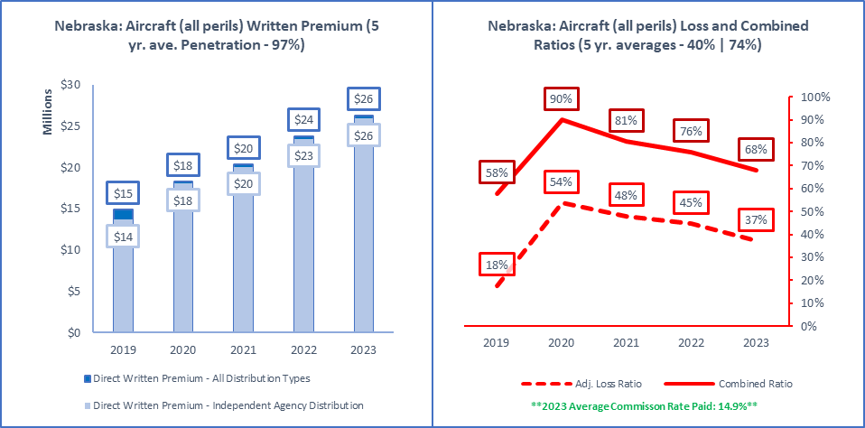

|  |  |  |  |  |
| --- | --- | --- | --- | --- |
| **ALL Direct Written Premium (DPW)** | **Ind Agent DPW** | **Excl.-Captive DPW** | **Direct DPW** | **Surplus Lines DPW** |
| $26,313,000 | $25,921,000 | $78,000 | $314,000 | $0 |
|  |  |  |  |  |
| **2019 to 2023 Ave Commission % (All Insurers)** | **Ind Agent Penetration** | **Excl.-Captive Penetration** | **Direct Penetration** | **Surplus Lines Utilization** |
| 16.0% | 14.8% | 14.7% | 14.9% | 14.9% | 99% | 0% | 1% | 0.0% |
|  |  |  |  |  |
| **Active Affiliated and Unaffiliated** | **IA+MGA+IA-Mixed** | **Excl.-Captive** | **Direct** | **Surplus Lines Insurers** |
| 25 | 23 | 1 | 1 | 0 |
|  |  |  |  |  |
| **1-yr | 5-yr Premium Growth: All Premium** | **1-yr | 5-yr: IA+MGA+IA-Mixed** | **1-yr | 5-yr: Excl.-Captive** | **1-yr | 5-yr: Direct** | **1-yr | 5-yr: Surplus Lines** |
| 11% | 15% | 11% | 17% | 16% | 9% | 8% | -28% | N/A | N/A |
|  |  |  |  |  |
| **Top 5 Groups** | **1-yr DPW** | **1-yr LR | CR** | **1-yr Growth | Comm%** | **Largest Insurer in Group or "N/A"** |
| Old Republic Insurance Group (G) | $3,770,000 | 25% | 60% | 17% | 23% | Old Republic Insurance Company |
| American International Group (G) | $3,456,000 | 54% | 98% | 0% | 31% | National Union Fire Ins Co Pittsburgh PA |
| Berkshire Hathaway Insurance Group (G) | $2,689,000 | 31% | 49% | 12% | 11% | National Liability & Fire Insurance Co |
| Sompo Holdings US Group (G) | $2,131,000 | 109% | 145% | 9% | 23% | Endurance American Insurance Company |
| Chubb INA Group (G) | $1,693,000 | 5% | 13% | 11% | 2% | ACE American Insurance Company |
| Total or Average | $26,313,000 | 0% | 0% | 11% | 15% | N/A |
|  |  |  |  |  |
| **Top 5 Pure Independent Agent-Broker Policy-Issuing Insurers** | | | | **Group or "N/A"** |
| American Alternative Insurance Corp | $3,887,000 | 26% | 32% | 19% | 3% | Munich-American Holding Corp Companies |
| Old Republic Insurance Company | $3,770,000 | 25% | 56% | 17% | 23% | Old Republic Insurance Group |
| National Union Fire Ins Co Pittsburgh PA | $3,456,000 | 54% | 98% | 0% | 31% | American International Group |
| Endurance American Insurance Company | $2,131,000 | 109% | 137% | 9% | 23% | Sompo Holdings US Group |
| Starr Indemnity & Liability Company | $1,521,000 | 1% | 20% | 13% | 12% | Starr International Group |
| **Top 3 MGA/Wholesale Policy-Issuing Insurers** | | | | **Group or "N/A"** |
| U.S. Specialty Insurance Company | $484,000 | 5% | 37% | 5% | 16% | Tokio Marine US PC Group |
| Harco National Insurance Company | $401,000 | 14% | 47% | 109% | 15% | IAT Insurance Group |
| MS Transverse Insurance Company | $88,000 | 7% | 37% | N/A | 23% | MS&AD US Insurance Group |
| **Top 3 Exclusive-Captive Policy-Issuing Insurers** | | | | **Group or "N/A"** |
| American National Property & Casualty Co | $78,000 | 13% | 50% | 16% | 27% | BAMR US PC Group |
| N/A | $0 | N/A | N/A | N/A | N/A | N/A |
| N/A | N/A | N/A | N/A | N/A | N/A | N/A |
| **Top 3 Direct Policy-Issuing Insurers** | | | | **Group or "N/A"** |
| Avemco Insurance Company | $314,000 | 19% | 43% | 8% | 0% | Tokio Marine US PC Group |
| N/A | $0 | N/A | N/A | N/A | N/A | N/A |
| N/A | N/A | N/A | N/A | N/A | N/A | N/A |
| **Top 3 Surplus Lines Policy Issuing Insurers** | | | | **Group or "N/A"** |
| N/A | $0 | N/A | N/A | N/A | N/A | N/A |
| N/A | N/A | N/A | N/A | N/A | N/A | N/A |
| N/A | N/A | N/A | N/A | N/A | N/A | N/A |
| **Top Individual RRG** | | | | **Group or "N/A"** |
| N/A | $0 | N/A | N/A | N/A | N/A | N/A |

Source: © A.M. Best Company — used by permission. (Included in the above data are all P&C policies issued in Nebraska for property damage to aircraft themselves with any liability for operating an aircraft, an airport and manufacture of aircraft)

|  |  |
| --- | --- |
| All Commercial Auto |  |

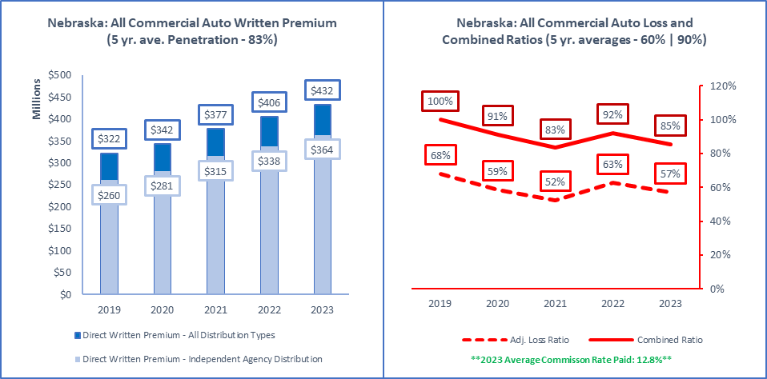

|  |  |  |  |  |
| --- | --- | --- | --- | --- |
| **ALL Direct Written Premium (DPW)** | **Ind Agent DPW** | **Excl.-Captive DPW** | **Direct DPW** | **Surplus Lines DPW** |
| $432,365,000 | $364,057,000 | $36,476,000 | $26,520,000 | $8,046,000 |
|  |  |  |  |  |
| **2019 to 2023 Ave Commission % (All Insurers)** | **Ind Agent Penetration** | **Excl.-Captive Penetration** | **Direct Penetration** | **Surplus Lines Utilization** |
| 13.0% | 13.1% | 13.2% | 12.7% | 12.8% | 84% | 8% | 6% | 1.9% |
|  |  |  |  |  |
| **Active Affiliated and Unaffiliated** | **IA+MGA+IA-Mixed** | **Excl.-Captive** | **Direct** | **Surplus Lines Insurers** |
| 308 | 247 | 25 | 22 | 46 |
|  |  |  |  |  |
| **1-yr | 5-yr Premium Growth: All Premium** | **1-yr | 5-yr: IA+MGA+IA-Mixed** | **1-yr | 5-yr: Excl.-Captive** | **1-yr | 5-yr: Direct** | **1-yr | 5-yr: Surplus Lines** |
| 7% | 8% | 8% | 9% | -4% | 2% | 9% | 1% | 7% | 23% |
|  |  |  |  |  |
| **Top 5 Groups** | **1-yr DPW** | **1-yr LR | CR** | **1-yr Growth | Comm%** | **Largest Insurer in Group or "N/A"** |
| Old Republic Insurance Group (G) | $58,864,000 | 61% | 86% | -5% | 13% | Great West Casualty Company |
| Progressive Insurance Group (G) | $43,373,000 | 65% | 90% | 0% | 10% | Progressive Northern Insurance Company |
| EMC Insurance Companies (G) | $27,168,000 | 60% | 98% | 2% | 18% | Employers Mutual Casualty Company |
| Nationwide Property & Casualty Group (G) | $27,068,000 | 63% | 95% | -8% | 15% | Nationwide Agribusiness Insurance Co |
| Travelers Group (G) | $24,333,000 | 38% | 69% | 4% | 15% | Travelers Indemnity Co of Connecticut |
| Total or Average | $432,365,000 | 0% | 0% | 7% | 13% | N/A |
|  |  |  |  |  |
| **Top 5 Pure Independent Agent-Broker Policy-Issuing Insurers** | | | | **Group or "N/A"** |
| Great West Casualty Company | $51,739,000 | 56% | 84% | -3% | 13% | Old Republic Insurance Group |
| Progressive Northern Insurance Company | $42,657,000 | 65% | 87% | -1% | 9% | Progressive Insurance Group |
| Employers Mutual Casualty Company | $18,024,000 | 73% | 115% | -2% | 18% | EMC Insurance Companies |
| Auto-Owners Insurance Company | $15,599,000 | 67% | 96% | 61% | 15% | Auto-Owners Insurance Group |
| Acuity, A Mutual Insurance Company | $10,846,000 | 69% | 95% | 12% | 16% | N/A |
| **Top 3 MGA/Wholesale Policy-Issuing Insurers** | | | | **Group or "N/A"** |
| National Interstate Insurance Company | $8,404,000 | 56% | 79% | 52% | 8% | Great American P & C Insurance Group |
| Northland Insurance Company | $3,457,000 | -4% | 29% | -33% | 20% | Travelers Group |
| Clear Blue Specialty Insurance Company | $1,676,000 | -4% | 20% | -11% | 19% | Clear Blue Insurance Group |
| **Top 3 Exclusive-Captive Policy-Issuing Insurers** | | | | **Group or "N/A"** |
| Farm Bureau Property & Casualty Ins Co | $8,767,000 | 69% | 104% | 25% | 15% | Farm Bureau Property & Casualty Group |
| Sentry Select Insurance Company | $5,909,000 | 48% | 73% | -1% | 9% | Sentry Insurance Group |
| Federated Mutual Insurance Company | $5,330,000 | 50% | 74% | 10% | 0% | Federated Mutual Group |
| **Top 3 Direct Policy-Issuing Insurers** | | | | **Group or "N/A"** |
| Nationwide Agribusiness Insurance Co | $11,562,000 | 52% | 75% | -1% | 15% | Nationwide Property & Casualty Group |
| Motors Insurance Corporation | $6,878,000 | 8% | 22% | 32% | 1% | Ally Insurance Group |
| Crestbrook Insurance Company | $3,774,000 | 87% | 103% | 59% | 12% | Nationwide Property & Casualty Group |
| **Top 3 Surplus Lines Policy Issuing Insurers** | | | | **Group or "N/A"** |
| Clear Blue Specialty Insurance Company | $1,676,000 | -4% | 20% | -11% | 19% | Clear Blue Insurance Group |
| Scottsdale Insurance Company | $1,055,000 | 62% | 74% | 133% | 12% | Nationwide Property & Casualty Group |
| Atlantic Casualty Insurance Company | $695,000 | 33% | 66% | 1% | 23% | Auto-Owners Insurance Group |
| **Top Individual RRG** | | | | **Group or "N/A"** |
| Technology Transportation Mutual RRG | $254,000 | 44% | 74% | N/A | 11% | N/A |

Source: © A.M. Best Company — used by permission. (Included in the above data are all P&C policies issued in Nebraska to cover commercial auto liability, physical damage, uninsured motorist, and no-fault benefits, if applicable).

|  |  |
| --- | --- |
| All Private Passenger Auto |  |

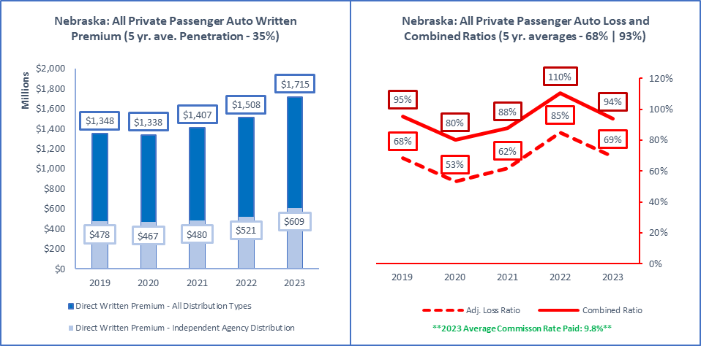

|  |  |  |  |  |
| --- | --- | --- | --- | --- |
| **ALL Direct Written Premium (DPW)** | **Ind Agent DPW** | **Excl.-Captive DPW** | **Direct DPW** | **Surplus Lines DPW** |
| $1,714,913,000 | $608,527,000 | $786,315,000 | $320,071,000 | $0 |
|  |  |  |  |  |
| **2019 to 2023 Ave Commission % (All Insurers)** | **Ind Agent Penetration** | **Excl.-Captive Penetration** | **Direct Penetration** | **Surplus Lines Utilization** |
| 9.5% | 10.1% | 9.8% | 9.7% | 9.8% | 35% | 46% | 19% | 0.0% |
|  |  |  |  |  |
| **Active Affiliated and Unaffiliated** | **IA+MGA+IA-Mixed** | **Excl.-Captive** | **Direct** | **Surplus Lines Insurers** |
| 118 | 63 | 26 | 29 | 0 |
|  |  |  |  |  |
| **1-yr | 5-yr Premium Growth: All Premium** | **1-yr | 5-yr: IA+MGA+IA-Mixed** | **1-yr | 5-yr: Excl.-Captive** | **1-yr | 5-yr: Direct** | **1-yr | 5-yr: Surplus Lines** |
| 14% | 6% | 17% | 6% | 13% | 7% | 9% | 4% | N/A | N/A |
|  |  |  |  |  |
| **Top 5 Groups** | **1-yr DPW** | **1-yr LR | CR** | **1-yr Growth | Comm%** | **Largest Insurer in Group or "N/A"** |
| State Farm Group (G) | $341,376,000 | 76% | 101% | 17% | 10% | State Farm Mutual Automobile Ins Co |
| Progressive Insurance Group (G) | $300,636,000 | 64% | 84% | 18% | 6% | Progressive Northern Insurance Company |
| Farmers Mutual Insurance Co of Nebraska | $161,323,000 | 72% | 101% | 12% | 15% | N/A |
| American Family Insurance Group (G) | $121,451,000 | 68% | 96% | 16% | 8% | American Family Insurance Company |
| Allstate Insurance Group (G) | $117,421,000 | 66% | 90% | 22% | 10% | Allstate Fire and Casualty Insurance Co |
| Total or Average | $1,714,913,000 | 0% | 0% | 14% | 10% | N/A |
|  |  |  |  |  |
| **Top 5 Pure Independent Agent-Broker Policy-Issuing Insurers** | | | | **Group or "N/A"** |
| Progressive Northern Insurance Company | $171,967,000 | 64% | 86% | 14% | 11% | Progressive Insurance Group |
| Farmers Mutual Insurance Co of Nebraska | $161,323,000 | 72% | 101% | 12% | 15% | N/A |
| Owners Insurance Company | $36,384,000 | 74% | 103% | 32% | 15% | Auto-Owners Insurance Group |
| Standard Fire Insurance Company | $34,233,000 | 69% | 90% | 11% | 13% | Travelers Group |
| Viking Insurance Company of Wisconsin | $31,046,000 | 57% | 87% | 22% | 12% | Sentry Insurance Group |
| **Top 3 MGA/Wholesale Policy-Issuing Insurers** | | | | **Group or "N/A"** |
| Liberty Mutual Personal Insurance Co | $3,848,000 | 73% | 78% | 67% | 2% | Liberty Mutual Insurance Companies |
| AssuranceAmerica Insurance Company | $2,551,000 | 83% | 106% | -17% | 20% | AssuranceAmerica Insurance Group |
| State National Insurance Company, Inc. | $834,000 | 42% | 98% | -2% | 49% | Markel Insurance Group |
| **Top 3 Exclusive-Captive Policy-Issuing Insurers** | | | | **Group or "N/A"** |
| State Farm Mutual Automobile Ins Co | $326,790,000 | 75% | 101% | 17% | 10% | State Farm Group |
| Farm Bureau Property & Casualty Ins Co | $92,018,000 | 86% | 120% | 13% | 16% | Farm Bureau Property & Casualty Group |
| Allstate Fire and Casualty Insurance Co | $78,574,000 | 65% | 78% | 14% | 10% | Allstate Insurance Group |
| **Top 3 Direct Policy-Issuing Insurers** | | | | **Group or "N/A"** |
| Progressive Universal Insurance Company | $128,669,000 | 64% | 73% | 23% | 0% | Progressive Insurance Group |
| GEICO Advantage Insurance Company | $33,735,000 | 56% | 58% | -18% | 0% | Berkshire Hathaway Insurance Group |
| United Services Automobile Association | $26,954,000 | 77% | 99% | 9% | 0% | USAA Group |
| **Top 3 Surplus Lines Policy Issuing Insurers** | | | | **Group or "N/A"** |
| N/A | $0 | N/A | N/A | N/A | N/A | N/A |
| N/A | N/A | N/A | N/A | N/A | N/A | N/A |
| N/A | N/A | N/A | N/A | N/A | N/A | N/A |
| **Top Individual RRG** | | | | **Group or "N/A"** |
| N/A | $0 | N/A | N/A | N/A | N/A | N/A |

Source: © A.M. Best Company — used by permission. (Included in the above data are all P&C policies issued in Nebraska to cover private passenger auto liability, physical damage, uninsured motorist, and no-fault benefits, if applicable).

|  |  |
| --- | --- |
| Allied Perils Only |  |

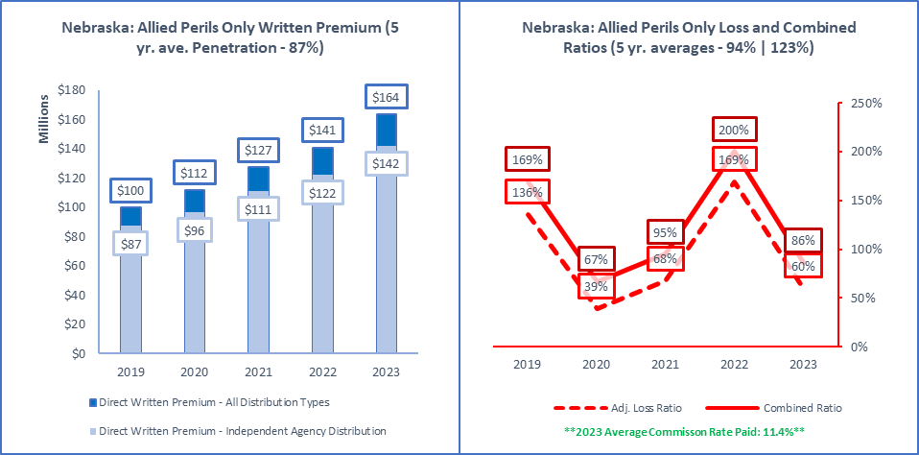

|  |  |  |  |  |
| --- | --- | --- | --- | --- |
| **ALL Direct Written Premium (DPW)** | **Ind Agent DPW** | **Excl.-Captive DPW** | **Direct DPW** | **Surplus Lines DPW** |
| $163,605,000 | $141,961,000 | $12,123,000 | $8,271,000 | $24,374,000 |
|  |  |  |  |  |
| **2019 to 2023 Ave Commission % (All Insurers)** | **Ind Agent Penetration** | **Excl.-Captive Penetration** | **Direct Penetration** | **Surplus Lines Utilization** |
| 11.8% | 12.7% | 11.2% | 11.3% | 11.4% | 87% | 7% | 5% | 14.9% |
|  |  |  |  |  |
| **Active Affiliated and Unaffiliated** | **IA+MGA+IA-Mixed** | **Excl.-Captive** | **Direct** | **Surplus Lines Insurers** |
| 219 | 182 | 14 | 17 | 67 |
|  |  |  |  |  |
| **1-yr | 5-yr Premium Growth: All Premium** | **1-yr | 5-yr: IA+MGA+IA-Mixed** | **1-yr | 5-yr: Excl.-Captive** | **1-yr | 5-yr: Direct** | **1-yr | 5-yr: Surplus Lines** |
| 16% | 13% | 16% | 13% | 6% | 18% | 36% | 10% | 43% | 23% |
|  |  |  |  |  |
| **Top 5 Groups** | **1-yr DPW** | **1-yr LR | CR** | **1-yr Growth | Comm%** | **Largest Insurer in Group or "N/A"** |
| EMC Insurance Companies (G) | $19,907,000 | 89% | 126% | 9% | 17% | Employers Mutual Casualty Company |
| Travelers Group (G) | $18,126,000 | -4% | 11% | 48% | 4% | Travelers Indemnity Company |
| FM Global Group (G) | $12,096,000 | 65% | 86% | -9% | 1% | Factory Mutual Insurance Company |
| Zurich Insurance US PC Group (G) | $11,421,000 | -46% | -32% | 18% | 5% | Zurich American Insurance Company |
| Farmers Mutual Insurance Co of Nebraska | $10,794,000 | 119% | 153% | 70% | 15% | N/A |
| Total or Average | $163,605,000 | 0% | 0% | 16% | 11% | N/A |
|  |  |  |  |  |
| **Top 5 Pure Independent Agent-Broker Policy-Issuing Insurers** | | | | **Group or "N/A"** |
| Travelers Indemnity Company | $11,475,000 | -11% | 3% | 51% | 5% | Travelers Group |
| Employers Mutual Casualty Company | $11,461,000 | 105% | 147% | 12% | 17% | EMC Insurance Companies |
| Farmers Mutual Insurance Co of Nebraska | $10,794,000 | 119% | 153% | 70% | 15% | N/A |
| Foremost Insurance Co Grand Rapids, MI | $8,175,000 | 54% | 95% | 12% | 14% | Farmers Insurance Group |
| North Star Mutual Insurance Company | $6,925,000 | 87% | 110% | 25% | 15% | North Star Companies |
| **Top 3 MGA/Wholesale Policy-Issuing Insurers** | | | | **Group or "N/A"** |
| MS Transverse Specialty Insurance Co | $526,000 | 87% | 112% | 51% | 22% | MS&AD US Insurance Group |
| Northfield Insurance Company | $483,000 | 13% | 40% | 134% | 22% | Travelers Group |
| Evanston Insurance Company | $296,000 | 69% | 101% | -33% | 17% | Markel Insurance Group |
| **Top 3 Exclusive-Captive Policy-Issuing Insurers** | | | | **Group or "N/A"** |
| Nationwide Mutual Insurance Company | $3,296,000 | 38% | 70% | -16% | 14% | Nationwide Property & Casualty Group |
| Federated Mutual Insurance Company | $3,064,000 | 122% | 151% | 22% | 0% | Federated Mutual Group |
| Shelter Mutual Insurance Company | $2,730,000 | 149% | 183% | 24% | 13% | Shelter Insurance Companies |
| **Top 3 Direct Policy-Issuing Insurers** | | | | **Group or "N/A"** |
| United Services Automobile Association | $2,304,000 | 91% | 113% | 5% | 0% | USAA Group |
| Standard Guaranty Insurance Company | $1,591,000 | 49% | 81% | 14% | 1% | Assurant P&C Group |
| Nationwide Agribusiness Insurance Co | $1,502,000 | 239% | 257% | 460% | 4% | Nationwide Property & Casualty Group |
| **Top 3 Surplus Lines Policy Issuing Insurers** | | | | **Group or "N/A"** |
| Travelers Excess and Surplus Lines Co | $2,955,000 | 6% | 7% | 44% | 1% | Travelers Group |
| Landmark American Insurance Company | $2,747,000 | 14% | 30% | 49% | 15% | Berkshire Hathaway Insurance Group |
| AIG Specialty Insurance Company | $1,847,000 | 25% | 26% | 162% | 1% | American International Group |
| **Top Individual RRG** | | | | **Group or "N/A"** |
| N/A | $0 | N/A | N/A | N/A | N/A | N/A |

Source: © A.M. Best Company — used by permission. (Included in the above data are all P&C policies issued in Nebraska to cover real or personal property for other than fire, such as windstorm, hail, vehicles, etc. If premiums are combined in policies with Fire, the premiums and losses are reported as they are allocated by insurers).

|  |  |
| --- | --- |
| Boiler & Machinery |  |

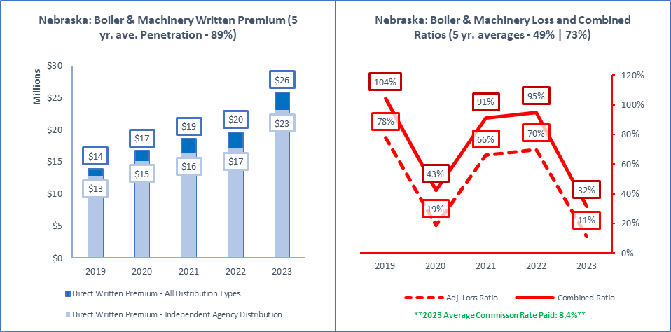

|  |  |  |  |  |  |  |
| --- | --- | --- | --- | --- | --- | --- |
| **ALL Direct Written Premium (DPW)** | | **Ind Agent DPW** | **Excl.-Captive DPW** |  | **Direct DPW** | **Surplus Lines DPW** |
| $25,855,000 | | $23,070,000 | $1,035,000 |  | $1,740,000 | $1,002,000 |
|  | |  |  |  |  |  |
| **2019 to 2023 Ave Commission % (All Insurers)** | | **Ind Agent Penetration** | **Excl.-Captive Penetration** |  | **Direct Penetration** | **Surplus Lines Utilization** |
| 9.4% | 8.6% | 8.7% | 9.2% | 8.4% | | 89% | 4% |  | 7% | 3.9% |
|  | |  |  |  |  |  |
| **Active Affiliated and Unaffiliated** | | **IA+MGA+IA-Mixed** | **Excl.-Captive** |  | **Direct** | **Surplus Lines Insurers** |
| 141 | | 125 | 7 |  | 6 | 30 |
|  | |  |  |  |  |  |
| **1-yr | 5-yr Premium Growth: All Premium** | | **1-yr | 5-yr: IA+MGA+IA-Mixed** | **1-yr | 5-yr: Excl.-Captive** |  | **1-yr | 5-yr: Direct** | **1-yr | 5-yr: Surplus Lines** |
| 32% | 17% | | 35% | 16% | -7% | 24% |  | 22% | 35% | 60% | 23% |
|  | |  |  |  |  |  |
| **Top 5 Groups** | | **1-yr DPW** | **1-yr LR | CR** |  | **1-yr Growth | Comm%** | **Largest Insurer in Group or "N/A"** |
| FM Global Group (G) | | $8,246,000 | 0% | 20% |  | 65% | 0% | Factory Mutual Insurance Company |
| Nationwide Property & Casualty Group (G) | | $2,672,000 | 32% | 60% |  | 5% | 14% | Nationwide Agribusiness Insurance Co |
| American International Group (G) | | $1,847,000 | 23% | 38% |  | 42% | 5% | National Union Fire Ins Co Pittsburgh PA |
| Travelers Group (G) | | $1,631,000 | 6% | 27% |  | 28% | 10% | Travelers Property Casualty Co of Amer |
| Zurich Insurance US PC Group (G) | | $1,482,000 | 4% | 16% |  | 64% | 3% | Zurich American Insurance Company |
| Total or Average | | $25,194,000 | 10% | 31% |  | 28% | 8% | N/A |
|  | |  |  |  |  |  |
|  | **Top 5 Pure Independent Agent-Broker Policy-Issuing Insurers** | | | | | **Group or "N/A"** |
| National Union Fire Ins Co Pittsburgh PA | | $1,234,000 | 4% | 17% |  | 42% | 4% | American International Group |
| Travelers Property Casualty Co of Amer | | $1,076,000 | 9% | 25% |  | 27% | 13% | Travelers Group |
| Federal Insurance Company | | $710,000 | 2% | 44% |  | 21% | 34% | Chubb INA Group |
| Employers Mutual Casualty Company | | $693,000 | 16% | 52% |  | 16% | 19% | EMC Insurance Companies |
| Hartford Steam Boiler Inspec & Ins | | $661,000 | 28% | 95% |  | -5% | 12% | Munich-American Holding Corp Co |
|  | **Top 3 MGA/Wholesale Policy-Issuing Insurers** | | | | | **Group or "N/A"** |
| Accelerant Specialty Insurance Company | | $104,000 | 22% | 30% |  | 2500% | 5% | Accelerant US Holdings Group |
| U.S. Specialty Insurance Company | | $7,000 | 0% | 33% |  | N/A | 29% | Tokio Marine US PC Group |
| Houston Casualty Company | | $5,000 | 25% | 49% |  | 400% | 20% | Tokio Marine US PC Group |
|  | **Top 3 Exclusive-Captive Policy-Issuing Insurers** | | | | | **Group or "N/A"** |
| Federated Mutual Insurance Company | | $473,000 | 31% | 54% |  | 24% | 0% | Federated Mutual Group |
| Nationwide Mutual Insurance Company | | $419,000 | 40% | 71% |  | -29% | 16% | Nationwide Property & Casualty Group |
| Federated Service Insurance Company | | $54,000 | -22% | -9% |  | 15% | 0% | Federated Mutual Group |
|  | **Top 3 Direct Policy-Issuing Insurers** | | | | | **Group or "N/A"** |
| Nationwide Agribusiness Insurance Co | | $805,000 | 12% | 26% |  | 15% | 8% | Nationwide Property & Casualty Group |
| Liberty Mutual Fire Insurance Company | | $497,000 | -20% | 3% |  | 12% | 9% | Liberty Mutual Insurance Companies |
| Crestbrook Insurance Company | | $364,000 | 38% | 54% |  | 79% | 15% | Nationwide Property & Casualty Group |
|  | **Top 3 Surplus Lines Policy Issuing Insurers** | | | | | **Group or "N/A"** |
| Lexington Insurance Company | | $289,000 | 161% | 182% |  | 63% | 11% | American International Group |
| AIG Specialty Insurance Company | | $177,000 | -3% | -2% |  | 14% | 1% | American International Group |
| AXIS Surplus Insurance Company | | $124,000 | 5% | 20% |  | 14% | 12% | AXIS US Operations |
|  | **Top Individual RRG** | | | | | **Group or "N/A"** |
| ARISE Boiler Inspection & Insurance RRG | | $7,000 | 0% | N/A |  | 0% | 0% | N/A |

Source: © A.M. Best Company — used by permission. (Included in the above data are all P&C policies issued in Nebraska to cover failure of boilers, machinery and electrical equipment).

|  |  |
| --- | --- |
| Burglary & Theft |  |

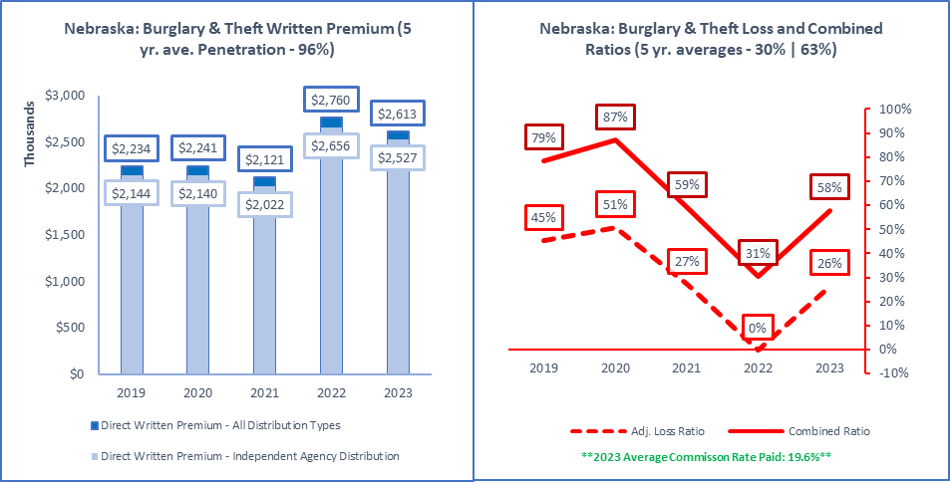

|  |  |  |  |  |
| --- | --- | --- | --- | --- |
| **ALL Direct Written Premium (DPW)** | **Ind Agent DPW** | **Excl.-Captive DPW** | **Direct DPW** | **Surplus Lines DPW** |
| $2,613,000 | $2,527,000 | $69,000 | $10,000 | $669,000 |
|  |  |  |  |  |
| **2019 to 2023 Ave Commission % (All Insurers)** | **Ind Agent Penetration** | **Excl.-Captive Penetration** | **Direct Penetration** | **Surplus Lines Utilization** |
| 18.4% | 19.5% | 20.1% | 20.7% | 19.6% | 97% | 3% | 0% | 25.6% |
|  |  |  |  |  |
| **Active Affiliated and Unaffiliated** | **IA+MGA+IA-Mixed** | **Excl.-Captive** | **Direct** | **Surplus Lines Insurers** |
| 70 | 59 | 6 | 3 | 11 |
|  |  |  |  |  |
| **1-yr | 5-yr Premium Growth: All Premium** | **1-yr | 5-yr: IA+MGA+IA-Mixed** | **1-yr | 5-yr: Excl.-Captive** | **1-yr | 5-yr: Direct** | **1-yr | 5-yr: Surplus Lines** |
| -5% | 4% | -5% | 4% | -23% | -4% | -9% | 6% | -5% | 70% |
|  |  |  |  |  |
| **Top 5 Groups** | **1-yr DPW** | **1-yr LR | CR** | **1-yr Growth | Comm%** | **Largest Insurer in Group or "N/A"** |
| Travelers Group (G) | $651,000 | 48% | 75% | 4% | 15% | Travelers Casualty and Surety Co of Amer |
| Zurich Insurance US PC Group (G) | $466,000 | 8% | 36% | -17% | 21% | Steadfast Insurance Company |
| Chubb INA Group (G) | $369,000 | 26% | 65% | 56% | 28% | Federal Insurance Company |
| CNA Insurance Companies (G) | $177,000 | 55% | 91% | 62% | 19% | Continental Casualty Company |
| The Cincinnati Insurance Companies (G) | $156,000 | 2% | 30% | -24% | 18% | Cincinnati Insurance Company |
| Total or Average | $2,616,000 | 26% | 58% | -5% | 20% | N/A |
|  |  |  |  |  |
| **Top 5 Pure Independent Agent-Broker Policy-Issuing Insurers** | | | | **Group or "N/A"** |
| Travelers Casualty and Surety Co of Amer | $641,000 | 49% | 81% | 5% | 15% | Travelers Group |
| Steadfast Insurance Company | $442,000 | 8% | 31% | -18% | 22% | Zurich Insurance US PC Group |
| Federal Insurance Company | $334,000 | 27% | 65% | 60% | 26% | Chubb INA Group |
| Cincinnati Insurance Company | $147,000 | 2% | 31% | -26% | 18% | The Cincinnati Insurance Companies |
| AXIS Surplus Insurance Company | $120,000 | 5% | 20% | 13% | 13% | AXIS US Operations |
| **Top 3 MGA/Wholesale Policy-Issuing Insurers** | | | | **Group or "N/A"** |
| U.S. Specialty Insurance Company | $75,000 | -100% | -48% | 121% | 45% | Tokio Marine US PC Group |
| Houston Casualty Company | $5,000 | 7% | 31% | -79% | 20% | Tokio Marine US PC Group |
| Clear Blue Specialty Insurance Company | $3,000 | 25% | 62% | -25% | 33% | Clear Blue Insurance Group |
| **Top 3 Exclusive-Captive Policy-Issuing Insurers** | | | | **Group or "N/A"** |
| Nationwide Mutual Insurance Company | $40,000 | 0% | 34% | -37% | 20% | Nationwide Property & Casualty Group |
| Shelter Mutual Insurance Company | $17,000 | 0% | 16% | 13% | 6% | Shelter Insurance Companies |
| Federated Mutual Insurance Company | $8,000 | 0% | 21% | 14% | 0% | Federated Mutual Group |
| **Top 3 Direct Policy-Issuing Insurers** | | | | **Group or "N/A"** |
| Federated Rural Electric Ins Exchange | $8,000 | 0% | 12% | 0% | 0% | N/A |
| Nationwide Agribusiness Insurance Co | $1,000 | 0% | 6% | -50% | 0% | Nationwide Property & Casualty Group |
| N/A | N/A | N/A | N/A | N/A | N/A | N/A |
| **Top 3 Surplus Lines Policy Issuing Insurers** | | | | **Group or "N/A"** |
| Steadfast Insurance Company | $442,000 | 8% | 31% | -18% | 22% | Zurich Insurance US PC Group |
| AXIS Surplus Insurance Company | $120,000 | 5% | 20% | 13% | 13% | AXIS US Operations |
| Columbia Casualty Company | $80,000 | 57% | 92% | 220% | 20% | CNA Insurance Companies |
| **Top Individual RRG** | | | | **Group or "N/A"** |
| N/A | $0 | N/A | N/A | N/A | N/A | N/A |

Source: © A.M. Best Company — used by permission. (Included in the above data are all P&C policies issued in Nebraska to cover property lost due to burglary, robbery, fraud or kidnap).

|  |  |
| --- | --- |
| Commercial Multi-Peril |  |

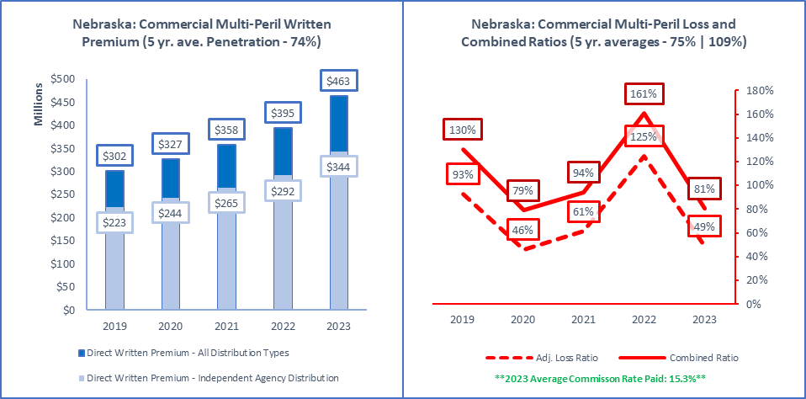

|  |  |  |  |  |
| --- | --- | --- | --- | --- |
| **ALL Direct Written Premium (DPW)** | **Ind Agent DPW** | **Excl.-Captive DPW** | **Direct DPW** | **Surplus Lines DPW** |
| $463,291,000 | $343,820,000 | $87,102,000 | $31,284,000 | $17,295,000 |
|  |  |  |  |  |
| **2019 to 2023 Ave Commission % (All Insurers)** | **Ind Agent Penetration** | **Excl.-Captive Penetration** | **Direct Penetration** | **Surplus Lines Utilization** |
| 15.5% | 15.5% | 15.6% | 15.5% | 15.3% | 74% | 19% | 7% | 3.7% |
|  |  |  |  |  |
| **Active Affiliated and Unaffiliated** | **IA+MGA+IA-Mixed** | **Excl.-Captive** | **Direct** | **Surplus Lines Insurers** |
| 280 | 232 | 23 | 15 | 57 |
|  |  |  |  |  |
| **1-yr | 5-yr Premium Growth: All Premium** | **1-yr | 5-yr: IA+MGA+IA-Mixed** | **1-yr | 5-yr: Excl.-Captive** | **1-yr | 5-yr: Direct** | **1-yr | 5-yr: Surplus Lines** |
| 17% | 11% | 18% | 11% | 14% | 9% | 22% | 21% | 28% | 20% |
|  |  |  |  |  |
| **Top 5 Groups** | **1-yr DPW** | **1-yr LR | CR** | **1-yr Growth | Comm%** | **Largest Insurer in Group or "N/A"** |
| Nationwide Property & Casualty Group (G) | $53,490,000 | 41% | 74% | 0% | 15% | Crestbrook Insurance Company |
| Travelers Group (G) | $48,469,000 | 14% | 42% | 16% | 15% | Travelers Property Casualty Co of Amer |
| State Farm Group (G) | $45,624,000 | 73% | 101% | 22% | 12% | State Farm Fire and Casualty Company |
| Auto-Owners Insurance Group (G) | $33,645,000 | 67% | 98% | 47% | 18% | Owners Insurance Company |
| W. R. Berkley Insurance Group (G) | $23,189,000 | 33% | 64% | 29% | 16% | Continental Western Insurance Company |
| Total or Average | $463,291,000 | 0% | 0% | 17% | 15% | N/A |
|  |  |  |  |  |
| **Top 5 Pure Independent Agent-Broker Policy-Issuing Insurers** | | | | **Group or "N/A"** |
| Owners Insurance Company | $20,057,000 | 67% | 98% | 46% | 18% | Auto-Owners Insurance Group |
| Philadelphia Indemnity Insurance Company | $16,194,000 | 16% | 50% | 24% | 16% | Tokio Marine US PC Group |
| Motorists Commercial Mutual Insurance Co | $14,712,000 | 31% | 61% | 27% | 17% | Encova Mutual Insurance Group |
| Cincinnati Insurance Company | $14,612,000 | 55% | 93% | 20% | 17% | The Cincinnati Insurance Companies |
| Auto-Owners Insurance Company | $13,226,000 | 70% | 98% | 49% | 18% | Auto-Owners Insurance Group |
| **Top 3 MGA/Wholesale Policy-Issuing Insurers** | | | | **Group or "N/A"** |
| National Specialty Insurance Company | $1,485,000 | 70% | 89% | 23% | 16% | Markel Insurance Group |
| Western World Insurance Company | $1,001,000 | 36% | 67% | 8% | 23% | American International Group |
| Houston Casualty Company | $979,000 | 72% | 107% | 134% | 31% | Tokio Marine US PC Group |
| **Top 3 Exclusive-Captive Policy-Issuing Insurers** | | | | **Group or "N/A"** |
| State Farm Fire and Casualty Company | $45,624,000 | 73% | 99% | 22% | 12% | State Farm Group |
| Farm Bureau Property & Casualty Ins Co | $11,812,000 | 58% | 94% | 26% | 16% | Farm Bureau Property & Casualty Group |
| American Family Insurance Company | $10,488,000 | -26% | 1% | 55% | 11% | American Family Insurance Group |
| **Top 3 Direct Policy-Issuing Insurers** | | | | **Group or "N/A"** |
| Crestbrook Insurance Company | $13,265,000 | 22% | 38% | 49% | 14% | Nationwide Property & Casualty Group |
| Nationwide Agribusiness Insurance Co | $9,874,000 | 5% | 22% | 3% | 10% | Nationwide Property & Casualty Group |
| Nationwide General Insurance Company | $2,769,000 | 53% | 77% | 0% | 18% | Nationwide Property & Casualty Group |
| **Top 3 Surplus Lines Policy Issuing Insurers** | | | | **Group or "N/A"** |
| Scottsdale Insurance Company | $2,613,000 | 21% | 42% | -6% | 22% | Nationwide Property & Casualty Group |
| Princeton Excess & Surplus Lines Ins Co | $1,985,000 | -16% | 18% | 21% | 27% | Munich-American Holding Corp Cos |
| Western World Insurance Company | $1,001,000 | 36% | 67% | 8% | 23% | American International Group |
| **Top Individual RRG** | | | | **Group or "N/A"** |
| N/A | $0 | N/A | N/A | N/A | N/A | N/A |

Source: © A.M. Best Company — used by permission. (Included in the above data are all P&C package policies issued in Nebraska to cover commercial enterprises for property and liability).

|  |  |
| --- | --- |
| Earthquake |  |

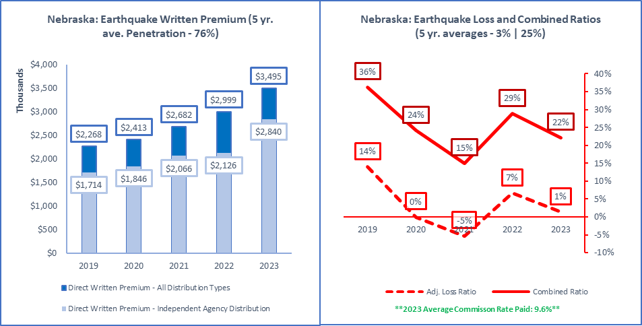

|  |  |  |  |  |
| --- | --- | --- | --- | --- |
| **ALL Direct Written Premium (DPW)** | **Ind Agent DPW** | **Excl.-Captive DPW** | **Direct DPW** | **Surplus Lines DPW** |
| $3,495,000 | $2,840,000 | $473,000 | $186,000 | $1,066,000 |
|  |  |  |  |  |
| **2019 to 2023 Ave Commission % (All Insurers)** | **Ind Agent Penetration** | **Excl.-Captive Penetration** | **Direct Penetration** | **Surplus Lines Utilization** |
| 7.8% | 10.2% | 8.9% | 10.0% | 9.6% | 81% | 14% | 5% | 30.5% |
|  |  |  |  |  |
| **Active Affiliated and Unaffiliated** | **IA+MGA+IA-Mixed** | **Excl.-Captive** | **Direct** | **Surplus Lines Insurers** |
| 112 | 90 | 12 | 10 | 29 |
|  |  |  |  |  |
| **1-yr | 5-yr Premium Growth: All Premium** | **1-yr | 5-yr: IA+MGA+IA-Mixed** | **1-yr | 5-yr: Excl.-Captive** | **1-yr | 5-yr: Direct** | **1-yr | 5-yr: Surplus Lines** |
| 17% | 11% | 34% | 13% | -5% | 5% | 0% | 10% | 10% | 15% |
|  |  |  |  |  |
| **Top 5 Groups** | **1-yr DPW** | **1-yr LR | CR** | **1-yr Growth | Comm%** | **Largest Insurer in Group or "N/A"** |
| Travelers Group (G) | $521,000 | 0% | 15% | 42% | 4% | Travelers Indemnity Company |
| American International Group (G) | $413,000 | 0% | 15% | 67% | 8% | Lexington Insurance Company |
| State Farm Group (G) | $368,000 | 0% | 20% | -1% | 11% | State Farm Fire and Casualty Company |
| Nationwide Property & Casualty Group (G) | $258,000 | -1% | 28% | 25% | 17% | AMCO Insurance Company |
| XL America Companies (G) | $232,000 | 2% | 13% | 29% | 1% | XL Insurance America, Inc. |
| Total or Average | $3,496,000 | 1% | 22% | 17% | 10% | N/A |
|  |  |  |  |  |
| **Top 5 Pure Independent Agent-Broker Policy-Issuing Insurers** | | | | **Group or "N/A"** |
| Travelers Indemnity Company | $302,000 | 0% | 14% | 54% | 4% | Travelers Group |
| XL Insurance America, Inc. | $229,000 | 2% | 4% | 29% | 1% | XL America Companies |
| Endurance American Specialty Ins Co | $206,000 | -4% | 3% | 0% | 8% | Sompo Holdings US Group |
| Lexington Insurance Company | $202,000 | 1% | 21% | 25% | 14% | American International Group |
| AIG Specialty Insurance Company | $192,000 | 1% | 1% | 187% | 1% | American International Group |
| **Top 3 MGA/Wholesale Policy-Issuing Insurers** | | | | **Group or "N/A"** |
| Evanston Insurance Company | $43,000 | 18% | 44% | -50% | 14% | Markel Insurance Group |
| MS Transverse Specialty Insurance Co | $33,000 | 13% | 42% | 175% | 27% | MS&AD US Insurance Group |
| Houston Casualty Company | $10,000 | 0% | 14% | 400% | 10% | Tokio Marine US PC Group |
| **Top 3 Exclusive-Captive Policy-Issuing Insurers** | | | | **Group or "N/A"** |
| State Farm Fire and Casualty Company | $368,000 | 0% | 19% | -1% | 11% | State Farm Group |
| American Family Mutual Ins Co, S.I. | $27,000 | 0% | 16% | -7% | 11% | American Family Insurance Group |
| Nationwide Mutual Insurance Company | $25,000 | -3% | 25% | -34% | 16% | Nationwide Property & Casualty Group |
| **Top 3 Direct Policy-Issuing Insurers** | | | | **Group or "N/A"** |
| United Services Automobile Association | $86,000 | 0% | 22% | 2% | 0% | USAA Group |
| USAA Casualty Insurance Company | $20,000 | 0% | 11% | -5% | 0% | USAA Group |
| Liberty Mutual Fire Insurance Company | $18,000 | 0% | 28% | 50% | 17% | Liberty Mutual Insurance Companies |
| **Top 3 Surplus Lines Policy Issuing Insurers** | | | | **Group or "N/A"** |
| Endurance American Specialty Ins Co | $206,000 | -4% | 3% | 0% | 8% | Sompo Holdings US Group |
| Lexington Insurance Company | $202,000 | 1% | 21% | 25% | 14% | American International Group |
| AIG Specialty Insurance Company | $192,000 | 1% | 1% | 187% | 1% | American International Group |
| **Top Individual RRG** | | | | **Group or "N/A"** |
| N/A | $0 | N/A | N/A | N/A | N/A | N/A |

Source: © A.M. Best Company — used by permission. (Included in the above data are all P&C policies issued in Nebraska to cover sudden trembling or shaking of the earth, including volcanos.

|  |  |
| --- | --- |
| Excess Workers’ Comp |  |

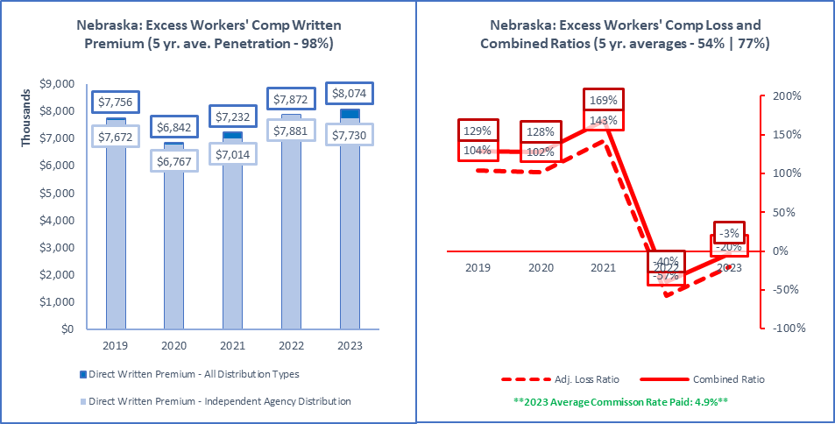

|  |  |  |  |  |
| --- | --- | --- | --- | --- |
| **ALL Direct Written Premium (DPW)** | **Ind Agent DPW** | **Excl.-Captive DPW** | **Direct DPW** | **Surplus Lines DPW** |
| $8,074,000 | $7,730,000 | $0 | $344,000 | $0 |
|  |  |  |  |  |
| **2019 to 2023 Ave Commission % (All Insurers)** | **Ind Agent Penetration** | **Excl.-Captive Penetration** | **Direct Penetration** | **Surplus Lines Utilization** |
| 6.4% | 7.1% | 7.0% | 4.8% | 4.9% | 96% | 0% | 4% | 0.0% |
|  |  |  |  |  |
| **Active Affiliated and Unaffiliated** | **IA+MGA+IA-Mixed** | **Excl.-Captive** | **Direct** | **Surplus Lines Insurers** |
| 10 | 9 | 0 | 1 | 0 |
|  |  |  |  |  |
| **1-yr | 5-yr Premium Growth: All Premium** | **1-yr | 5-yr: IA+MGA+IA-Mixed** | **1-yr | 5-yr: Excl.-Captive** | **1-yr | 5-yr: Direct** | **1-yr | 5-yr: Surplus Lines** |
| 3% | 1% | -2% | 0% | N/A | N/A | -3922% | 42% | N/A | N/A |
|  |  |  |  |  |
| **Top 5 Groups** | **1-yr DPW** | **1-yr LR | CR** | **1-yr Growth | Comm%** | **Largest Insurer in Group or "N/A"** |
| W. R. Berkley Insurance Group (G) | $2,784,000 | 22% | 35% | 7% | 2% | Midwest Employers Casualty Company |
| Tokio Marine US PC Group (G) | $2,358,000 | 42% | 62% | -11% | 8% | Safety National Casualty Corporation |
| Chubb INA Group (G) | $1,768,000 | 59% | 72% | -7% | 5% | ACE American Insurance Company |
| Everest Re U.S. Group (G) | $358,000 | 52% | 60% | 1% | 0% | Everest National Insurance Company |
| Liberty Mutual Insurance Companies (G) | $344,000 | -173% | -147% | -3922% | 4% | Liberty Mutual Fire Insurance Company |
| Total or Average | $8,074,000 | -21% | -4% | 3% | 5% | N/A |
|  |  |  |  |  |
| **Top 5 Pure Independent Agent-Broker Policy-Issuing Insurers** | | | | **Group or "N/A"** |
| Midwest Employers Casualty Company | $2,784,000 | 22% | 25% | 7% | 2% | W. R. Berkley Insurance Group |
| Safety National Casualty Corporation | $2,358,000 | 42% | 63% | -11% | 8% | Tokio Marine US PC Group |
| ACE American Insurance Company | $1,768,000 | 59% | 70% | -7% | 5% | Chubb INA Group |
| Everest National Insurance Company | $358,000 | 52% | 65% | 1% | 0% | Everest Re U.S. Group |
| Arch Insurance Company | $226,000 | -3% | 23% | 56% | 15% | Arch Insurance Group |
| **Top 3 MGA/Wholesale Policy-Issuing Insurers** | | | | **Group or "N/A"** |
| N/A | $0 | N/A | N/A | N/A | N/A | N/A |
| N/A | N/A | N/A | N/A | N/A | N/A | N/A |
| N/A | N/A | N/A | N/A | N/A | N/A | N/A |
| **Top 3 Exclusive-Captive Policy-Issuing Insurers** | | | | **Group or "N/A"** |
| N/A | $0 | N/A | N/A | N/A | N/A | N/A |
| N/A | N/A | N/A | N/A | N/A | N/A | N/A |
| N/A | N/A | N/A | N/A | N/A | N/A | N/A |
| **Top 3 Direct Policy-Issuing Insurers** | | | | **Group or "N/A"** |
| Liberty Mutual Fire Insurance Company | $344,000 | 30% | 62% | N/A | 4% | Liberty Mutual Insurance Companies |
| N/A | $0 | N/A | N/A | N/A | N/A | N/A |
| N/A | N/A | N/A | N/A | N/A | N/A | N/A |
| **Top 3 Surplus Lines Policy Issuing Insurers** | | | | **Group or "N/A"** |
| N/A | $0 | N/A | N/A | N/A | N/A | N/A |
| N/A | N/A | N/A | N/A | N/A | N/A | N/A |
| N/A | N/A | N/A | N/A | N/A | N/A | N/A |
| **Top Individual RRG** | | | | **Group or "N/A"** |
| N/A | $0 | N/A | N/A | N/A | N/A | N/A |

Source: © A.M. Best Company — used by permission. (Included in the above data are all P&C policies issued in Nebraska to cover indemnity of employers for self-insured employers, usually written on an excess or high deductible).

|  |  |
| --- | --- |
| Farmowners Multi-Peril |  |

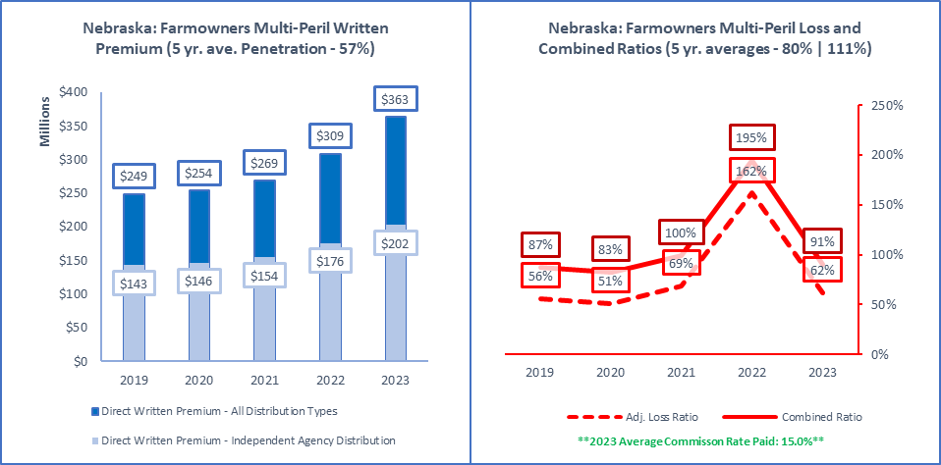

|  |  |  |  |  |
| --- | --- | --- | --- | --- |
| **ALL Direct Written Premium (DPW)** | **Ind Agent DPW** | **Excl.-Captive DPW** | **Direct DPW** | **Surplus Lines DPW** |
| $363,158,000 | $202,336,000 | $133,506,000 | $27,316,000 | $17,000 |
|  |  |  |  |  |
| **2019 to 2023 Ave Commission % (All Insurers)** | **Ind Agent Penetration** | **Excl.-Captive Penetration** | **Direct Penetration** | **Surplus Lines Utilization** |
| 14.9% | 15.8% | 15.3% | 14.8% | 15.0% | 56% | 37% | 8% | 0.0% |
|  |  |  |  |  |
| **Active Affiliated and Unaffiliated** | **IA+MGA+IA-Mixed** | **Excl.-Captive** | **Direct** | **Surplus Lines Insurers** |
| 39 | 28 | 9 | 2 | 1 |
|  |  |  |  |  |
| **1-yr | 5-yr Premium Growth: All Premium** | **1-yr | 5-yr: IA+MGA+IA-Mixed** | **1-yr | 5-yr: Excl.-Captive** | **1-yr | 5-yr: Direct** | **1-yr | 5-yr: Surplus Lines** |
| 18% | 10% | 15% | 9% | 8% | 9% | 207% | 29% | -93% | -54% |
|  |  |  |  |  |
| **Top 5 Groups** | **1-yr DPW** | **1-yr LR | CR** | **1-yr Growth | Comm%** | **Largest Insurer in Group or "N/A"** |
| Farmers Mutual Insurance Co of Nebraska | $155,727,000 | 62% | 90% | 22% | 15% | N/A |
| Farm Bureau Property & Casualty Group (G) | $90,081,000 | 74% | 104% | 23% | 16% | Farm Bureau Property & Casualty Ins Co |
| Nationwide Property & Casualty Group (G) | $34,118,000 | 52% | 83% | 9% | 16% | Nationwide Agribusiness Insurance Co |
| State Farm Group (G) | $29,647,000 | 54% | 78% | 0% | 11% | State Farm Fire and Casualty Company |
| North Star Companies (G) | $20,508,000 | 52% | 75% | 23% | 15% | North Star Mutual Insurance Company |
| Total or Average | $363,155,000 | 62% | 91% | 18% | 15% | N/A |
|  |  |  |  |  |
| **Top 5 Pure Independent Agent-Broker Policy-Issuing Insurers** | | | | **Group or "N/A"** |
| Farmers Mutual Insurance Co of Nebraska | $155,727,000 | 62% | 90% | 22% | 15% | N/A |
| North Star Mutual Insurance Company | $20,508,000 | 52% | 75% | 23% | 15% | North Star Companies |
| Battle Creek Mutual Insurance Company | $7,535,000 | 33% | 52% | 13% | 16% | Nodak Insurance Group |
| Farmers Alliance Mutual Insurance Co | $6,757,000 | 88% | 120% | 11% | 16% | Farmers Alliance Companies |
| AMCO Insurance Company | $3,513,000 | 20% | 32% | -64% | 11% | Nationwide Property & Casualty Group |
| **Top 3 MGA/Wholesale Policy-Issuing Insurers** | | | | **Group or "N/A"** |
| Markel Insurance Company | $215,000 | 93% | 118% | -5% | 9% | Markel Insurance Group |
| American Reliable Insurance Company | $148,000 | 9% | 40% | -1% | 21% | ECM Group |
| N/A | $0 | N/A | N/A | N/A | N/A | N/A |
| **Top 3 Exclusive-Captive Policy-Issuing Insurers** | | | | **Group or "N/A"** |
| Farm Bureau Property & Casualty Ins Co | $84,997,000 | 74% | 106% | 22% | 16% | Farm Bureau Property & Casualty Group |
| State Farm Fire and Casualty Company | $29,647,000 | 54% | 76% | 0% | 11% | State Farm Group |
| Western Agricultural Insurance Company | $5,084,000 | 85% | 100% | 31% | 12% | Farm Bureau Property & Casualty Group |
| **Top 3 Direct Policy-Issuing Insurers** | | | | **Group or "N/A"** |
| Nationwide Agribusiness Insurance Co | $14,515,000 | 74% | 101% | 197% | 18% | Nationwide Property & Casualty Group |
| Crestbrook Insurance Company | $12,801,000 | 47% | 64% | 219% | 14% | Nationwide Property & Casualty Group |
| N/A | $0 | N/A | N/A | N/A | N/A | N/A |
| **Top 3 Surplus Lines Policy Issuing Insurers** | | | | **Group or "N/A"** |
| Scottsdale Insurance Company | $17,000 | -279% | -273% | -62% | 24% | Nationwide Property & Casualty Group |
| N/A | $0 | 0% | N/A | -100% | N/A | N/A |
| N/A | N/A | N/A | N/A | N/A | N/A | N/A |
| **Top Individual RRG** | | | | **Group or "N/A"** |
| N/A | $0 | N/A | N/A | N/A | N/A | N/A |

Source: © A.M. Best Company — used by permission. (Included in the above data are all P&C policies issued in Nebraska to cover property and liability risks of farming and ranching operations).

|  |  |
| --- | --- |
| Federal Flood |  |

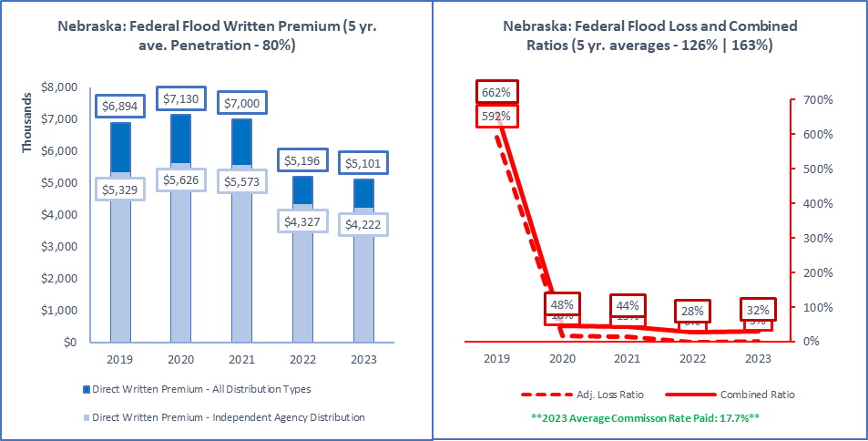

|  |  |  |  |  |
| --- | --- | --- | --- | --- |
| **ALL Direct Written Premium (DPW)** | **Ind Agent DPW** | **Excl.-Captive DPW** | **Direct DPW** | **Surplus Lines DPW** |
| $5,101,000 | $4,222,000 | $630,000 | $249,000 | $119,000 |
|  |  |  |  |  |
| **2019 to 2023 Ave Commission % (All Insurers)** | **Ind Agent Penetration** | **Excl.-Captive Penetration** | **Direct Penetration** | **Surplus Lines Utilization** |
| 15.7% | 15.5% | 15.5% | 15.8% | 17.7% | 83% | 12% | 5% | 2.3% |
|  |  |  |  |  |
| **Active Affiliated and Unaffiliated** | **IA+MGA+IA-Mixed** | **Excl.-Captive** | **Direct** | **Surplus Lines Insurers** |
| 22 | 14 | 5 | 3 | 2 |
|  |  |  |  |  |
| **1-yr | 5-yr Premium Growth: All Premium** | **1-yr | 5-yr: IA+MGA+IA-Mixed** | **1-yr | 5-yr: Excl.-Captive** | **1-yr | 5-yr: Direct** | **1-yr | 5-yr: Surplus Lines** |
| -2% | -7% | -2% | -6% | 4% | -13% | -6% | -13% | 116% | N/A |
|  |  |  |  |  |
| **Top 5 Groups** | **1-yr DPW** | **1-yr LR | CR** | **1-yr Growth | Comm%** | **Largest Insurer in Group or "N/A"** |
| Auto-Owners Insurance Group (G) | $848,000 | 6% | 30% | -3% | 15% | Auto-Owners Insurance Company |
| Assurant P&C Group (G) | $846,000 | -1% | 30% | -9% | 17% | American Bankers Insurance Co of Florida |
| Wright National Flood Insurance Company | $765,000 | 1% | 29% | -2% | 19% | N/A |
| Selective Insurance Group (G) | $744,000 | 0% | 39% | -4% | 29% | Selective Insurance Company of America |
| Hartford Insurance Group (G) | $522,000 | 0% | 32% | -3% | 18% | Hartford Insurance Co of the Midwest |
| Total or Average | $5,100,000 | 3% | 32% | -2% | 18% | N/A |
|  |  |  |  |  |
| **Top 5 Pure Independent Agent-Broker Policy-Issuing Insurers** | | | | **Group or "N/A"** |
| Auto-Owners Insurance Company | $848,000 | 6% | 28% | -3% | 15% | Auto-Owners Insurance Group |
| American Bankers Insurance Co of Florida | $846,000 | -1% | 27% | -9% | 17% | Assurant P&C Group |
| Selective Insurance Company of America | $744,000 | 0% | 40% | -4% | 29% | Selective Insurance Group |
| Hartford Insurance Co of the Midwest | $522,000 | 0% | 21% | -2% | 18% | Hartford Insurance Group |
| Philadelphia Indemnity Insurance Company | $124,000 | 5% | 36% | -11% | 19% | Tokio Marine US PC Group |
| **Top 3 MGA/Wholesale Policy-Issuing Insurers** | | | | **Group or "N/A"** |
| Wright National Flood Insurance Company | $765,000 | 1% | 29% | -2% | 19% | N/A |
| Trisura Specialty Insurance Company | $109,000 | 79% | 115% | 110% | 45% | Trisura US Insurance Group |
| MS Transverse Specialty Insurance Co | $10,000 | 0% | 32% | 233% | 30% | MS&AD US Insurance Group |
| **Top 3 Exclusive-Captive Policy-Issuing Insurers** | | | | **Group or "N/A"** |
| American Family Mutual Ins Co, S.I. | $300,000 | 6% | 12% | -1% | 0% | American Family Insurance Group |
| Allstate Insurance Company | $150,000 | 9% | 33% | 23% | 13% | Allstate Insurance Group |
| Fire Insurance Exchange | $142,000 | -44% | -11% | 1% | 15% | Farmers Insurance Group |
| **Top 3 Direct Policy-Issuing Insurers** | | | | **Group or "N/A"** |
| USAA General Indemnity Company | $197,000 | -48% | -47% | -8% | 0% | USAA Group |
| Homesite Indemnity Company | $39,000 | 16% | 41% | 15% | 15% | American Family Insurance Group |
| Liberty Mutual Fire Insurance Company | $13,000 | 0% | 27% | -32% | 15% | Liberty Mutual Insurance Companies |
| **Top 3 Surplus Lines Policy Issuing Insurers** | | | | **Group or "N/A"** |
| Trisura Specialty Insurance Company | $109,000 | 79% | 115% | 110% | 45% | Trisura US Insurance Group |
| MS Transverse Specialty Insurance Co | $10,000 | 0% | 32% | 233% | 30% | MS&AD US Insurance Group |
| N/A | $0 | N/A | N/A | N/A | N/A | N/A |
| **Top Individual RRG** | | | | **Group or "N/A"** |
| N/A | $0 | N/A | N/A | N/A | N/A | N/A |

Source: © A.M. Best Company — used by permission. (Included in the above data are all P&C policies issued in Nebraska under the Federal Flood Insurance Program and the Write Your Own program).

|  |  |
| --- | --- |
| Fidelity |  |

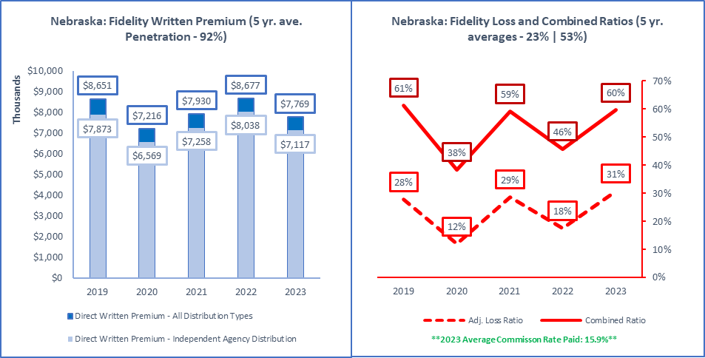

|  |  |  |  |  |
| --- | --- | --- | --- | --- |
| **ALL Direct Written Premium (DPW)** | **Ind Agent DPW** | **Excl.-Captive DPW** | **Direct DPW** | **Surplus Lines DPW** |
| $7,769,000 | $7,117,000 | $195,000 | $457,000 | $76,000 |
|  |  |  |  |  |
| **2019 to 2023 Ave Commission % (All Insurers)** | **Ind Agent Penetration** | **Excl.-Captive Penetration** | **Direct Penetration** | **Surplus Lines Utilization** |
| 17.2% | 15.7% | 15.9% | 16.5% | 15.9% | 92% | 3% | 6% | 1.0% |
|  |  |  |  |  |
| **Active Affiliated and Unaffiliated** | **IA+MGA+IA-Mixed** | **Excl.-Captive** | **Direct** | **Surplus Lines Insurers** |
| 78 | 64 | 8 | 6 | 7 |
|  |  |  |  |  |
| **1-yr | 5-yr Premium Growth: All Premium** | **1-yr | 5-yr: IA+MGA+IA-Mixed** | **1-yr | 5-yr: Excl.-Captive** | **1-yr | 5-yr: Direct** | **1-yr | 5-yr: Surplus Lines** |
| -10% | -3% | -11% | -2% | 0% | 2% | 3% | 3% | -28% | -17% |
|  |  |  |  |  |
| **Top 5 Groups** | **1-yr DPW** | **1-yr LR | CR** | **1-yr Growth | Comm%** | **Largest Insurer in Group or "N/A"** |
| Travelers Group (G) | $2,351,000 | 44% | 74% | 9% | 17% | Travelers Casualty and Surety Co of Amer |
| Chubb INA Group (G) | $1,143,000 | 57% | 83% | 2% | 15% | Federal Insurance Company |
| Great American P & C Insurance Group (G) | $1,004,000 | 43% | 80% | -30% | 20% | Great American Insurance Company |
| CNA Insurance Companies (G) | $629,000 | 37% | 68% | -4% | 18% | Western Surety Company |
| CUMIS Insurance Society Group (G) | $378,000 | 32% | 51% | 4% | 0% | CUMIS Insurance Society, Inc. |
| Total or Average | $7,769,000 | 31% | 60% | -10% | 16% | N/A |
|  |  |  |  |  |
| **Top 5 Pure Independent Agent-Broker Policy-Issuing Insurers** | | | | **Group or "N/A"** |
| Travelers Casualty and Surety Co of Amer | $2,340,000 | 43% | 78% | 10% | 17% | Travelers Group |
| Federal Insurance Company | $1,055,000 | 59% | 85% | 3% | 14% | Chubb INA Group |
| Great American Insurance Company | $753,000 | 43% | 73% | 16% | 15% | Great American P & C Insurance Group |
| Hartford Fire Insurance Company | $255,000 | -13% | 15% | -1% | 18% | Hartford Insurance Group |
| National Union Fire Ins Co Pittsburgh PA | $253,000 | 1% | 15% | -17% | 5% | American International Group |
| **Top 3 MGA/Wholesale Policy-Issuing Insurers** | | | | **Group or "N/A"** |
| Southwest Marine and General Ins Co | $144,000 | 123% | 155% | -48% | 19% | Coaction Specialty Insurance Group |
| Houston Specialty Insurance Company | $8,000 | 0% | 32% | -47% | 25% | Skyward Specialty Insurance Group |
| U.S. Specialty Insurance Company | $7,000 | 50% | 84% | 133% | 29% | Tokio Marine US PC Group |
| **Top 3 Exclusive-Captive Policy-Issuing Insurers** | | | | **Group or "N/A"** |
| Nationwide Mutual Insurance Company | $70,000 | -4% | 27% | 1% | 16% | Nationwide Property & Casualty Group |
| Federated Mutual Insurance Company | $62,000 | -3% | 19% | 9% | 0% | Federated Mutual Group |
| State Farm Fire and Casualty Company | $34,000 | 74% | 94% | 3% | 9% | State Farm Group |
| **Top 3 Direct Policy-Issuing Insurers** | | | | **Group or "N/A"** |
| CUMIS Insurance Society, Inc. | $378,000 | 32% | 50% | 4% | 0% | CUMIS Insurance Society Group |
| Federated Rural Electric Ins Exchange | $24,000 | 0% | 12% | 4% | 0% | N/A |
| Nationwide Agribusiness Insurance Co | $21,000 | 19% | 35% | -5% | 10% | Nationwide Property & Casualty Group |
| **Top 3 Surplus Lines Policy Issuing Insurers** | | | | **Group or "N/A"** |
| Chubb Custom Insurance Company | $47,000 | 64% | 89% | -22% | 17% | Chubb INA Group |
| Aspen Specialty Insurance Company | $11,000 | 40% | 76% | 450% | 27% | Aspen US Insurance Group |
| Houston Specialty Insurance Company | $8,000 | 0% | 32% | -47% | 25% | Skyward Specialty Insurance Group |
| **Top Individual RRG** | | | | **Group or "N/A"** |
| ICI Mutual Insurance Company, a RRG | $17,000 | -53% | -40% | 0% | 0% | N/A |

Source: © A.M. Best Company — used by permission. (Included in the above data are all P&C policies issued in Nebraska to cover dishonest acts of employees.

|  |  |
| --- | --- |
| Fire Peril Only |  |

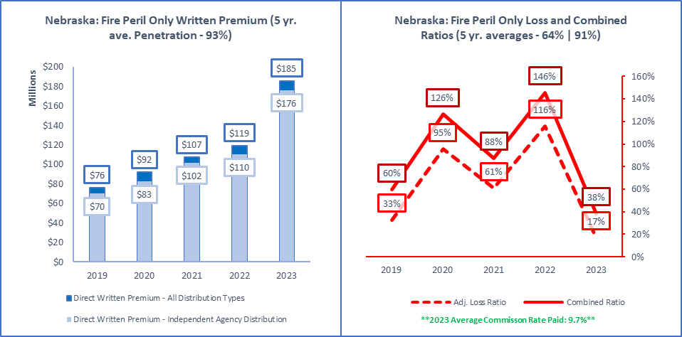

|  |  |  |  |  |
| --- | --- | --- | --- | --- |
| **ALL Direct Written Premium (DPW)** | **Ind Agent DPW** | **Excl.-Captive DPW** | **Direct DPW** | **Surplus Lines DPW** |
| $185,259,000 | $176,234,000 | $3,830,000 | $4,887,000 | $88,371,000 |
|  |  |  |  |  |
| **2019 to 2023 Ave Commission % (All Insurers)** | **Ind Agent Penetration** | **Excl.-Captive Penetration** | **Direct Penetration** | **Surplus Lines Utilization** |
| 11.6% | 12.3% | 11.1% | 11.0% | 9.7% | 95% | 2% | 3% | 47.7% |
|  |  |  |  |  |
| **Active Affiliated and Unaffiliated** | **IA+MGA+IA-Mixed** | **Excl.-Captive** | **Direct** | **Surplus Lines Insurers** |
| 220 | 187 | 13 | 15 | 72 |
|  |  |  |  |  |
| **1-yr | 5-yr Premium Growth: All Premium** | **1-yr | 5-yr: IA+MGA+IA-Mixed** | **1-yr | 5-yr: Excl.-Captive** | **1-yr | 5-yr: Direct** | **1-yr | 5-yr: Surplus Lines** |
| 55% | 25% | 60% | 26% | 6% | 13% | 21% | 14% | 198% | 67% |
|  |  |  |  |  |
| **Top 5 Groups** | **1-yr DPW** | **1-yr LR | CR** | **1-yr Growth | Comm%** | **Largest Insurer in Group or "N/A"** |
| Starr International Group (G) | $59,638,000 | 23% | 34% | 544% | 4% | Starr Surplus Lines Insurance Company |
| Travelers Group (G) | $14,773,000 | 25% | 46% | 46% | 8% | Travelers Indemnity Company |
| American International Group (G) | $9,785,000 | 34% | 51% | 107% | 8% | Lexington Insurance Company |
| Farmers Insurance Group (G) | $9,013,000 | 21% | 59% | 7% | 14% | Foremost Insurance Co Grand Rapids, MI |
| Berkshire Hathaway Insurance Group (G) | $8,224,000 | 62% | 89% | 44% | 18% | United States Liability Insurance Co |
| Total or Average | $180,340,000 | 17% | 38% | 51% | 10% | N/A |
|  |  |  |  |  |
| **Top 5 Pure Independent Agent-Broker Policy-Issuing Insurers** | | | | **Group or "N/A"** |
| Starr Surplus Lines Insurance Company | $59,602,000 | 23% | 32% | 544% | 4% | Starr International Group |
| Foremost Insurance Co Grand Rapids, MI | $9,013,000 | 21% | 58% | 7% | 14% | Farmers Insurance Group |
| Auto-Owners Insurance Company | $7,091,000 | 37% | 58% | 41% | 15% | Auto-Owners Insurance Group |
| Travelers Indemnity Company | $6,683,000 | 44% | 61% | 50% | 6% | Travelers Group |
| Travelers Property Casualty Co of Amer | $5,819,000 | 14% | 28% | 43% | 12% | Travelers Group |
| **Top 3 MGA/Wholesale Policy-Issuing Insurers** | | | | **Group or "N/A"** |
| Houston Casualty Company | $462,000 | 37% | 59% | 245% | 17% | Tokio Marine US PC Group |
| Falls Lake Fire and Casualty Company | $453,000 | 54% | 93% | -9% | 22% | James River Group |
| Obsidian Insurance Company | $370,000 | 26% | 54% | 825% | 16% | Obsidian Insurance Group |
| **Top 3 Exclusive-Captive Policy-Issuing Insurers** | | | | **Group or "N/A"** |
| Federated Mutual Insurance Company | $1,336,000 | 12% | 36% | 28% | 0% | Federated Mutual Group |
| Shelter Mutual Insurance Company | $735,000 | 73% | 102% | 21% | 12% | Shelter Insurance Companies |
| Nationwide Mutual Insurance Company | $554,000 | 5% | 37% | -38% | 15% | Nationwide Property & Casualty Group |
| **Top 3 Direct Policy-Issuing Insurers** | | | | **Group or "N/A"** |
| Liberty Mutual Fire Insurance Company | $1,824,000 | -22% | -5% | 84% | 5% | Liberty Mutual Insurance Companies |
| Nationwide Agribusiness Insurance Co | $1,337,000 | 29% | 63% | -9% | 28% | Nationwide Property & Casualty Group |
| Standard Guaranty Insurance Company | $689,000 | 42% | 73% | 14% | 1% | Assurant P&C Group |
| **Top 3 Surplus Lines Policy Issuing Insurers** | | | | **Group or "N/A"** |
| Starr Surplus Lines Insurance Company | $59,602,000 | 23% | 32% | 544% | 4% | Starr International Group |
| Lexington Insurance Company | $4,314,000 | 27% | 51% | 103% | 17% | American International Group |
| Landmark American Insurance Company | $2,321,000 | 17% | 34% | 61% | 15% | Berkshire Hathaway Insurance Group |
| **Top Individual RRG** | | | | **Group or "N/A"** |
| N/A | $0 | N/A | N/A | N/A | N/A | N/A |

Source: © A.M. Best Company — used by permission. (Included in the above data are all P&C policies issued in Nebraska to cover fire or lightning loss to real or personal property. If premiums are combined in policies with other perils like windstorm, the premiums and losses are reported as they are allocated by insurers).

|  |  |
| --- | --- |
| Homeowners |  |

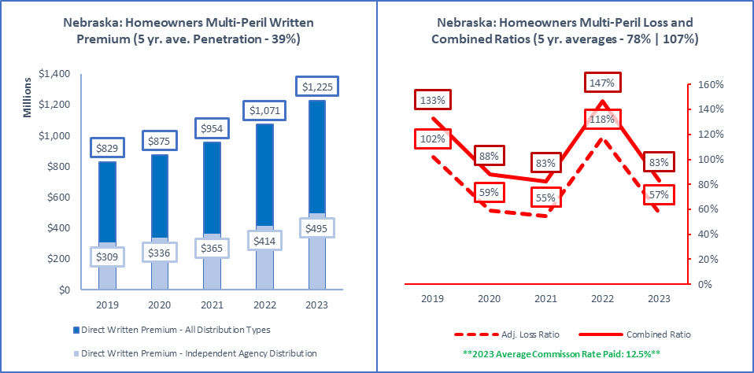

|  |  |  |  |  |
| --- | --- | --- | --- | --- |
| **ALL Direct Written Premium (DPW)** | **Ind Agent DPW** | **Excl.-Captive DPW** | **Direct DPW** | **Surplus Lines DPW** |
| $1,225,410,000 | $494,566,000 | $604,828,000 | $126,016,000 | $1,267,000 |
|  |  |  |  |  |
| **2019 to 2023 Ave Commission % (All Insurers)** | **Ind Agent Penetration** | **Excl.-Captive Penetration** | **Direct Penetration** | **Surplus Lines Utilization** |
| 12.3% | 12.5% | 12.6% | 12.4% | 12.5% | 40% | 49% | 10% | 0.1% |
|  |  |  |  |  |
| **Active Affiliated and Unaffiliated** | **IA+MGA+IA-Mixed** | **Excl.-Captive** | **Direct** | **Surplus Lines Insurers** |
| 108 | 65 | 20 | 23 | 6 |
|  |  |  |  |  |
| **1-yr | 5-yr Premium Growth: All Premium** | **1-yr | 5-yr: IA+MGA+IA-Mixed** | **1-yr | 5-yr: Excl.-Captive** | **1-yr | 5-yr: Direct** | **1-yr | 5-yr: Surplus Lines** |
| 14% | 10% | 20% | 12% | 12% | 11% | 11% | 11% | 41% | 26% |
|  |  |  |  |  |
| **Top 5 Groups** | **1-yr DPW** | **1-yr LR | CR** | **1-yr Growth | Comm%** | **Largest Insurer in Group or "N/A"** |
| State Farm Group (G) | $271,269,000 | 64% | 89% | 11% | 11% | State Farm Fire and Casualty Company |
| Farmers Mutual Insurance Co of Nebraska | $126,304,000 | 77% | 106% | 12% | 15% | N/A |
| American Family Insurance Group (G) | $125,249,000 | 35% | 65% | 14% | 12% | American Family Mutual Ins Co, S.I. |
| Nationwide Property & Casualty Group (G) | $109,333,000 | 62% | 92% | 13% | 13% | Nationwide Mutual Insurance Company |
| Allstate Insurance Group (G) | $95,351,000 | 39% | 63% | 26% | 12% | Allstate Vehicle and Property Ins Co |
| Total or Average | $1,219,384,000 | 57% | 83% | 14% | 13% | N/A |
|  |  |  |  |  |
| **Top 5 Pure Independent Agent-Broker Policy-Issuing Insurers** | | | | **Group or "N/A"** |
| Farmers Mutual Insurance Co of Nebraska | $126,304,000 | 77% | 106% | 12% | 15% | N/A |
| Allstate Vehicle and Property Ins Co | $55,029,000 | 34% | 47% | 16% | 11% | Allstate Insurance Group |
| Auto-Owners Insurance Company | $49,013,000 | 66% | 92% | 46% | 18% | Auto-Owners Insurance Group |
| Travelers Personal Insurance Company | $45,567,000 | 62% | 80% | 27% | 16% | Travelers Group |
| Nationwide Insurance Company of America | $28,268,000 | 60% | 78% | 2% | 13% | Nationwide Property & Casualty Group |
| **Top 3 MGA/Wholesale Policy-Issuing Insurers** | | | | **Group or "N/A"** |
| Spinnaker Insurance Company | $2,123,000 | 24% | 48% | 9% | 18% | Spinnaker Insurance Group |
| Branch Insurance Exchange | $635,000 | 49% | 72% | 68% | 16% | N/A |
| Evanston Insurance Company | $603,000 | 38% | 75% | 139% | 24% | Markel Insurance Group |
| **Top 3 Exclusive-Captive Policy-Issuing Insurers** | | | | **Group or "N/A"** |
| State Farm Fire and Casualty Company | $271,269,000 | 64% | 88% | 11% | 11% | State Farm Group |
| Farm Bureau Property & Casualty Ins Co | $73,277,000 | 55% | 85% | 14% | 15% | Farm Bureau Property & Casualty Group |
| Nationwide Mutual Insurance Company | $60,243,000 | 68% | 100% | 16% | 13% | Nationwide Property & Casualty Group |
| **Top 3 Direct Policy-Issuing Insurers** | | | | **Group or "N/A"** |
| United Services Automobile Association | $30,106,000 | 66% | 87% | 8% | 0% | USAA Group |
| USAA Casualty Insurance Company | $17,008,000 | 55% | 69% | 16% | 0% | USAA Group |
| Homesite Insurance Company | $16,357,000 | 32% | 59% | 47% | 13% | American Family Insurance Group |
| **Top 3 Surplus Lines Policy Issuing Insurers** | | | | **Group or "N/A"** |
| Evanston Insurance Company | $603,000 | 38% | 75% | 139% | 24% | Markel Insurance Group |
| Chubb Custom Insurance Company | $495,000 | 123% | 139% | 18% | 12% | Chubb INA Group |
| Scottsdale Insurance Company | $89,000 | 112% | 139% | -43% | 22% | Nationwide Property & Casualty Group |
| **Top Individual RRG** | | | | **Group or "N/A"** |
| N/A | $0 | N/A | N/A | N/A | N/A | N/A |

Source: © A.M. Best Company — used by permission. (Included in the above data are all P&C policies issued in Nebraska to cover liability, and real and personal property of homeowners, condo owners and renters).

|  |  |
| --- | --- |
| Inland Marine |  |

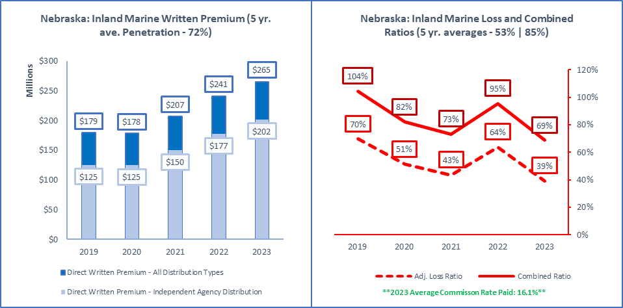

|  |  |  |  |  |
| --- | --- | --- | --- | --- |
| **ALL Direct Written Premium (DPW)** | **Ind Agent DPW** | **Excl.-Captive DPW** | **Direct DPW** | **Surplus Lines DPW** |
| $265,345,000 | $201,872,000 | $56,627,000 | $4,767,000 | $13,343,000 |
|  |  |  |  |  |
| **2019 to 2023 Ave Commission % (All Insurers)** | **Ind Agent Penetration** | **Excl.-Captive Penetration** | **Direct Penetration** | **Surplus Lines Utilization** |
| 17.2% | 14.8% | 15.3% | 16.5% | 16.1% | 76% | 21% | 2% | 5.0% |
|  |  |  |  |  |
| **Active Affiliated and Unaffiliated** | **IA+MGA+IA-Mixed** | **Excl.-Captive** | **Direct** | **Surplus Lines Insurers** |
| 315 | 253 | 26 | 27 | 54 |
|  |  |  |  |  |
| **1-yr | 5-yr Premium Growth: All Premium** | **1-yr | 5-yr: IA+MGA+IA-Mixed** | **1-yr | 5-yr: Excl.-Captive** | **1-yr | 5-yr: Direct** | **1-yr | 5-yr: Surplus Lines** |
| 10% | 10% | 14% | 13% | 2% | 5% | -30% | 8% | 16% | 1% |
|  |  |  |  |  |
| **Top 5 Groups** | **1-yr DPW** | **1-yr LR | CR** | **1-yr Growth | Comm%** | **Largest Insurer in Group or "N/A"** |
| Liberty Mutual Insurance Companies (G) | $43,241,000 | 51% | 68% | -2% | 1% | Liberty Insurance Underwriters, Inc. |
| Chubb INA Group (G) | $31,840,000 | 55% | 82% | 32% | 18% | Federal Insurance Company |
| Berkshire Hathaway Insurance Group (G) | $15,149,000 | 25% | 47% | 26% | 16% | Central States Indemnity Co. of Omaha |
| Assurant P&C Group (G) | $13,798,000 | 18% | 45% | 15% | 13% | American Bankers Insurance Co of Florida |
| American International Group (G) | $11,945,000 | 16% | 47% | 48% | 22% | National Union Fire Ins Co Pittsburgh PA |
| Total or Average | $264,125,000 | 39% | 69% | 9% | 16% | N/A |
|  |  |  |  |  |
| **Top 5 Pure Independent Agent-Broker Policy-Issuing Insurers** | | | | **Group or "N/A"** |
| Federal Insurance Company | $25,299,000 | 63% | 92% | 32% | 19% | Chubb INA Group |
| American Bankers Insurance Co of Florida | $13,505,000 | 18% | 42% | 16% | 13% | Assurant P&C Group |
| Central States Indemnity Co. of Omaha | $12,420,000 | 22% | 37% | 31% | 12% | Berkshire Hathaway Insurance Group |
| Hartford Fire Insurance Company | $9,349,000 | 61% | 95% | 6% | 18% | Hartford Insurance Group |
| National Union Fire Ins Co Pittsburgh PA | $7,171,000 | 12% | 44% | 56% | 23% | American International Group |
| **Top 3 MGA/Wholesale Policy-Issuing Insurers** | | | | **Group or "N/A"** |
| Generali USB | $3,664,000 | 27% | 75% | 92% | 45% | N/A |
| American Pet Insurance Company | $2,783,000 | 61% | 82% | 28% | 1% | Trupanion Insurance Group |
| Atain Specialty Insurance Company | $2,688,000 | 68% | 98% | -26% | 21% | Atain Insurance Companies |
| **Top 3 Exclusive-Captive Policy-Issuing Insurers** | | | | **Group or "N/A"** |
| Liberty Insurance Underwriters, Inc. | $39,783,000 | 53% | 54% | 2% | 0% | Liberty Mutual Insurance Companies |
| State Farm Fire and Casualty Company | $5,799,000 | 33% | 55% | 4% | 11% | State Farm Group |
| Nationwide Mutual Insurance Company | $3,806,000 | 32% | 62% | -16% | 14% | Nationwide Property & Casualty Group |
| **Top 3 Direct Policy-Issuing Insurers** | | | | **Group or "N/A"** |
| Crestbrook Insurance Company | $687,000 | 17% | 33% | 26% | 14% | Nationwide Property & Casualty Group |
| Liberty Mutual Fire Insurance Company | $561,000 | -14% | 8% | -78% | 9% | Liberty Mutual Insurance Companies |
| United Services Automobile Association | $530,000 | 24% | 46% | 2% | 0% | USAA Group |
| **Top 3 Surplus Lines Policy Issuing Insurers** | | | | **Group or "N/A"** |
| Lexington Insurance Company | $3,195,000 | 21% | 44% | 37% | 16% | American International Group |
| Atain Specialty Insurance Company | $2,688,000 | 68% | 98% | -26% | 21% | Atain Insurance Companies |
| Interstate Fire & Casualty Company | $1,583,000 | 26% | 51% | 21% | 24% | Allianz US PC Insurance Companies |
| **Top Individual RRG** | | | | **Group or "N/A"** |
| N/A | $0 | N/A | N/A | N/A | N/A | N/A |

Source: © A.M. Best Company — used by permission. (Included in the above data are all P&C policies issued in Nebraska for a wide variety of risks including contractors equipment, other moveable property, pet insurance, event cancellation, travel insurance, watercraft and cash in transit.

|  |  |
| --- | --- |
| International |  |

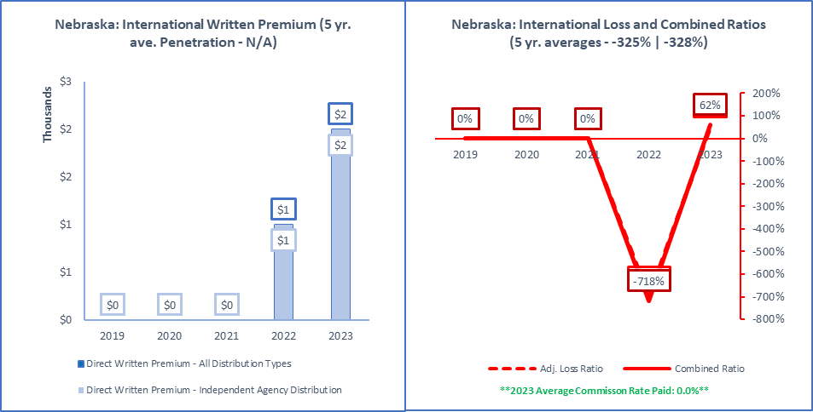

|  |  |  |  |  |
| --- | --- | --- | --- | --- |
| **ALL Direct Written Premium (DPW)** | **Ind Agent DPW** | **Excl.-Captive DPW** | **Direct DPW** | **Surplus Lines DPW** |
| $2,000 | $2,000 | $0 | $0 | $0 |
|  |  |  |  |  |
| **2019 to 2023 Ave Commission % (All Insurers)** | **Ind Agent Penetration** | **Excl.-Captive Penetration** | **Direct Penetration** | **Surplus Lines Utilization** |
| N/A | 100% | 0% | 0% | 0.0% |
|  |  |  |  |  |
| **Active Affiliated and Unaffiliated** | **IA+MGA+IA-Mixed** | **Excl.-Captive** | **Direct** | **Surplus Lines Insurers** |
| 1 | 1 | 0 | 0 | 0 |
|  |  |  |  |  |
| **1-yr | 5-yr Premium Growth: All Premium** | **1-yr | 5-yr: IA+MGA+IA-Mixed** | **1-yr | 5-yr: Excl.-Captive** | **1-yr | 5-yr: Direct** | **1-yr | 5-yr: Surplus Lines** |
| 100% | N/A | 100% | N/A | N/A | N/A | N/A | N/A | N/A | N/A |
|  |  |  |  |  |
| **Top 5 Groups** | **1-yr DPW** | **1-yr LR | CR** | **1-yr Growth | Comm%** | **Largest Insurer in Group or "N/A"** |
| Chubb INA Group (G) | $2,000 | 50% | 57% | 100% | 0% | Executive Risk Indemnity Inc. |
| 0 | $0 | N/A | N/A | N/A | N/A |
| 0 | $0 | N/A | N/A | N/A | N/A |
| 0 | $0 | N/A | N/A | N/A | N/A |
| 0 | $0 | N/A | N/A | N/A | N/A |
| Total or Average | $0 | 0% | 0% | N/A | N/A |
|  |  |  |  |  |
| **Top 5 Pure Independent Agent-Broker Policy-Issuing Insurers** | | | | **Group or "N/A"** |
| Executive Risk Indemnity Inc. | $2,000 | 50% | 62% | 100% | 0% | Chubb INA Group |
| N/A | $0 | N/A | N/A | N/A | N/A | N/A |
| N/A | N/A | N/A | N/A | N/A | N/A | N/A |
| N/A | N/A | N/A | N/A | N/A | N/A | N/A |
| N/A | N/A | N/A | N/A | N/A | N/A | N/A |
| **Top 3 MGA/Wholesale Policy-Issuing Insurers** | | | | **Group or "N/A"** |
| N/A | $0 | N/A | N/A | N/A | N/A | N/A |
| N/A | N/A | N/A | N/A | N/A | N/A | N/A |
| N/A | N/A | N/A | N/A | N/A | N/A | N/A |
| **Top 3 Exclusive-Captive Policy-Issuing Insurers** | | | | **Group or "N/A"** |
| N/A | $0 | N/A | N/A | N/A | N/A | N/A |
| N/A | N/A | N/A | N/A | N/A | N/A | N/A |
| N/A | N/A | N/A | N/A | N/A | N/A | N/A |
| **Top 3 Direct Policy-Issuing Insurers** | | | | **Group or "N/A"** |
| N/A | $0 | N/A | N/A | N/A | N/A | N/A |
| N/A | N/A | N/A | N/A | N/A | N/A | N/A |
| N/A | N/A | N/A | N/A | N/A | N/A | N/A |
| **Top 3 Surplus Lines Policy Issuing Insurers** | | | | **Group or "N/A"** |
| N/A | $0 | N/A | N/A | N/A | N/A | N/A |
| N/A | N/A | N/A | N/A | N/A | N/A | N/A |
| N/A | N/A | N/A | N/A | N/A | N/A | N/A |
| **Top Individual RRG** | | | | **Group or "N/A"** |
| N/A | $0 | N/A | N/A | N/A | N/A | N/A |

Source: © A.M. Best Company — used by permission. (Included in the above data are all P&C policies issued in Nebraska to cover losses outside the U.S. where a line of business is not determined.)

|  |  |
| --- | --- |
| Medical Malpractice |  |

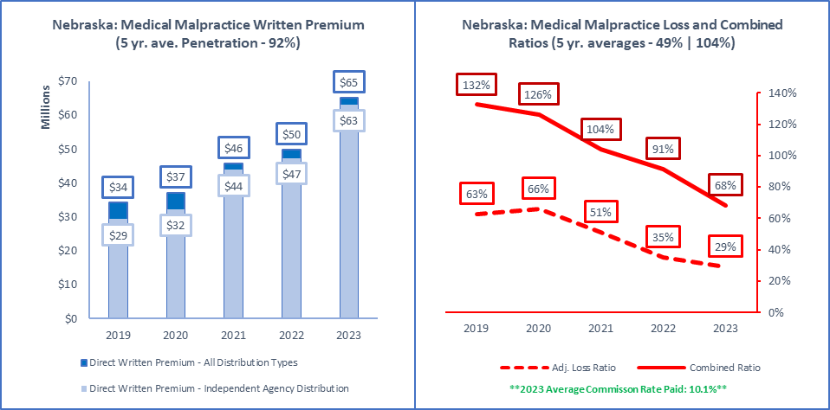

|  |  |  |  |  |
| --- | --- | --- | --- | --- |
| **ALL Direct Written Premium (DPW)** | **Ind Agent DPW** | **Excl.-Captive DPW** | **Direct DPW** | **Surplus Lines DPW** |
| $65,173,000 | $63,102,000 | $990,000 | $924,000 | $19,064,000 |
|  |  |  |  |  |
| **2019 to 2023 Ave Commission % (All Insurers)** | **Ind Agent Penetration** | **Excl.-Captive Penetration** | **Direct Penetration** | **Surplus Lines Utilization** |
| 10.1% | 9.3% | 9.3% | 12.2% | 10.1% | 97% | 2% | 1% | 29.3% |
|  |  |  |  |  |
| **Active Affiliated and Unaffiliated** | **IA+MGA+IA-Mixed** | **Excl.-Captive** | **Direct** | **Surplus Lines Insurers** |
| 81 | 60 | 5 | 9 | 32 |
|  |  |  |  |  |
| **1-yr | 5-yr Premium Growth: All Premium** | **1-yr | 5-yr: IA+MGA+IA-Mixed** | **1-yr | 5-yr: Excl.-Captive** | **1-yr | 5-yr: Direct** | **1-yr | 5-yr: Surplus Lines** |
| 31% | 18% | 33% | 21% | 7% | 5% | 1% | -30% | 24% | 36% |
|  |  |  |  |  |
| **Top 5 Groups** | **1-yr DPW** | **1-yr LR | CR** | **1-yr Growth | Comm%** | **Largest Insurer in Group or "N/A"** |
| Doctors Company Insurance Group (G) | $15,138,000 | 45% | 104% | 77% | 6% | Doctors Company, An Interinsurance Exch |
| COPIC Insurance Group (G) | $13,858,000 | -13% | -25% | 33% | 6% | COPIC Insurance Company |
| Curi Insurance Group (G) | $11,521,000 | -8% | 63% | -6% | 6% | Medical Mutual Ins Co of North Carolina |
| Berkshire Hathaway Insurance Group (G) | $4,364,000 | 51% | 91% | 2% | 18% | Medical Protective Company |
| Coverys Companies (G) | $3,446,000 | 181% | 330% | -374% | 18% | Coverys Specialty Insurance Company |
| Total or Average | $65,173,000 | 0% | 0% | 31% | 10% | N/A |
|  |  |  |  |  |
| **Top 5 Pure Independent Agent-Broker Policy-Issuing Insurers** | | | | **Group or "N/A"** |
| MMIC Insurance, Inc. | $9,748,000 | -9% | 63% | 11% | 5% | Constellation Insurance Group |
| Coverys Specialty Insurance Company | $2,955,000 | 30% | 67% | 167% | 19% | Coverys Companies |
| Lexington Insurance Company | $2,722,000 | 52% | 84% | 31% | 18% | American International Group |
| MMIC Risk Retention Group, Inc. | $1,773,000 | 56% | 132% | -34% | 10% | Constellation Insurance Group |
| American Casualty Company of Reading, PA | $1,653,000 | 35% | 94% | 11% | 39% | CNA Insurance Companies |
| **Top 3 MGA/Wholesale Policy-Issuing Insurers** | | | | **Group or "N/A"** |
| TDC Specialty Insurance Company | $5,575,000 | 35% | 92% | 21% | 17% | Doctors Company Insurance Group |
| Health Care Industry Liab Recip Ins RRG | $1,291,000 | 51% | 83% | 17% | 0% | N/A |
| Evanston Insurance Company | $844,000 | 198% | 254% | 203% | 19% | Markel Insurance Group |
| **Top 3 Exclusive-Captive Policy-Issuing Insurers** | | | | **Group or "N/A"** |
| Liberty Insurance Underwriters, Inc. | $421,000 | -5% | 44% | -4% | 30% | Liberty Mutual Insurance Companies |
| Pharmacists Mutual Insurance Company | $411,000 | 28% | 40% | -1% | 0% | Pharmacists Mutual Insurance Group |
| MAG Mutual Insurance Company | $86,000 | 0% | 32% | N/A | 13% | MAG Mutual Companies |
| **Top 3 Direct Policy-Issuing Insurers** | | | | **Group or "N/A"** |
| NCMIC Insurance Company | $527,000 | 6% | 46% | 4% | 0% | NCMIC Group |
| Future Care Risk Retention Group, Inc. | $207,000 | 48% | 99% | -17% | 19% | N/A |
| Preferred Professional Insurance Company | $89,000 | 2717% | 4165% | 3% | 21% | Coverys Companies |
| **Top 3 Surplus Lines Policy Issuing Insurers** | | | | **Group or "N/A"** |
| TDC Specialty Insurance Company | $5,575,000 | 35% | 92% | 21% | 17% | Doctors Company Insurance Group |
| Coverys Specialty Insurance Company | $2,955,000 | 30% | 67% | 167% | 19% | Coverys Companies |
| Lexington Insurance Company | $2,722,000 | 52% | 84% | 31% | 18% | American International Group |
| **Top Individual RRG** | | | | **Group or "N/A"** |
| MMIC Risk Retention Group, Inc. | $1,773,000 | 56% | 132% | -34% | 10% | Constellation Insurance Group |

Source: © A.M. Best Company — used by permission. (Included in the above data are all P&C policies issued in Nebraska to cover liability losses of licensed healthcare providers).

|  |  |
| --- | --- |
| Multi-Peril Crop |  |

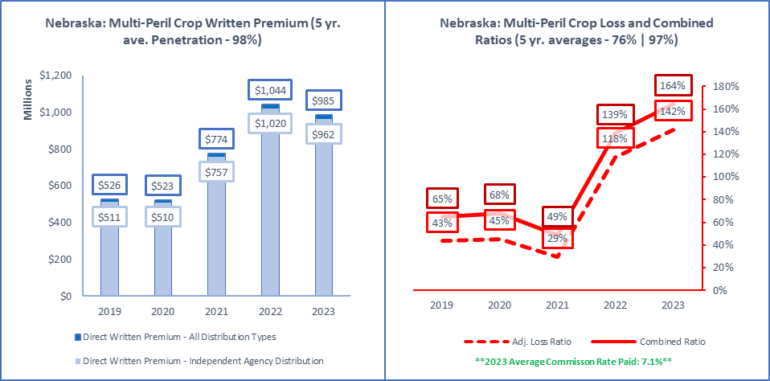

|  |  |  |  |  |
| --- | --- | --- | --- | --- |
| **ALL Direct Written Premium (DPW)** | **Ind Agent DPW** | **Excl.-Captive DPW** | **Direct DPW** | **Surplus Lines DPW** |
| $984,725,000 | $961,992,000 | $20,371,000 | $2,362,000 | $0 |
|  |  |  |  |  |
| **2019 to 2023 Ave Commission % (All Insurers)** | **Ind Agent Penetration** | **Excl.-Captive Penetration** | **Direct Penetration** | **Surplus Lines Utilization** |
| 7.6% | 8.9% | 7.1% | 6.3% | 7.1% | 98% | 2% | 0% | 0.0% |
|  |  |  |  |  |
| **Active Affiliated and Unaffiliated** | **IA+MGA+IA-Mixed** | **Excl.-Captive** | **Direct** | **Surplus Lines Insurers** |
| 16 | 13 | 2 | 1 | 0 |
|  |  |  |  |  |
| **1-yr | 5-yr Premium Growth: All Premium** | **1-yr | 5-yr: IA+MGA+IA-Mixed** | **1-yr | 5-yr: Excl.-Captive** | **1-yr | 5-yr: Direct** | **1-yr | 5-yr: Surplus Lines** |
| -6% | 17% | -6% | 17% | -12% | 9% | 880% | N/A | N/A | N/A |
|  |  |  |  |  |
| **Top 5 Groups** | **1-yr DPW** | **1-yr LR | CR** | **1-yr Growth | Comm%** | **Largest Insurer in Group or "N/A"** |
| Zurich Insurance US PC Group (G) | $246,064,000 | 123% | 137% | -12% | 5% | Rural Community Insurance Company |
| QBE North America Insurance Group (G) | $205,616,000 | 152% | 173% | 5% | 11% | NAU Country Insurance Company |
| Chubb INA Group (G) | $191,365,000 | 145% | 156% | -3% | 2% | ACE Property and Casualty Insurance Co |
| Great American P & C Insurance Group (G) | $92,034,000 | 91% | 113% | -2% | 10% | Great American Insurance Company |
| FMH Insurance Group (G) | $79,838,000 | 139% | 159% | -8% | 11% | Farmers Mutual Hail Insurance Co of Iowa |
| Total or Average | $984,726,000 | 142% | 164% | -6% | 7% | N/A |
|  |  |  |  |  |
| **Top 5 Pure Independent Agent-Broker Policy-Issuing Insurers** | | | | **Group or "N/A"** |
| NAU Country Insurance Company | $205,616,000 | 152% | 167% | 5% | 11% | QBE North America Insurance Group |
| ACE Property and Casualty Insurance Co | $174,904,000 | 140% | 153% | -2% | 2% | Chubb INA Group |
| Great American Insurance Company | $92,034,000 | 91% | 113% | -2% | 10% | Great American P & C Insurance Group |
| Farmers Mutual Hail Insurance Co of Iowa | $69,547,000 | 146% | 166% | -7% | 11% | FMH Insurance Group |
| Producers Agriculture Insurance Company | $44,436,000 | 130% | 139% | 81% | 15% | Tokio Marine US PC Group |
| **Top 3 MGA/Wholesale Policy-Issuing Insurers** | | | | **Group or "N/A"** |
| Stratford Insurance Company | $24,380,000 | 195% | 191% | -4% | -1% | American International Group |
| FMH Ag Risk Insurance Company | $10,291,000 | 99% | 109% | -13% | 11% | FMH Insurance Group |
| N/A | $0 | N/A | N/A | N/A | N/A | N/A |
| **Top 3 Exclusive-Captive Policy-Issuing Insurers** | | | | **Group or "N/A"** |
| Western Agricultural Insurance Company | $17,884,000 | 222% | 222% | -13% | 0% | Farm Bureau Property & Casualty Group |
| State Farm Fire and Casualty Company | $2,487,000 | 130% | 156% | -8% | 11% | State Farm Group |
| N/A | $0 | N/A | N/A | N/A | N/A | N/A |
| **Top 3 Direct Policy-Issuing Insurers** | | | | **Group or "N/A"** |
| American Agricultural Insurance Company | $2,362,000 | 130% | 165% | 880% | 24% | N/A |
| N/A | $0 | N/A | N/A | N/A | N/A | N/A |
| N/A | N/A | N/A | N/A | N/A | N/A | N/A |
| **Top 3 Surplus Lines Policy Issuing Insurers** | | | | **Group or "N/A"** |
| N/A | $0 | N/A | N/A | N/A | N/A | N/A |
| N/A | N/A | N/A | N/A | N/A | N/A | N/A |
| N/A | N/A | N/A | N/A | N/A | N/A | N/A |
| **Top Individual RRG** | | | | **Group or "N/A"** |
| N/A | $0 | N/A | N/A | N/A | N/A | N/A |

Source: © A.M. Best Company — used by permission. (Included in the above data are all P&C policies issued in Nebraska to cover losses that are subsidized or reinsured by the Federal Crop Insurance Corporation.)

|  |  |
| --- | --- |
| Ocean Marine |  |

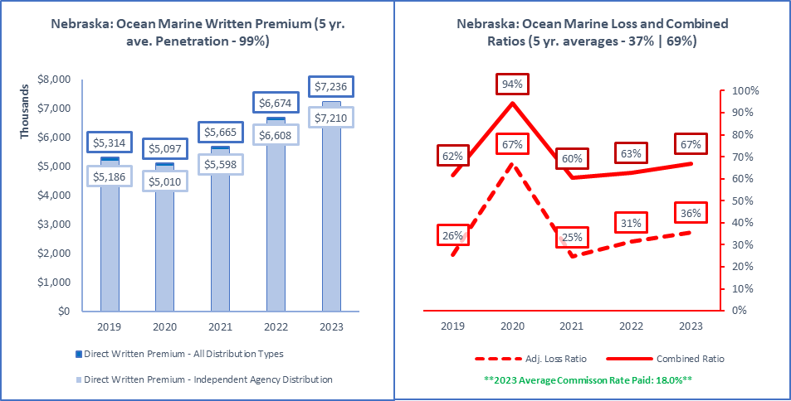

|  |  |  |  |  |
| --- | --- | --- | --- | --- |
| **ALL Direct Written Premium (DPW)** | **Ind Agent DPW** | **Excl.-Captive DPW** | **Direct DPW** | **Surplus Lines DPW** |
| $7,236,000 | $7,210,000 | $0 | $26,000 | $221,000 |
|  |  |  |  |  |
| **2019 to 2023 Ave Commission % (All Insurers)** | **Ind Agent Penetration** | **Excl.-Captive Penetration** | **Direct Penetration** | **Surplus Lines Utilization** |
| 15.8% | 16.4% | 15.9% | 17.0% | 18.0% | 100% | 0% | 0% | 3.1% |
|  |  |  |  |  |
| **Active Affiliated and Unaffiliated** | **IA+MGA+IA-Mixed** | **Excl.-Captive** | **Direct** | **Surplus Lines Insurers** |
| 50 | 45 | 0 | 5 | 6 |
|  |  |  |  |  |
| **1-yr | 5-yr Premium Growth: All Premium** | **1-yr | 5-yr: IA+MGA+IA-Mixed** | **1-yr | 5-yr: Excl.-Captive** | **1-yr | 5-yr: Direct** | **1-yr | 5-yr: Surplus Lines** |
| 8% | 8% | 9% | 9% | N/A | N/A | -61% | -27% | 154% | 96% |
|  |  |  |  |  |
| **Top 5 Groups** | **1-yr DPW** | **1-yr LR | CR** | **1-yr Growth | Comm%** | **Largest Insurer in Group or "N/A"** |
| American International Group (G) | $1,751,000 | 8% | 40% | 12% | 24% | National Union Fire Ins Co Pittsburgh PA |
| Zurich Insurance US PC Group (G) | $1,361,000 | 70% | 99% | -15% | 17% | Zurich American Insurance Company |
| Travelers Group (G) | $647,000 | 1% | 27% | 29% | 16% | Travelers Property Casualty Co of Amer |
| Hartford Insurance Group (G) | $541,000 | 127% | 163% | 36% | 18% | Navigators Insurance Company |
| Tokio Marine US PC Group (G) | $432,000 | 13% | 43% | 56% | 17% | Tokio Marine America Insurance Company |
| Total or Average | $7,237,000 | 36% | 67% | 8% | 18% | N/A |
|  |  |  |  |  |
| **Top 5 Pure Independent Agent-Broker Policy-Issuing Insurers** | | | | **Group or "N/A"** |
| National Union Fire Ins Co Pittsburgh PA | $1,614,000 | 10% | 42% | 20% | 24% | American International Group |
| Navigators Insurance Company | $541,000 | 127% | 160% | 36% | 18% | Hartford Insurance Group |
| Travelers Property Casualty Co of Amer | $530,000 | -11% | 4% | 38% | 14% | Travelers Group |
| Ascot Insurance Company | $371,000 | 85% | 121% | 88% | 16% | Ascot Insurance U.S. Group |
| Tokio Marine America Insurance Company | $248,000 | 8% | 43% | 6% | 15% | Tokio Marine US PC Group |
| **Top 3 MGA/Wholesale Policy-Issuing Insurers** | | | | **Group or "N/A"** |
| Houston Casualty Company | $162,000 | 25% | 49% | 575% | 20% | Tokio Marine US PC Group |
| RLI Insurance Company | $93,000 | 35% | 66% | -45% | 11% | RLI Group |
| New York Marine and General Insurance Co | $78,000 | 1% | 37% | -38% | 23% | Coaction Specialty Insurance Group |
| **Top 3 Exclusive-Captive Policy-Issuing Insurers** | | | | **Group or "N/A"** |
| N/A | $0 | N/A | N/A | N/A | N/A | N/A |
| N/A | N/A | N/A | N/A | N/A | N/A | N/A |
| N/A | N/A | N/A | N/A | N/A | N/A | N/A |
| **Top 3 Direct Policy-Issuing Insurers** | | | | **Group or "N/A"** |
| Liberty Mutual Insurance Company | $8,000 | -129% | -90% | -83% | 25% | Liberty Mutual Insurance Companies |
| N/A | N/A | N/A | N/A | N/A | N/A | N/A |
| Amica Mutual Insurance Company | $6,000 | 0% | 41% | 0% | 0% | Amica Mutual Group |
| **Top 3 Surplus Lines Policy Issuing Insurers** | | | | **Group or "N/A"** |
| Houston Casualty Company | $162,000 | 25% | 49% | 575% | 20% | Tokio Marine US PC Group |
| Evanston Insurance Company | $20,000 | 24% | 59% | 25% | 20% | Markel Insurance Group |
| Accredited Specialty Insurance Company | $17,000 | 18% | 50% | -19% | 29% | Randall & Quilter America Holdings Inc. |
| **Top Individual RRG** | | | | **Group or "N/A"** |
| N/A | $0 | N/A | N/A | N/A | N/A | N/A |

Source: © A.M. Best Company — used by permission. (Included in the above data are all P&C policies issued in Nebraska to cover losses resulting from transportation on ocean and inland waters).

|  |  |
| --- | --- |
| Other Liability (Claims-made) |  |

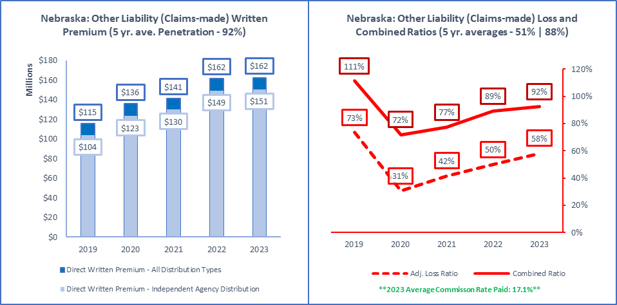

|  |  |  |  |  |
| --- | --- | --- | --- | --- |
| **ALL Direct Written Premium (DPW)** | **Ind Agent DPW** | **Excl.-Captive DPW** | **Direct DPW** | **Surplus Lines DPW** |
| $162,475,000 | $150,570,000 | $1,270,000 | $5,627,000 | $68,508,000 |
|  |  |  |  |  |
| **2019 to 2023 Ave Commission % (All Insurers)** | **Ind Agent Penetration** | **Excl.-Captive Penetration** | **Direct Penetration** | **Surplus Lines Utilization** |
| 15.1% | 14.8% | 15.6% | 16.6% | 17.1% | 93% | 1% | 3% | 42.2% |
|  |  |  |  |  |
| **Active Affiliated and Unaffiliated** | **IA+MGA+IA-Mixed** | **Excl.-Captive** | **Direct** | **Surplus Lines Insurers** |
| 292 | 236 | 16 | 18 | 95 |
|  |  |  |  |  |
| **1-yr | 5-yr Premium Growth: All Premium** | **1-yr | 5-yr: IA+MGA+IA-Mixed** | **1-yr | 5-yr: Excl.-Captive** | **1-yr | 5-yr: Direct** | **1-yr | 5-yr: Surplus Lines** |
| 1% | 9% | 1% | 10% | -2% | 9% | -1% | 9% | 8% | 21% |
|  |  |  |  |  |
| **Top 5 Groups** | **1-yr DPW** | **1-yr LR | CR** | **1-yr Growth | Comm%** | **Largest Insurer in Group or "N/A"** |
| Travelers Group (G) | $16,691,000 | 49% | 70% | 15% | 15% | Travelers Casualty and Surety Co of Amer |
| CNA Insurance Companies (G) | $13,731,000 | 55% | 78% | 16% | 18% | Continental Casualty Company |
| Chubb INA Group (G) | $11,428,000 | 50% | 86% | -1% | 14% | Federal Insurance Company |
| XL America Companies (G) | $9,922,000 | 169% | 209% | -22% | 22% | Indian Harbor Insurance Company |
| Berkshire Hathaway Insurance Group (G) | $9,272,000 | 87% | 119% | 13% | 17% | National Fire & Marine Insurance Co |
| Total or Average | $162,475,000 | 0% | 0% | 1% | 17% | N/A |
|  |  |  |  |  |
| **Top 5 Pure Independent Agent-Broker Policy-Issuing Insurers** | | | | **Group or "N/A"** |
| Travelers Casualty and Surety Co of Amer | $13,012,000 | 44% | 76% | 11% | 15% | Travelers Group |
| Continental Casualty Company | $10,696,000 | 52% | 67% | 7% | 18% | CNA Insurance Companies |
| Federal Insurance Company | $7,148,000 | 58% | 100% | 7% | 15% | Chubb INA Group |
| Indian Harbor Insurance Company | $5,451,000 | 90% | 107% | -37% | 15% | XL America Companies |
| XL Specialty Insurance Company | $4,279,000 | 55% | 80% | 12% | 12% | XL America Companies |
| **Top 3 MGA/Wholesale Policy-Issuing Insurers** | | | | **Group or "N/A"** |
| Houston Casualty Company | $2,105,000 | 85% | 132% | 44% | 32% | Tokio Marine US PC Group |
| Evanston Insurance Company | $1,836,000 | 133% | 184% | -35% | 17% | Markel Insurance Group |
| Trisura Specialty Insurance Company | $1,598,000 | 26% | 53% | 59% | 25% | Trisura US Insurance Group |
| **Top 3 Exclusive-Captive Policy-Issuing Insurers** | | | | **Group or "N/A"** |
| Federated Mutual Insurance Company | $370,000 | 39% | 71% | 15% | 0% | Federated Mutual Group |
| Ironshore Indemnity Inc. | $301,000 | 52% | 61% | -9% | 7% | Liberty Mutual Insurance Companies |
| State Farm Fire and Casualty Company | $150,000 | 13% | 58% | 13% | 30% | State Farm Group |
| **Top 3 Direct Policy-Issuing Insurers** | | | | **Group or "N/A"** |
| Minnesota Lawyers Mutual Insurance Co | $2,156,000 | 17% | 59% | 1% | 0% | MLM Group |
| Homesite Insurance Company of Florida | $984,000 | 15% | 47% | 13% | 19% | American Family Insurance Group |
| ALPS Property & Casualty Insurance Co | $652,000 | -95% | -260% | -1% | 8% | N/A |
| **Top 3 Surplus Lines Policy Issuing Insurers** | | | | **Group or "N/A"** |
| Indian Harbor Insurance Company | $5,451,000 | 90% | 107% | -37% | 15% | XL America Companies |
| National Fire & Marine Insurance Co | $4,276,000 | 40% | 71% | 45% | 13% | Berkshire Hathaway Insurance Group |
| Columbia Casualty Company | $2,963,000 | 67% | 106% | 69% | 19% | CNA Insurance Companies |
| **Top Individual RRG** | | | | **Group or "N/A"** |
| United Educators Ins, a Reciprocal RRG | $949,000 | -65% | -54% | 0% | 2% | N/A |

Source: © A.M. Best Company — used by permission. (Included in the above data are all P&C policies issued in Nebraska to cover legal liability losses liability losses from a wide variety of exposures that are issued on a claims-made basis. Common examples include errors & omissions, directors & officers, and Internet liability).

|  |  |
| --- | --- |
| Other Liability (Occurrence) |  |

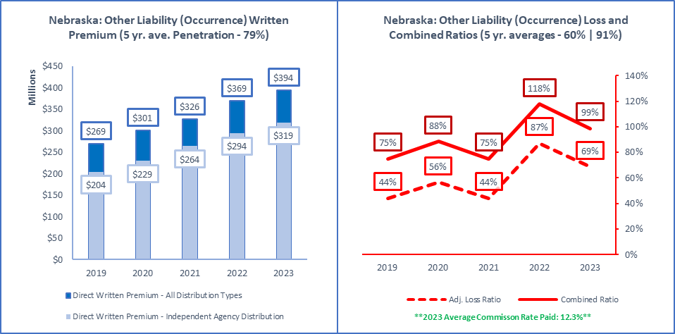

|  |  |  |  |  |
| --- | --- | --- | --- | --- |
| **ALL Direct Written Premium (DPW)** | **Ind Agent DPW** | **Excl.-Captive DPW** | **Direct DPW** | **Surplus Lines DPW** |
| $394,482,000 | $318,684,000 | $44,828,000 | $16,882,000 | $115,704,000 |
|  |  |  |  |  |
| **2019 to 2023 Ave Commission % (All Insurers)** | **Ind Agent Penetration** | **Excl.-Captive Penetration** | **Direct Penetration** | **Surplus Lines Utilization** |
| 11.5% | 11.6% | 12.1% | 12.0% | 12.3% | 81% | 11% | 4% | 29.3% |
|  |  |  |  |  |
| **Active Affiliated and Unaffiliated** | **IA+MGA+IA-Mixed** | **Excl.-Captive** | **Direct** | **Surplus Lines Insurers** |
| 452 | 364 | 33 | 35 | 112 |
|  |  |  |  |  |
| **1-yr | 5-yr Premium Growth: All Premium** | **1-yr | 5-yr: IA+MGA+IA-Mixed** | **1-yr | 5-yr: Excl.-Captive** | **1-yr | 5-yr: Direct** | **1-yr | 5-yr: Surplus Lines** |
| 7% | 10% | 8% | 12% | 6% | 0% | -16% | 2% | 19% | 29% |
|  |  |  |  |  |
| **Top 5 Groups** | **1-yr DPW** | **1-yr LR | CR** | **1-yr Growth | Comm%** | **Largest Insurer in Group or "N/A"** |
| Berkshire Hathaway Insurance Group (G) | $26,643,000 | 50% | 79% | 32% | 7% | National Fire & Marine Insurance Co |
| Travelers Group (G) | $24,994,000 | 74% | 101% | 24% | 12% | Travelers Property Casualty Co of Amer |
| Chubb INA Group (G) | $24,534,000 | 27% | 44% | 7% | 6% | ACE Property and Casualty Insurance Co |
| Nationwide Property & Casualty Group (G) | $20,110,000 | 72% | 104% | -6% | 14% | Nationwide Agribusiness Insurance Co |
| EMC Insurance Companies (G) | $19,803,000 | 35% | 75% | 5% | 18% | Employers Mutual Casualty Company |
| Total or Average | $394,482,000 | 0% | 0% | 7% | 12% | N/A |
|  |  |  |  |  |
| **Top 5 Pure Independent Agent-Broker Policy-Issuing Insurers** | | | | **Group or "N/A"** |
| Travelers Property Casualty Co of Amer | $19,588,000 | 85% | 100% | 26% | 12% | Travelers Group |
| National Fire & Marine Insurance Co | $18,113,000 | 61% | 84% | 32% | 2% | Berkshire Hathaway Insurance Group |
| Employers Mutual Casualty Company | $15,973,000 | 36% | 75% | 6% | 18% | EMC Insurance Companies |
| American Bankers Insurance Co of Florida | $10,664,000 | 34% | 49% | 14% | 3% | Assurant P&C Group |
| ACE Property and Casualty Insurance Co | $10,331,000 | 53% | 69% | 5% | 2% | Chubb INA Group |
| **Top 3 MGA/Wholesale Policy-Issuing Insurers** | | | | **Group or "N/A"** |
| Gemini Insurance Company | $9,350,000 | 72% | 87% | -4% | 13% | W. R. Berkley Insurance Group |
| Evanston Insurance Company | $4,013,000 | 55% | 107% | 122% | 15% | Markel Insurance Group |
| Securian Casualty Company | $2,419,000 | 42% | 89% | -6% | 41% | N/A |
| **Top 3 Exclusive-Captive Policy-Issuing Insurers** | | | | **Group or "N/A"** |
| State Farm Fire and Casualty Company | $12,065,000 | 162% | 192% | 7% | 11% | State Farm Group |
| Farm Bureau Property & Casualty Ins Co | $7,205,000 | 118% | 152% | 9% | 16% | Farm Bureau Property & Casualty Group |
| American Family Mutual Ins Co, S.I. | $4,456,000 | 17% | 36% | 1% | 11% | American Family Insurance Group |
| **Top 3 Direct Policy-Issuing Insurers** | | | | **Group or "N/A"** |
| Nationwide Agribusiness Insurance Co | $5,942,000 | 130% | 154% | -2% | 10% | Nationwide Property & Casualty Group |
| Crestbrook Insurance Company | $4,325,000 | 53% | 67% | 54% | 11% | Nationwide Property & Casualty Group |
| Caterpillar Insurance Company | $1,936,000 | 67% | 75% | 18% | 0% | N/A |
| **Top 3 Surplus Lines Policy Issuing Insurers** | | | | **Group or "N/A"** |
| National Fire & Marine Insurance Co | $18,113,000 | 61% | 84% | 32% | 2% | Berkshire Hathaway Insurance Group |
| Gemini Insurance Company | $9,350,000 | 72% | 87% | -4% | 13% | W. R. Berkley Insurance Group |
| Cincinnati Specialty Underwriters Ins Co | $5,211,000 | 34% | 67% | 35% | 17% | The Cincinnati Insurance Companies |
| **Top Individual RRG** | | | | **Group or "N/A"** |
| United Educators Ins, a Reciprocal RRG | $2,802,000 | 11% | 24% | 5% | 2% | N/A |

Source: © A.M. Best Company — used by permission. (Included in the above data are all P&C policies issued in Nebraska to cover legal liability losses liability losses from a wide variety of exposures that are issued on an occurrence basis. Examples include premises, completed operations, and umbrella.

|  |  |
| --- | --- |
| Private Crop |  |

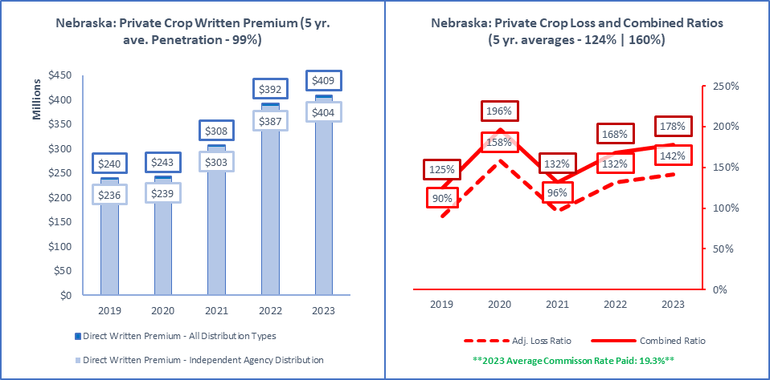

|  |  |  |  |  |
| --- | --- | --- | --- | --- |
| **ALL Direct Written Premium (DPW)** | **Ind Agent DPW** | **Excl.-Captive DPW** | **Direct DPW** | **Surplus Lines DPW** |
| $409,457,000 | $404,435,000 | $5,022,000 | $0 | $0 |
|  |  |  |  |  |
| **2019 to 2023 Ave Commission % (All Insurers)** | **Ind Agent Penetration** | **Excl.-Captive Penetration** | **Direct Penetration** | **Surplus Lines Utilization** |
| 17.1% | 17.4% | 19.1% | 19.1% | 19.3% | 99% | 1% | 0% | 0.0% |
|  |  |  |  |  |
| **Active Affiliated and Unaffiliated** | **IA+MGA+IA-Mixed** | **Excl.-Captive** | **Direct** | **Surplus Lines Insurers** |
| 16 | 14 | 2 | 0 | 0 |
|  |  |  |  |  |
| **1-yr | 5-yr Premium Growth: All Premium** | **1-yr | 5-yr: IA+MGA+IA-Mixed** | **1-yr | 5-yr: Excl.-Captive** | **1-yr | 5-yr: Direct** | **1-yr | 5-yr: Surplus Lines** |
| 4% | 14% | 5% | 14% | -3% | 6% | N/A | N/A | N/A | N/A |
|  |  |  |  |  |
| **Top 5 Groups** | **1-yr DPW** | **1-yr LR | CR** | **1-yr Growth | Comm%** | **Largest Insurer in Group or "N/A"** |
| Zurich Insurance US PC Group (G) | $129,728,000 | 143% | 174% | 3% | 18% | Rural Community Insurance Company |
| QBE North America Insurance Group (G) | $100,908,000 | 111% | 137% | 26% | 18% | NAU Country Insurance Company |
| Chubb INA Group (G) | $44,622,000 | 116% | 158% | 26% | 33% | ACE Property and Casualty Insurance Co |
| Great American P & C Insurance Group (G) | $41,503,000 | 176% | 207% | 14% | 15% | Great American Alliance Insurance Co |
| Sompo Holdings US Group (G) | $40,991,000 | 222% | 254% | -39% | 21% | American Agri-Business Insu Company |
| Total or Average | $409,457,000 | 0% | 0% | 4% | 19% | N/A |
|  |  |  |  |  |
| **Top 5 Pure Independent Agent-Broker Policy-Issuing Insurers** | | | | **Group or "N/A"** |
| NAU Country Insurance Company | $100,908,000 | 111% | 132% | 26% | 18% | QBE North America Insurance Group |
| Great American Alliance Insurance Co | $41,390,000 | 176% | 192% | 14% | 15% | Great American P & C Insurance Group |
| ACE Property and Casualty Insurance Co | $39,678,000 | 110% | 153% | 29% | 33% | Chubb INA Group |
| Farmers Mutual Hail Insurance Co of Iowa | $21,184,000 | 131% | 159% | 4% | 19% | FMH Insurance Group |
| Hudson Insurance Company | $5,119,000 | 115% | 144% | 72% | 18% | Fairfax Financial (USA) Group |
| **Top 3 MGA/Wholesale Policy-Issuing Insurers** | | | | **Group or "N/A"** |
| Stratford Insurance Company | $15,602,000 | 149% | 165% | 14% | 18% | American International Group |
| FMH Ag Risk Insurance Company | $2,294,000 | 151% | 153% | 9% | 1% | FMH Insurance Group |
| N/A | $0 | N/A | N/A | N/A | N/A | N/A |
| **Top 3 Exclusive-Captive Policy-Issuing Insurers** | | | | **Group or "N/A"** |
| Western Agricultural Insurance Company | $4,560,000 | 105% | 105% | -4% | 0% | Farm Bureau Property & Casualty Group |
| State Farm Fire and Casualty Company | $462,000 | 56% | 71% | 1% | 4% | State Farm Group |
| N/A | $0 | N/A | N/A | N/A | N/A | N/A |
| **Top 3 Direct Policy-Issuing Insurers** | | | | **Group or "N/A"** |
| N/A | $0 | N/A | N/A | N/A | N/A | N/A |
| N/A | N/A | N/A | N/A | N/A | N/A | N/A |
| N/A | N/A | N/A | N/A | N/A | N/A | N/A |
| **Top 3 Surplus Lines Policy Issuing Insurers** | | | | **Group or "N/A"** |
| N/A | $0 | N/A | N/A | N/A | N/A | N/A |
| N/A | N/A | N/A | N/A | N/A | N/A | N/A |
| N/A | N/A | N/A | N/A | N/A | N/A | N/A |
| **Top Individual RRG** | | | | **Group or "N/A"** |
| N/A | $0 | N/A | N/A | N/A | N/A | N/A |

Source: © A.M. Best Company — used by permission. (Included in the above data are all P&C policies issued in Nebraska to cover crop hail and fire and other risks NOT subsidized or reinsured by the Federal Crop Insurance Corporation).

|  |  |
| --- | --- |
| Private Flood |  |

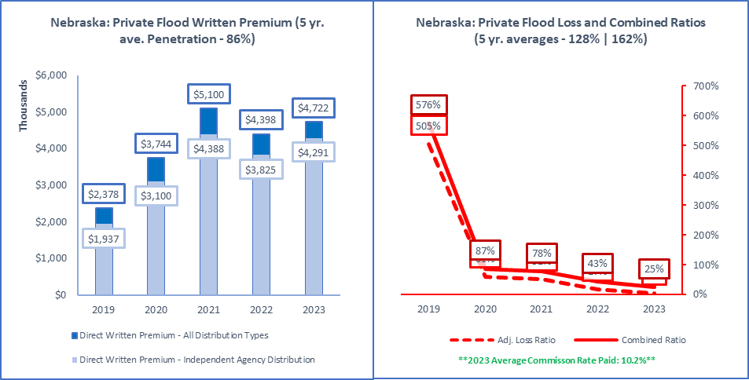

|  |  |  |  |  |
| --- | --- | --- | --- | --- |
| **ALL Direct Written Premium (DPW)** | **Ind Agent DPW** | **Excl.-Captive DPW** | **Direct DPW** | **Surplus Lines DPW** |
| $4,722,000 | $4,291,000 | $8,000 | $494,000 | $1,449,000 |
|  |  |  |  |  |
| **2019 to 2023 Ave Commission % (All Insurers)** | **Ind Agent Penetration** | **Excl.-Captive Penetration** | **Direct Penetration** | **Surplus Lines Utilization** |
| 8.5% | 12.4% | 11.9% | 12.6% | 10.2% | 91% | 0% | 10% | 30.7% |
|  |  |  |  |  |
| **Active Affiliated and Unaffiliated** | **IA+MGA+IA-Mixed** | **Excl.-Captive** | **Direct** | **Surplus Lines Insurers** |
| 66 | 56 | 1 | 9 | 24 |
|  |  |  |  |  |
| **1-yr | 5-yr Premium Growth: All Premium** | **1-yr | 5-yr: IA+MGA+IA-Mixed** | **1-yr | 5-yr: Excl.-Captive** | **1-yr | 5-yr: Direct** | **1-yr | 5-yr: Surplus Lines** |
| 7% | 19% | 12% | 22% | -75% | 19% | 11% | 9% | -5% | 27% |
|  |  |  |  |  |
| **Top 5 Groups** | **1-yr DPW** | **1-yr LR | CR** | **1-yr Growth | Comm%** | **Largest Insurer in Group or "N/A"** |
| Zurich Insurance US PC Group (G) | $1,507,000 | 3% | 16% | 72% | 4% | Zurich American Insurance Company |
| XL America Companies (G) | $618,000 | -14% | 1% | 56% | 8% | XL Insurance America, Inc. |
| American International Group (G) | $391,000 | 0% | 25% | -55% | 18% | Lexington Insurance Company |
| Swiss Reinsurance Group (G) | $383,000 | 37% | 56% | -20% | 1% | Swiss Re Corporate Solutions Elite Ins |
| Assurant P&C Group (G) | $311,000 | 0% | 28% | -1% | 15% | Voyager Indemnity Insurance Company |
| Total or Average | $4,698,000 | 5% | 26% | 7% | 10% | N/A |
|  |  |  |  |  |
| **Top 5 Pure Independent Agent-Broker Policy-Issuing Insurers** | | | | **Group or "N/A"** |
| American Guarantee and Liability Ins Co | $591,000 | 4% | 8% | 83% | 1% | Zurich Insurance US PC Group |
| XL Insurance America, Inc. | $503,000 | 1% | 6% | 73% | 4% | XL America Companies |
| Swiss Re Corporate Solutions Elite Ins | $345,000 | 43% | 61% | -7% | 1% | Swiss Reinsurance Group |
| Lexington Insurance Company | $230,000 | 2% | 30% | -30% | 22% | American International Group |
| StarStone Specialty Insurance Company | $200,000 | 15% | 34% | N/A | 12% | Core Specialty Insurance Group |
| **Top 3 MGA/Wholesale Policy-Issuing Insurers** | | | | **Group or "N/A"** |
| MS Transverse Specialty Insurance Co | $97,000 | -5% | 29% | 64% | 32% | MS&AD US Insurance Group |
| Trisura Specialty Insurance Company | $15,000 | 10% | 22% | -92% | 33% | Trisura US Insurance Group |
| Wright National Flood Insurance Company | $7,000 | 0% | 37% | 0% | 29% | N/A |
| **Top 3 Exclusive-Captive Policy-Issuing Insurers** | | | | **Group or "N/A"** |
| Nationwide Mutual Insurance Company | $8,000 | 0% | 37% | -74% | 25% | Nationwide Property & Casualty Group |
| N/A | $0 | N/A | N/A | N/A | N/A | N/A |
| N/A | N/A | N/A | N/A | N/A | N/A | N/A |
| **Top 3 Direct Policy-Issuing Insurers** | | | | **Group or "N/A"** |
| Voyager Indemnity Insurance Company | $183,000 | -1% | 43% | -4% | 25% | Assurant P&C Group |
| American Security Insurance Company | $128,000 | 0% | 24% | 4% | 2% | Assurant P&C Group |
| Liberty Mutual Fire Insurance Company | $60,000 | 0% | 18% | 107% | 5% | Liberty Mutual Insurance Companies |
| **Top 3 Surplus Lines Policy Issuing Insurers** | | | | **Group or "N/A"** |
| Lexington Insurance Company | $230,000 | 2% | 30% | -30% | 22% | American International Group |
| StarStone Specialty Insurance Company | $200,000 | 15% | 34% | N/A | 12% | Core Specialty Insurance Group |
| Voyager Indemnity Insurance Company | $183,000 | -1% | 43% | -4% | 25% | Assurant P&C Group |
| **Top Individual RRG** | | | | **Group or "N/A"** |
| N/A | $0 | N/A | N/A | N/A | N/A | N/A |

Source: © A.M. Best Company — used by permission. (Included in the above data are all P&C policies issued in Nebraska to cover flood and are NOT under the Federal Flood Insurance Program and its Write Your Own program).

|  |  |
| --- | --- |
| Products Liability |  |

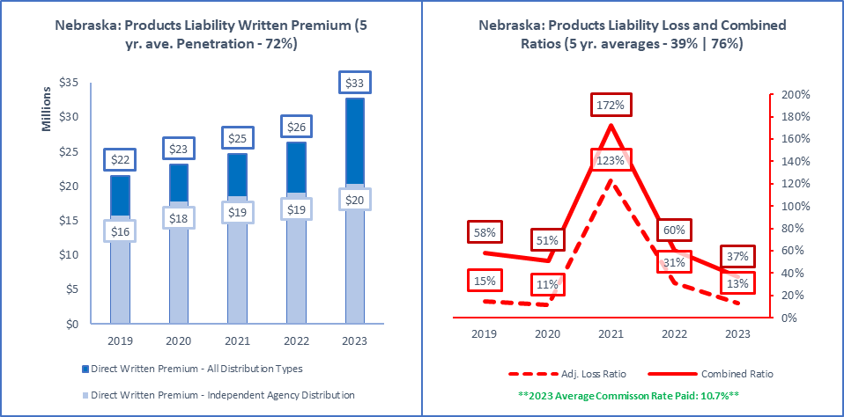

|  |  |  |  |  |
| --- | --- | --- | --- | --- |
| **ALL Direct Written Premium (DPW)** | **Ind Agent DPW** | **Excl.-Captive DPW** | **Direct DPW** | **Surplus Lines DPW** |
| $32,714,000 | $20,364,000 | $1,516,000 | $9,923,000 | $7,294,000 |
|  |  |  |  |  |
| **2019 to 2023 Ave Commission % (All Insurers)** | **Ind Agent Penetration** | **Excl.-Captive Penetration** | **Direct Penetration** | **Surplus Lines Utilization** |
| 17.4% | 13.2% | 12.1% | 12.1% | 10.7% | 62% | 5% | 30% | 22.3% |
|  |  |  |  |  |
| **Active Affiliated and Unaffiliated** | **IA+MGA+IA-Mixed** | **Excl.-Captive** | **Direct** | **Surplus Lines Insurers** |
| 142 | 125 | 9 | 5 | 42 |
|  |  |  |  |  |
| **1-yr | 5-yr Premium Growth: All Premium** | **1-yr | 5-yr: IA+MGA+IA-Mixed** | **1-yr | 5-yr: Excl.-Captive** | **1-yr | 5-yr: Direct** | **1-yr | 5-yr: Surplus Lines** |
| 24% | 11% | 7% | 7% | -3% | -7% | 86% | 32% | 13% | 14% |
|  |  |  |  |  |
| **Top 5 Groups** | **1-yr DPW** | **1-yr LR | CR** | **1-yr Growth | Comm%** | **Largest Insurer in Group or "N/A"** |
| Liberty Mutual Insurance Companies (G) | $7,116,000 | 18% | 37% | 155% | 1% | Liberty Mutual Fire Insurance Company |
| Nationwide Property & Casualty Group (G) | $3,602,000 | 9% | 31% | 7% | 12% | Crestbrook Insurance Company |
| EMC Insurance Companies (G) | $2,094,000 | 68% | 127% | 62% | 19% | Employers Mutual Casualty Company |
| United Fire & Casualty Group (G) | $1,850,000 | -13% | 6% | 26% | 17% | United Fire & Casualty Company |
| Chubb INA Group (G) | $1,731,000 | 60% | 99% | 23% | 15% | Penn Millers Insurance Company |
| Total or Average | $32,714,000 | 0% | 0% | 24% | 11% | N/A |
|  |  |  |  |  |
| **Top 5 Pure Independent Agent-Broker Policy-Issuing Insurers** | | | | **Group or "N/A"** |
| United Fire & Casualty Company | $1,503,000 | -27% | -16% | 26% | 17% | United Fire & Casualty Group |
| Employers Mutual Casualty Company | $1,429,000 | 43% | 104% | 60% | 18% | EMC Insurance Companies |
| Allianz Global Risks US Insurance Co | $1,134,000 | -44% | -29% | 4% | 0% | Allianz US PC Insurance Companies |
| Cincinnati Insurance Company | $881,000 | -17% | 28% | 17% | 19% | The Cincinnati Insurance Companies |
| James River Insurance Company | $832,000 | -19% | 4% | 24% | 13% | James River Group |
| **Top 3 MGA/Wholesale Policy-Issuing Insurers** | | | | **Group or "N/A"** |
| Houston Casualty Company | $412,000 | 151% | 191% | -9% | 33% | Tokio Marine US PC Group |
| Western World Insurance Company | $357,000 | 5% | 45% | 11% | 22% | American International Group |
| Gemini Insurance Company | $185,000 | 143% | 286% | 16% | 17% | W. R. Berkley Insurance Group |
| **Top 3 Exclusive-Captive Policy-Issuing Insurers** | | | | **Group or "N/A"** |
| Federated Mutual Insurance Company | $563,000 | 13% | 35% | 36% | 0% | Federated Mutual Group |
| Sentry Insurance Company | $403,000 | 19% | 28% | 11% | 5% | Sentry Insurance Group |
| Sentry Select Insurance Company | $362,000 | 11% | 33% | 12% | 9% | Sentry Insurance Group |
| **Top 3 Direct Policy-Issuing Insurers** | | | | **Group or "N/A"** |
| Liberty Mutual Fire Insurance Company | $6,549,000 | 14% | 31% | 217% | 0% | Liberty Mutual Insurance Companies |
| Crestbrook Insurance Company | $1,756,000 | 13% | 31% | 91% | 12% | Nationwide Property & Casualty Group |
| Nationwide Agribusiness Insurance Co | $1,504,000 | 12% | 28% | -25% | 10% | Nationwide Property & Casualty Group |
| **Top 3 Surplus Lines Policy Issuing Insurers** | | | | **Group or "N/A"** |
| James River Insurance Company | $832,000 | -19% | 4% | 24% | 13% | James River Group |
| Lexington Insurance Company | $734,000 | 32% | 53% | -2% | 10% | American International Group |
| Kinsale Insurance Company | $569,000 | 23% | 73% | 58% | 15% | N/A |
| **Top Individual RRG** | | | | **Group or "N/A"** |
| N/A | $0 | N/A | N/A | N/A | N/A | N/A |

Source: © A.M. Best Company — used by permission. (Included in the above data are all P&C policies issued in Nebraska to cover liability from manufacturing or selling of defective products that cause injury or damage).

|  |  |
| --- | --- |
| Surety |  |

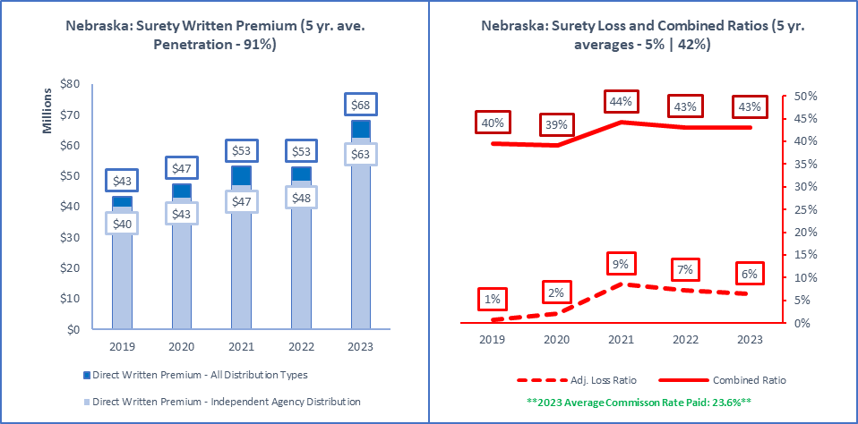

|  |  |  |  |  |
| --- | --- | --- | --- | --- |
| **ALL Direct Written Premium (DPW)** | **Ind Agent DPW** | **Excl.-Captive DPW** | **Direct DPW** | **Surplus Lines DPW** |
| $68,088,000 | $62,541,000 | $1,584,000 | $3,473,000 | $507,000 |
|  |  |  |  |  |
| **2019 to 2023 Ave Commission % (All Insurers)** | **Ind Agent Penetration** | **Excl.-Captive Penetration** | **Direct Penetration** | **Surplus Lines Utilization** |
| 23.9% | 22.5% | 21.7% | 23.1% | 23.6% | 92% | 2% | 5% | 0.7% |
|  |  |  |  |  |
| **Active Affiliated and Unaffiliated** | **IA+MGA+IA-Mixed** | **Excl.-Captive** | **Direct** | **Surplus Lines Insurers** |
| 111 | 98 | 6 | 1 | 3 |
|  |  |  |  |  |
| **1-yr | 5-yr Premium Growth: All Premium** | **1-yr | 5-yr: IA+MGA+IA-Mixed** | **1-yr | 5-yr: Excl.-Captive** | **1-yr | 5-yr: Direct** | **1-yr | 5-yr: Surplus Lines** |
| 29% | 12% | 29% | 12% | 3% | 11% | 53% | 16% | 13% | 106% |
|  |  |  |  |  |
| **Top 5 Groups** | **1-yr DPW** | **1-yr LR | CR** | **1-yr Growth | Comm%** | **Largest Insurer in Group or "N/A"** |
| Berkshire Hathaway Insurance Group (G) | $9,147,000 | 0% | 7% | 1% | 1% | National Indemnity Company |
| Zurich Insurance US PC Group (G) | $7,294,000 | 9% | 34% | 402% | 16% | Fidelity and Deposit Company of Maryland |
| Travelers Group (G) | $7,079,000 | -8% | 22% | 47% | 19% | Travelers Casualty and Surety Co of Amer |
| CNA Insurance Companies (G) | $5,969,000 | 22% | 63% | 86% | 27% | Western Surety Company |
| Universal Inland Insurance Group (G) | $5,032,000 | 5% | 59% | -6% | 36% | Universal Surety Company |
| Total or Average | $67,367,000 | 6% | 43% | 27% | 24% | N/A |
|  |  |  |  |  |
| **Top 5 Pure Independent Agent-Broker Policy-Issuing Insurers** | | | | **Group or "N/A"** |
| National Indemnity Company | $8,838,000 | 0% | 1% | 0% | 0% | Berkshire Hathaway Insurance Group |
| Fidelity and Deposit Company of Maryland | $7,294,000 | 9% | 27% | 417% | 15% | Zurich Insurance US PC Group |
| Travelers Casualty and Surety Co of Amer | $6,707,000 | -8% | 24% | 48% | 18% | Travelers Group |
| Western Surety Company | $4,069,000 | 31% | 85% | 51% | 27% | CNA Insurance Companies |
| Universal Surety Company | $3,884,000 | 0% | 54% | -2% | 36% | Universal Inland Insurance Group |
| **Top 3 MGA/Wholesale Policy-Issuing Insurers** | | | | **Group or "N/A"** |
| Harco National Insurance Company | $463,000 | -6% | 35% | 1% | 35% | IAT Insurance Group |
| Clear Blue Specialty Insurance Company | $401,000 | 52% | 70% | 16% | 13% | Clear Blue Insurance Group |
| RLI Insurance Company | $251,000 | -3% | 45% | -18% | 29% | RLI Group |
| **Top 3 Exclusive-Captive Policy-Issuing Insurers** | | | | **Group or "N/A"** |
| Nationwide Mutual Insurance Company | $1,239,000 | 1% | 47% | -9% | 30% | Nationwide Property & Casualty Group |
| Euler Hermes North America Insurance Co. | $167,000 | 16% | 71% | 1756% | 25% | Allianz US PC Insurance Companies |
| State Farm Fire and Casualty Company | $119,000 | -7% | 46% | -5% | 23% | State Farm Group |
| **Top 3 Direct Policy-Issuing Insurers** | | | | **Group or "N/A"** |
| Liberty Mutual Insurance Company | $3,473,000 | 12% | 44% | 53% | 15% | Liberty Mutual Insurance Companies |
| N/A | $0 | N/A | N/A | N/A | N/A | N/A |
| N/A | N/A | N/A | N/A | N/A | N/A | N/A |
| **Top 3 Surplus Lines Policy Issuing Insurers** | | | | **Group or "N/A"** |
| Clear Blue Specialty Insurance Company | $401,000 | 52% | 70% | 16% | 13% | Clear Blue Insurance Group |
| Republic-Vanguard Insurance Company | $120,000 | 0% | 23% | N/A | 23% | AmTrust Group |
| Accelerant Specialty Insurance Company | $4,000 | 20% | 124% | -20% | 100% | Accelerant US Holdings Group |
| **Top Individual RRG** | | | | **Group or "N/A"** |
| N/A | $0 | N/A | N/A | N/A | N/A | N/A |

Source: © A.M. Best Company — used by permission. (Included in the above data are all P&C policies issued in Nebraska for 3-party agreements covering the default of a principal on an obligation to an obligee).

|  |  |
| --- | --- |
| Workers' Compensation |  |

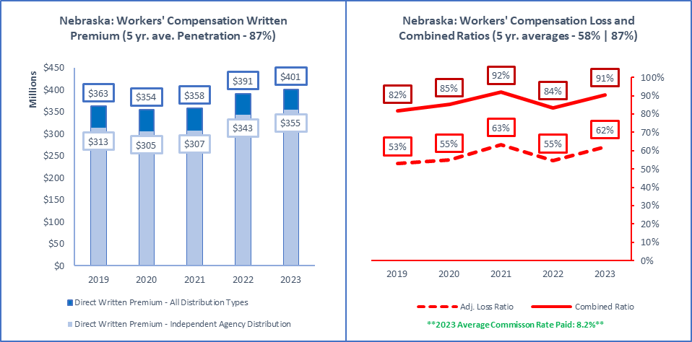

|  |  |  |  |  |
| --- | --- | --- | --- | --- |
| **ALL Direct Written Premium (DPW)** | **Ind Agent DPW** | **Excl.-Captive DPW** | **Direct DPW** | **Surplus Lines DPW** |
| $401,127,000 | $354,922,000 | $25,482,000 | $18,760,000 | $27,000 |
|  |  |  |  |  |
| **2019 to 2023 Ave Commission % (All Insurers)** | **Ind Agent Penetration** | **Excl.-Captive Penetration** | **Direct Penetration** | **Surplus Lines Utilization** |
| 8.0% | 8.0% | 8.3% | 8.0% | 8.2% | 88% | 6% | 5% | 0.0% |
|  |  |  |  |  |
| **Active Affiliated and Unaffiliated** | **IA+MGA+IA-Mixed** | **Excl.-Captive** | **Direct** | **Surplus Lines Insurers** |
| 289 | 252 | 19 | 12 | 2 |
|  |  |  |  |  |
| **1-yr | 5-yr Premium Growth: All Premium** | **1-yr | 5-yr: IA+MGA+IA-Mixed** | **1-yr | 5-yr: Excl.-Captive** | **1-yr | 5-yr: Direct** | **1-yr | 5-yr: Surplus Lines** |
| 3% | 2% | 3% | 3% | 7% | 0% | -13% | -5% | N/A | N/A |
|  |  |  |  |  |
| **Top 5 Groups** | **1-yr DPW** | **1-yr LR | CR** | **1-yr Growth | Comm%** | **Largest Insurer in Group or "N/A"** |
| Travelers Group (G) | $50,466,000 | 78% | 105% | 2% | 8% | Travelers Property Casualty Co of Amer |
| Zurich Insurance US PC Group (G) | $33,656,000 | 37% | 60% | 22% | 2% | Zurich American Insurance Company |
| AF Group (G) | $28,223,000 | 90% | 123% | 8% | 11% | Accident Fund General Insurance Co |
| Markel Insurance Group (G) | $20,673,000 | 57% | 83% | 6% | 11% | FirstComp Insurance Company |
| EMC Insurance Companies (G) | $17,091,000 | 55% | 88% | -9% | 10% | Employers Mutual Casualty Company |
| Total or Average | $401,124,000 | 62% | 91% | 3% | 8% | N/A |
|  |  |  |  |  |
| **Top 5 Pure Independent Agent-Broker Policy-Issuing Insurers** | | | | **Group or "N/A"** |
| Travelers Property Casualty Co of Amer | $16,609,000 | 112% | 127% | -11% | 6% | Travelers Group |
| Accident Fund General Insurance Co | $12,764,000 | 96% | 113% | 16% | 10% | AF Group |
| SFM Mutual Insurance Company | $11,867,000 | 94% | 136% | 7% | 10% | SFM Companies |
| Employers Mutual Casualty Company | $11,048,000 | 40% | 73% | -5% | 9% | EMC Insurance Companies |
| FirstComp Insurance Company | $11,019,000 | 39% | 67% | 5% | 11% | Markel Insurance Group |
| **Top 3 MGA/Wholesale Policy-Issuing Insurers** | | | | **Group or "N/A"** |
| Markel Insurance Company | $2,931,000 | 127% | 166% | -7% | 11% | Markel Insurance Group |
| Stonetrust Commercial Insurance Company | $2,136,000 | 72% | 128% | -20% | 17% | Stonetrust Insurance Group |
| Praetorian Insurance Company | $1,273,000 | 268% | 310% | 89% | 17% | QBE North America Insurance Group |
| **Top 3 Exclusive-Captive Policy-Issuing Insurers** | | | | **Group or "N/A"** |
| Farm Bureau Property & Casualty Ins Co | $5,306,000 | 37% | 63% | 17% | 6% | Farm Bureau Property & Casualty Group |
| State Farm Fire and Casualty Company | $4,596,000 | 32% | 56% | 3% | 9% | State Farm Group |
| Federated Mutual Insurance Company | $4,145,000 | 31% | 59% | 14% | 0% | Federated Mutual Group |
| **Top 3 Direct Policy-Issuing Insurers** | | | | **Group or "N/A"** |
| LM Insurance Corporation | $5,602,000 | 42% | 48% | -5% | 0% | Liberty Mutual Insurance Companies |
| Service American Indemnity Company | $3,860,000 | 64% | 95% | -16% | 19% | Service Insurance Group |
| Nationwide Agribusiness Insurance Co | $3,846,000 | 53% | 73% | -15% | 8% | Nationwide Property & Casualty Group |
| **Top 3 Surplus Lines Policy Issuing Insurers** | | | | **Group or "N/A"** |
| Houston Specialty Insurance Company | $17,000 | 0% | 24% | N/A | 18% | Skyward Specialty Insurance Group |
| Mobilitas Insurance Company | $10,000 | 45% | 65% | N/A | 10% | CSAA Insurance Group |
| N/A | $0 | N/A | N/A | N/A | N/A | N/A |
| **Top Individual RRG** | | | | **Group or "N/A"** |
| N/A | $0 | N/A | N/A | N/A | N/A | N/A |

Source: © A.M. Best Company — used by permission. (Included in the above data are all P&C policies issued in Nebraska for liability for worker injuries under statutes or common law but not on excess basis. This includes Occurrence and Claims-Made policies).

# Appendix #1: Distribution Style Classifications

This *2024* *Nebraska P&C Marketplace Summary* classifies insurers into Distribution Styles based on the insurer’s reported Marketing Type(s). These Marketing Types are providedby A.M. Best as part of what is known as a “Galley Process.”. Below are the various Marketing Types reported by insurers in 2023.

Marketing Types Reported by A.M. Best Company:

* Affinity Group Marketing
* Bank
* Broker
* Career Agent
* Direct Response
* Exclusive/Captive Agent
* General Agent
* Inactive
* Independent Agency
* Internet
* Managing General Agent
* Not Available
* Other
* Other Agency
* Other Direct
* Worksite Marketing

Distribution Style Classifications:

The approach used by this *Summary* is to take each insurer’s reported Marketing Type and classify data from that insurer into one of 6 Distribution Styles. Some insurer classifications are obvious and straight forward, others less so. When insurers list multiple Marketing Types, more weight is given to the Marketing Type listed first, that closest aligns to each Distribution Style. About 10% of insurers have “Not Available” for their listed Marketing Type. These insurers represent less than 1% of all written premiums in 2023.

There are 6 Distribution Styles into which each insurer is categorized in this *Summary*: **(1) Pure IA or Broker, (2) MGA/Wholesale, (3) IA-Mixed, (4) Exclusive-Captive, (5) Direct, and (6) Other.** When general Independent Agent distribution figures are cited, data for the first three Distribution Styles are combined. The remaining 3 Distribution Styles stand on their own. Other industry analyses of distribution and penetration may vary in how the impact of insurer Distribution Style choices are determined, but generally the results are similar to the approach taken in this *Summary*.

By controlling the Distribution Style classification in this way, for each insurer, flexibility is attained in providing data that matches an Independent Agent’s view of the marketplace. It allows determination of approximate penetrations of the Distribution Styles by Line of Business, and also the creation of lists of insurers by Line of Business for each Distribution Style. This is illustrated in the 2 tables below.

Proprietary Classification of Premiums by Line of Business

Featured in the table below, *Nebraska: All Lines of Business Distribution Style*, are the premiums, calculated based on the proprietary classification of insurers into Distribution Styles. Premiums are shown first for each Line of Business and all Distribution Styles combined, and then for each of 6 Distribution Styles previously listed above. All 32 Lines of Business are included, but bold and underlined are the 26 P&C Independent Agent-focused Lines of Business. The total for those 26 lines is provided in the last line of the table, Total (IA-Focused Lines).

Nebraska: All Lines of Business Distribution Style  
(Premiums in Millions of Dollars)

|  |  |  |  |  |  |  |  |
| --- | --- | --- | --- | --- | --- | --- | --- |
| **Nebraska All P-C Lines of P-C Business** | **All Distribution (1+2+3+4+5+6)** | **Pure IA or Broker DPW (1)** | **MGA/ Wholesale DPW (2)** | **IA-Mixed DPW (3)** | **Exclusive-Captive DPW (4)** | **Direct DPW (5)** | **Other (6)** |
| Accident & Health | 94 | 61 | 14 | 1 | 16 | 0 | 1 |
| Aggregate Write-ins | 8 | 4 | 1 | 1 | 0 | 2 | 0 |
| **Aircraft (all perils)** | 26 | 25 | 1 | 0 | 0 | 0 | 0 |
| **All Commercial Auto** | 432 | 339 | 18 | 6 | 36 | 27 | 5 |
| **All Private Passenger Auto** | 1,715 | 580 | 8 | 21 | 786 | 320 | 0 |
| **Allied Perils Only** | 164 | 123 | 3 | 16 | 12 | 8 | 1 |
| **Boiler & Machinery** | 26 | 14 | 0 | 9 | 1 | 2 | 0 |
| **Burglary & Theft** | 3 | 2 | 0 | 0 | 0 | 0 | 0 |
| **Commercial Multi-Peril** | 463 | 314 | 10 | 20 | 87 | 31 | 1 |
| Credit | 8 | 4 | 2 | 0 | 1 | 1 | 0 |
| **Earthquake** | 3 | 3 | 0 | 0 | 0 | 0 | (0) |
| **Excess Workers' Comp** | 8 | 8 | 0 | 0 | 0 | 0 | 0 |
| **Farmowners Multi-Peril** | 363 | 202 | 0 | 0 | 134 | 27 | 0 |
| **Federal Flood** | 5 | 3 | 1 | 0 | 1 | 0 | 0 |
| **Fidelity** | 8 | 7 | 0 | 0 | 0 | 0 | 0 |
| Financial Guaranty | 0 | 0 | 0 | 0 | 0 | 0 | 0 |
| **Fire Peril Only** | 185 | 159 | 4 | 13 | 4 | 5 | 0 |
| **Homeowners Multi-Peril** | 1,225 | 482 | 4 | 9 | 605 | 126 | 0 |
| **Inland Marine** | 265 | 172 | 16 | 14 | 57 | 5 | 2 |
| **International** | 0 | 0 | 0 | 0 | 0 | 0 | 0 |
| **Medical Malpractice** | 65 | 28 | 8 | 28 | 1 | 1 | 0 |
| Mortgage Guaranty | 34 | 4 | 0 | 0 | 0 | 23 | 7 |
| **Multi-Peril Crop** | 985 | 603 | 35 | 324 | 20 | 2 | 0 |
| **Ocean Marine** | 7 | 7 | 0 | 0 | 0 | 0 | 0 |
| **Other Liability (Claims-made)** | 162 | 133 | 16 | 2 | 1 | 6 | 5 |
| **Other Liability (Occurrence)** | 394 | 283 | 31 | 5 | 45 | 17 | 14 |
| **Private Crop** | 409 | 216 | 18 | 171 | 5 | 0 | 0 |
| **Private Flood** | 5 | 4 | 0 | 0 | 0 | 0 | (0) |
| **Products Liability** | 33 | 19 | 1 | 0 | 2 | 10 | 1 |
| **Surety** | 68 | 60 | 2 | 1 | 2 | 3 | 0 |
| Warranty | 4 | 2 | 0 | 0 | 0 | 2 | (0) |
| **Workers' Compensation** | 401 | 323 | 11 | 22 | 25 | 19 | 2 |
| Total (All Lines) | 7,571 | 4,182 | 204 | 663 | 1,842 | 639 | 41 |
|  |  |  |  |  |  |  |  |
| **Total (IA-Focused Lines)** | 7,423 | 4,107 | 187 | 661 | 1,824 | 611 | 33 |

Source: © A.M. Best Company — used by permission, and the Real Insurance Solutions Consulting proprietary classification of policy issuing insurers, based on reported Marketing Types into Distribution Styles.

Top 10 Largest Insurers by Distribution Style

To provide examples of the classification approach results, the top insurers in each Distribution Style are shown below with the reported Marketing Type and premiums for Nebraska.

Top 10 Insurers by Distribution Style  
(Premium in Thousands)

|  |  |  |  |
| --- | --- | --- | --- |
| **Top 10 Insurers Classified as IA or Broker** | | | |
| **Nebraska Policy-Issuing Insurers** | **Group** | **2023 Premium ($000)** | **Listed Marketing Type** |
| Farmers Mutual Insurance Co of Nebraska | ... | 472,715 | Independent Agency |
| NAU Country Insurance Company | QBE North America Insurance Group | 306,524 | Independent Agency |
| ACE Property and Casualty Insurance Co | Chubb INA Group | 226,348 | Independent Agency |
| Progressive Northern Insurance Company | Progressive Insurance Group | 221,332 | Independent Agency |
| Great American Insurance Company | Great American P & C Insurance Group | 105,638 | Independent Agency |
| Auto-Owners Insurance Company | Auto-Owners Insurance Group | 97,949 | Independent Agency |
| Farmers Mutual Hail Insurance Co of Iowa | FMH Insurance Group | 93,819 | Independent Agency |
| North Star Mutual Insurance Company | North Star Companies | 82,275 | Independent Agency |
| Employers Mutual Casualty Company | EMC Insurance Companies | 71,420 | Independent Agency |
| Travelers Property Casualty Co of Amer | Travelers Group | 70,703 | Independent Agency |
|  |  |  |  |
| **Top 10 Insurers Classified as MGA/Wholesale** | | | |
| **Nebraska Policy-Issuing Insurers** | **Group** | **2023 Premium ($000)** | **Listed Marketing Type** |
| Stratford Insurance Company | American International Group | 40,122 | General Agent |
| FMH Ag Risk Insurance Company | FMH Insurance Group | 12,585 | General Agent |
| Gemini Insurance Company | W. R. Berkley Insurance Group | 10,140 | Managing General Agent |
| National Interstate Insurance Company | Great American P & C Insurance Group | 9,347 | General Agent |
| BCS Insurance Company | BCS Financial Group | 8,907 | Managing General Agent, Exclusive/Captive Agent |
| Evanston Insurance Company | Markel Insurance Group | 8,296 | Managing General Agent |
| Markel Insurance Company | Markel Insurance Group | 7,727 | Managing General Agent |
| TDC Specialty Insurance Company | Doctors Company Insurance Group | 7,603 | Managing General Agent |
| Fair American Insurance and Reins Co | Berkshire Hathaway Insurance Group | 4,981 | Managing General Agent |
| Houston Casualty Company | Tokio Marine US PC Group | 4,712 | Managing General Agent, Independent Agency |
|  |  |  |  |
| **Top 10 Insurers Classified as IA-Mixed** | | | |
| **Nebraska Policy-Issuing Insurers** | **Group** | **2023 Premium ($000)** | **Listed Marketing Type** |
| Rural Community Insurance Company | Zurich Insurance US PC Group | 375,792 | Other |
| American Agri-Business Insurance Company | Sompo Holdings US Group | 118,794 | Other Agency |
| Factory Mutual Insurance Company | FM Global Group | 29,942 | Direct Response, Broker |
| American Modern Property & Casualty Ins | Munich-American Holding Corp Companies | 14,025 | Worksite Marketing |
| COPIC Insurance Company | COPIC Insurance Group | 13,988 | Direct Response, Independent Agency |
| Triangle Insurance Company, Inc | ... | 10,800 | Independent Agency, Exclusive/Captive Agent |
| Depositors Insurance Company | Nationwide Property & Casualty Group | 9,882 | Direct Response, Independent Agency |
| Doctors Company, An Interinsurance Exch | Doctors Company Insurance Group | 9,563 | Independent Agency, Direct Response |
| Church Mutual Insurance Company, S.I. | Church Mutual Insurance Group | 9,264 | Direct Response, Independent Agency |
| Dakota Truck Underwriters | Dakota Group | 9,199 | Direct Response, Independent Agency |
|  |  |  |  |
| **Top 10 Insurers Classified as Exclusive-Captive** | | | |
| **Nebraska Policy-Issuing Insurers** | **Group** | **2023 Premium ($000)** | **Listed Marketing Type** |
| State Farm Fire and Casualty Company | State Farm Group | 387,858 | Exclusive/Captive Agent |
| State Farm Mutual Automobile Ins Co | State Farm Group | 345,894 | Exclusive/Captive Agent |
| Farm Bureau Property & Casualty Ins Co | Farm Bureau Property & Casualty Group | 284,632 | Exclusive/Captive Agent |
| American Family Insurance Company | American Family Insurance Group | 136,747 | Exclusive/Captive Agent |
| Nationwide Mutual Insurance Company | Nationwide Property & Casualty Group | 118,958 | Exclusive/Captive Agent |
| American Family Mutual Ins Co, S.I. | American Family Insurance Group | 106,242 | Exclusive/Captive Agent |
| Allstate Fire and Casualty Insurance Co | Allstate Insurance Group | 78,574 | Exclusive/Captive Agent |
| Western Agricultural Insurance Company | Farm Bureau Property & Casualty Group | 70,368 | Exclusive/Captive Agent, Managing General Agent |
| Shelter Mutual Insurance Company | Shelter Insurance Companies | 56,336 | Exclusive/Captive Agent |
| Liberty Insurance Underwriters, Inc. | Liberty Mutual Insurance Companies | 40,441 | Exclusive/Captive Agent, Direct Response |

|  |  |  |  |
| --- | --- | --- | --- |
|  |  |  |  |
| **Top 10 Insurers Classified as Direct** | | | |
| **Nebraska Policy-Issuing Insurers** | **Group** | **2023 Premium ($000)** | **Listed Marketing Type** |
| Progressive Universal Insurance Company | Progressive Insurance Group | 129,292 | Direct Response |
| United Services Automobile Association | USAA Group | 61,093 | Direct Response |
| Nationwide Agribusiness Insurance Co | Nationwide Property & Casualty Group | 51,169 | Direct Response |
| Crestbrook Insurance Company | Nationwide Property & Casualty Group | 42,182 | Direct Response |
| USAA Casualty Insurance Company | USAA Group | 39,148 | Direct Response |
| USAA General Indemnity Company | USAA Group | 36,116 | Direct Response |
| GEICO Advantage Insurance Company | Berkshire Hathaway Insurance Group | 33,735 | Direct Response |
| Nationwide General Insurance Company | Nationwide Property & Casualty Group | 19,267 | Direct Response |
| GEICO Secure Insurance Company | Berkshire Hathaway Insurance Group | 18,210 | Direct Response |
| GEICO Choice Insurance Company | Berkshire Hathaway Insurance Group | 17,118 | Direct Response |
|  |  |  |  |
| **Top 10 Insurers Classified as Other** | | | |
| **Nebraska Policy-Issuing Insurers** | **Group** | **2023 Premium ($000)** | **Listed Marketing Type** |
| Vanliner Insurance Company | Great American P & C Insurance Group | 6,886 | General Agent, Other |
| Cincinnati Specialty Underwriters Ins Co | The Cincinnati Insurance Companies | 6,584 | Not Available |
| Berkshire Hathaway Specialty Ins Co | Berkshire Hathaway Insurance Group | 3,932 | Not Available |
| Essent Guaranty, Inc. | Essent Guaranty Group | 3,770 | Not Available |
| Westfield Specialty Insurance Company | Westfield Group | 3,249 | Inactive |
| National Mortgage Insurance Corporation | National Mortgage Insurance Group | 3,166 | Not Available |
| North American Capacity Insurance Co | ... | 2,998 | Inactive |
| Greenwich Insurance Company | XL America Companies | 1,961 | Not Available |
| Upland Specialty Insurance Company | ... | 1,348 | Inactive |
| Fireman's Fund Indemnity Corporation | Allianz US PC Insurance Companies | 1,036 | Inactive |

# Appendix #2: NAIC Line of Business Definitions

The National Association of Insurance Commissioners (NAIC) provides instructions to insurers for completing their annual report. For reference, below are definitions for Lines of Business taken from an NAIC appendix. Note: The Fire and Allied Lines breakouts are significant and listed last, out of alphabetical order.

|  |  |  |
| --- | --- | --- |
| **Line-of-Business (L.O.B. or Combination)** | **NAIC Line Numbers** | **Definition** |
| Aggregate Write-ins | Line 34 | Explained coverage written in that do not fit elsewhere. |
| Aircraft (all perils) | Line 22 | Coverage for aircraft (hull) and their contents; aircraft owners’ and aircraft manufacturers’ liability to passengers, airports and other third parties. |
| Allied Lines | Line 2 | Extended coverage; glass; tornado, windstorm and hail; sprinkler and water damage; explosion, riot and civil commotion; rain; and damage from aircraft and vehicle. |
| All Commercial Auto | Lines 19.3+19.4+21.1 | Commercial Auto No-Fault (Personal Injury Protection). Other Commercial Auto Passenger Liability (Include-BI, PD, UM and UIM). Commercial Auto Physical Damage. |
| All Private Passenger | Lines 19.1+19.2+21.1 | Private Passenger Auto No-Fault (Personal Injury Protection). Other Private Passenger Auto Liability (Include-BI/PD/UM and UIM). Private Passenger Auto Physical Damage. |
| Boiler & Machinery | Line 27 | Coverage for the failure of boilers, machinery and electrical equipment. Benefits include: (i) property of the insured that has been directly damaged by the accident. (ii) Costs of temporary repairs and expediting expenses. (iii) Liability for damage to the property of others. |
| Burglary & Theft | Line 26 | Coverage for property taken or destroyed by breaking and entering the insured’s premises, burglary or theft, forgery or counterfeiting, fraud, kidnap and ransom, and off-premises exposure. |
| Commercial Multiple Peril | Line 5 | A contract for a commercial enterprise that packages two or more insurance coverages protecting an enterprise from various property and liability risk exposures. Frequently includes fire, allied lines, various other coverages (e.g., difference in conditions) and liability coverage (such coverages would be included in other annual statement lines, if written individually). Include multi-peril policies (other than farmowners, homeowners and automobile policies) that include coverage for liability other than auto. (Builders’ Risk Policies, Businessowners, Commercial Package Policies, Manufacturers Output Policies, e-Commerce and Difference-in-Conditions). |
| Credit | Line 28 | Coverage purchased by consumers, manufacturers, merchants, educational institutions or other providers of goods and services extending credit, for indemnification of losses or damages resulting from the nonpayment of debts owed to/from them for goods or services provided in the normal course of their business. |
| Excess Workers’ Compensation | Line 17.3 | Indemnification coverage provided to self-insured employers on an excess of loss basis. |
| Farmowners Multiperil | Line 4 | A package policy for farming and ranching risks, similar to a homeowners policy, that has been adopted for farms and ranches and includes both property and liability coverages for personal and business losses. Coverages include farm dwellings and their contents, barns, stables, other farm structures and farm inland marine, such as mobile equipment and livestock. A commercial package policy for farming and ranching risks that includes both property and liability coverage. Coverage includes barns, stables, other farm structures and farm inland marine, such as mobile equipment and livestock. |
| Fidelity | Line 23 | A bond covering an employer’s loss resulting from an employee’s dishonest act (e.g., loss of cash, securities, valuables, etc.) |
| Financial Guaranty | Line 10 | A surety bond, insurance policy, or when issued by an insurer, an indemnity contract and any guaranty similar to the foregoing types, under which loss is payable upon proof of occurrence of financial loss to an insured claimant, obligee or indemnitee as a result of failure to perform a financial obligation (see Financial Guaranty Insurance Guideline (#1626)). |
| Fire | Lines 1 | Coverage protecting the insured against the loss to real or personal property from damage caused by the peril of fire or lightning, including business interruption, loss of rents, etc. |
| Homeowners Multiperil | Line 3 | A package policy combining broad property coverage for the personal property and/or structure with broad personal liability coverage. Coverage applicable to the dwelling, appurtenant structures, unscheduled personal property and additional living expense are typical. Includes mobile homes at a fixed location. (Alternative Workers’ Compensation, Employers’ Liability and Standard Workers’ Compensation). |
| Inland Marine | Line 9 | Coverage for property that may be in transit, held by a bailee, at a fixed location, a movable good that is often at different locations (e.g., off-road construction equipment) or scheduled property (e.g., Homeowners Personal Property Floater), including items such as live animals, property with antique or collector’s value, etc. This line also includes instrumentalities of transportation and communication, such as bridges, tunnels, piers, wharves, docks, pipelines, power and phone lines, and radio and television towers. (Animal Mortality, EDP Policies, Pet Insurance Plans, Communication Equipment, Event Cancellation, Travel Coverage, Vehicle Excess Waiver, Boatowners, Other Commercial Inland Marine, Other Personal Marine and Cash and Cash in Transit Insurance). |
| International | Line-29 | Includes all business transacted outside the U.S. and its territories and possessions where the appropriate Line of Business is not determinable |
| Medical Professional Liability | Line 11 | Insurance coverage protecting a licensed health care provider or health care facility against legal liability resulting from the death or injury of any person due to the insured’s misconduct, negligence, or incompetence in rendering professional services. Medical Professional Liability is also known as Medical Malpractice. |
| Mortgage Guaranty | Line 6 | Insurance that indemnifies a lender from loss if a borrower fails to meet required mortgage payments. |
| Ocean Marine | Line 8 | Coverage for ocean and inland water transportation exposures; goods or cargoes; ships or hulls; earnings; and liability. |
| Other Liability (Claims-made) | Line 17.2 | Same as 17.1 but on a Claims-Made Basis. These policies cover insured events that are reported (as defined in the policy) within the effective dates of the policy, subject to retroactive dates and extended reporting periods when applicable. |
| Other Liability (Occurrence) | Line 17.1 | Occurrence Based: These policies cover insured events that occur within the effective dates of the policy, regardless of when they are reported to the reporting entity. Insurance coverage protecting the insured against legal liability resulting from negligence, carelessness or a failure to act, causing property damage or personal injury to others. Typically, coverages include construction and alteration liability; contingent liability; contractual liability; elevators and escalators liability; errors and omissions liability, environmental pollution liability; excess stop loss, excess over insured or self-insured amounts and umbrella liability; liquor liability; personal injury liability; premises and operations liability; completed operations liability, nonmedical professional liability, etc. Also includes indemnification coverage provided to self-insured employers on an excess of loss basis (excess workers’ compensation). (Completed Operations, Construction Liability, Contingent Liability, Contractual Liability, Elevators, Error and Omissions, Environmental Pollution, Excess and Umbrella, Personal Liability, Premises and Operations, Excess Workers’ Compensation, Commercial General Liability, Comprehensive Personal Liability, Day Care Centers, Directors and Officers, Employee Benefit Liability, Employers’ Liability, Employment Practices, Fire Legal, Municipal Liability, Nuclear Energy, Veterinarian, Internet Liability and Cyber Liability). Excludes excess workers’ compensation. |
| Products Liability | Line 18 | Insurance coverage protecting the manufacturer, distributor, seller or lessor of a product against legal liability resulting from a defective condition causing personal injury, or damage, to any individual or entity, associated with the use of the product. |
| Surety | Line 24 | A three–party agreement where the insurer agrees to pay a second party (the obligee) or make complete an obligation in response to the default, acts or omissions of a third party (the principal). |
| Warranty | Line 30 | Coverage that protects against manufacturer’s defects past the normal warranty period and for repair after breakdown to return a product to its originally intended use. Warranty insurance generally protects consumers from financial loss caused by the seller’s failure to rectify or compensate for defective or incomplete work and cost of parts and labor necessary to restore a product’s usefulness. Includes, but is not limited to, coverage for all obligations and liabilities incurred by a service contract provider, mechanical breakdown insurance and service contracts written by insurers. (Mechanical Breakdown and Service Contracts). |
| Workers Compensation | Line 16 | Insurance that covers an employer’s liability for injuries, disability or death to persons in their employment, without regard to fault, as prescribed by state or Federal workers’ compensation laws and other statutes. Includes employer’s liability coverage against the common law liability for injuries to employees (as distinguished from the liability imposed by Workers’ Compensation Laws). Excludes excess workers’ compensation. |

|  |  |  |
| --- | --- | --- |
| **Fire & Allied Lines Breakout** | **NAIC Line Numbers** | **Definition** |
| Fire Only | Line 1 | Coverage protecting the insured against the loss to real or personal property from damage caused by the peril of fire or lightning, including business interruption, loss of rents, etc. |
| Allied Lines | Line 2.1 | Extended coverage; glass; tornado, windstorm and hail; sprinkler and water damage; explosion, riot and civil commotion; rain; and damage from aircraft and vehicle. |
| Multi-Peril Crop | Line 2.2 | Insurance protection that is subsidized or reinsured by the Federal Crop Insurance Corporation for protection against losses due to damage, decreases in revenues and/or gross margins from crop, livestock and other agricultural-related production from unfavorable weather conditions, drought, wind, frost, fire or lightning, flood, hail, insect infestation, disease or other yield-reducing conditions or perils. |
| Federal Flood | Line 2.3 | Coverage provided by the Federal Insurance Administration (FIA) of the Federal Emergency Management Agency (FEMA) through insurers participating in the National Flood Insurance Program’s (NFIP) Write Your Own (WYO) program. Coverage is subject to the terms and conditions provided in the Financial Assistance/Subsidy Arrangement between the reporting entity and the FIA. |
| Private Crop | Line 2.4 | Private market coverage for crop insurance and agricultural-related protection, such as hail and fire, and is not reinsured by the Federal Crop Ins |
| Private Flood | Line 2.5 | Private market coverage (primary standalone, first dollar policies that cover the flood peril and excess flood) for flood insurance that is not offered through the National Flood Insurance Program. (Sewer/water backup coverage issued as an endorsement homeowners or commercial policy.) |
| Earthquake | Line 12 | Property coverages for losses resulting from a sudden trembling or shaking of the earth, including that caused by volcanic eruption. Excluded are losses resulting from fire, explosion, flood or tidal wave following the covered event. |

Source: ©1984 –2019 National Association of Insurance Commissioners: Annual Statement Instructions Property/Casualty-2019 Reporting Year

# Appendix #3: Line of Business Facts—A Visual Reference

Below is an image of a sample *Line of Business* *In-Depth Detail* page. It is provided with notations (A-I) to assist in understanding the components of the product details provided for each Line of Business.

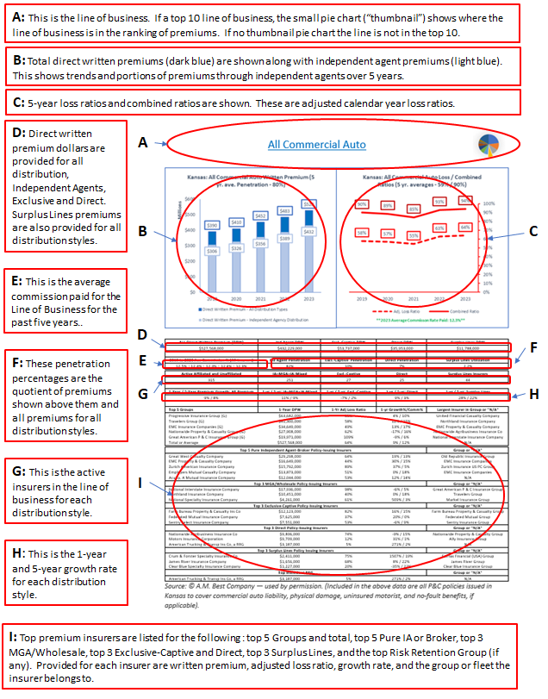

# Appendix #4: Nebraska All Active Insurers List

On the following pages, *Appendix #4: Nebraska All Active Insurers List* presents the 2023 year’s list of policy-issuing insurers with any direct written premium greater than $0, for all reporting insurers in Nebraska. Insurers are listed in alphabetical order.

Included for each insurer on the *List* is:

* the insurer’s total Direct Written Premium
* the Premium Change from 2022 to 2023
* the percentage that Nebraska premiums are to all the insurer’s premium in all jurisdictions, including all 50 states, the District of Columbia, plus any territories (e.g. Guam or Puerto Rico)
* the policy-issuing insurer’s Nebraska Adjusted Loss Ratio

This appendix allows you to quickly see basic information on the many insurers that might be encountered in daily Independent Agent insurance agency operations. If you desire to know more about a particular insurer, you can check with your **Independent Insurance Agents of Nebraska** staff.

|  |  |  |  |  |  |
| --- | --- | --- | --- | --- | --- |
| Academic Medical Prof Ins Exchange RRG | ... | $1,000 | N/A | <1% | -300.0% |
| Acadia Insurance Company | W. R. Berkley Insurance Group | $7,630,000 | 55% | 2% | 31.3% |
| Accelerant National Insurance Company | Accelerant US Holdings Group | $1,214,000 | 89% | <1% | 6.6% |
| Accelerant Specialty Insurance Company | Accelerant US Holdings Group | $2,041,000 | 54% | <1% | 41.6% |
| Accident Fund General Insurance Co | AF Group | $12,764,000 | 16% | 3% | 95.8% |
| Accident Fund Ins Co of America | AF Group | $10,788,000 | 4% | 1% | 103.1% |
| Accident Fund National Insurance Co | AF Group | $1,827,000 | 10% | 1% | 51.9% |
| Accredited Specialty Insurance Company | Randall & Quilter America Holdings Inc. | $1,025,000 | -5% | <1% | 22.0% |
| Accredited Surety and Casualty Co, Inc. | Randall & Quilter America Holdings Inc. | $234,000 | 200% | <1% | 50.3% |
| ACE American Insurance Company | Chubb INA Group | $21,892,000 | -14% | <1% | 36.1% |
| ACE Fire Underwriters Insurance Company | Chubb INA Group | $314,000 | -19% | <1% | 69.5% |
| ACE Property and Casualty Insurance Co | Chubb INA Group | $226,348,000 | 3% | 5% | 131.2% |
| ACIG Insurance Company | American Contractors Insurance Group | $27,000 | -23% | <1% | 0.0% |
| Acuity, A Mutual Insurance Company | ... | $33,118,000 | 8% | 1% | 84.6% |
| Addison Insurance Company | United Fire & Casualty Group | $5,686,000 | -1% | 7% | 26.4% |
| Admiral Insurance Company | W. R. Berkley Insurance Group | $2,350,000 | 22% | <1% | -6.8% |
| Aegis Security Insurance Company | LD Investments Group | $6,000 | -88% | <1% | -30.8% |
| AF&L Insurance Company | ... | $334,000 | -14% | 5% | 212.9% |
| Affiliated FM Insurance Company | FM Global Group | $2,756,000 | 51% | <1% | 370.1% |
| Affiliates Insurance Reciprocal, A RRG | ... | $13,000 | -7% | <1% | -661.5% |
| AGCS Marine Insurance Company | Allianz US PC Insurance Companies | $1,839,000 | 34% | <1% | 21.8% |
| Agent Alliance Insurance Company | Allstate Insurance Group | $287,000 | 13% | <1% | -3.6% |
| Agri General Insurance Company | Chubb INA Group | $15,895,000 | -5% | 3% | 183.2% |
| AIG Property Casualty Company | American International Group | $3,993,000 | 18% | <1% | 51.7% |
| AIG Specialty Insurance Company | American International Group | $5,894,000 | 102% | <1% | 0.4% |
| AIU Insurance Company | American International Group | $1,379,000 | -24% | <1% | 17.8% |
| AIX Specialty Insurance Company | Hanover Ins Group Prop & Cas Cos | $507,000 | 26% | <1% | 119.2% |
| Allegheny Casualty Company | IAT Insurance Group | $4,000 | 100% | <1% | 0.0% |
| Alliance Indemnity Company | Farmers Alliance Companies | $10,303,000 | 23% | 22% | 89.1% |
| Alliance Insurance Company, Inc. | Farmers Alliance Companies | $779,000 | 3% | 5% | 149.6% |
| Alliance of Nonprofits for Ins RRG, Inc. | Nonprofits Insurance Alliance Group | $66,000 | -35% | <1% | -40.6% |
| Allianz Global Risks US Insurance Co | Allianz US PC Insurance Companies | $7,552,000 | 7% | <1% | 82.5% |
| Allianz Underwriters Insurance Company | Allianz US PC Insurance Companies | $576,000 | 658% | <1% | -22.6% |
| Allied Insurance Company of America | Nationwide Property & Casualty Group | $340,000 | -72% | <1% | -45.0% |
| Allied Professionals Ins Co, A RRG, Inc. | ... | $31,000 | -9% | <1% | 0.0% |
| ALLIED Property and Casualty Ins Co | Nationwide Property & Casualty Group | $717,000 | -65% | <1% | -8.9% |
| Allied World Assurance Co (U.S.) Inc. | Fairfax Financial (USA) Group | $1,709,000 | -25% | <1% | -45.6% |
| Allied World Insurance Company | Fairfax Financial (USA) Group | $430,000 | 23% | <1% | 16.5% |
| Allied World National Assurance Company | Fairfax Financial (USA) Group | $996,000 | -13% | <1% | 206.9% |
| Allied World Specialty Insurance Company | Fairfax Financial (USA) Group | $338,000 | -23% | <1% | 35.3% |
| Allied World Surplus Lines Insurance Co | Fairfax Financial (USA) Group | $3,333,000 | 12% | <1% | 13.6% |
| Allmerica Financial Alliance Ins Co | Hanover Ins Group Prop & Cas Cos | $2,000 | -67% | <1% | -50.0% |
| Allmerica Financial Benefit Insurance Co | Hanover Ins Group Prop & Cas Cos | $469,000 | 17% | <1% | 29.3% |
| Allstate Fire and Casualty Insurance Co | Allstate Insurance Group | $78,574,000 | 14% | <1% | 65.3% |
| Allstate Indemnity Company | Allstate Insurance Group | $8,814,000 | 5% | <1% | 22.9% |
| Allstate Insurance Company | Allstate Insurance Group | $7,853,000 | -8% | <1% | 38.9% |
| Allstate Property and Casualty Ins Co | Allstate Insurance Group | $7,077,000 | -8% | <1% | 50.5% |
| Allstate Vehicle and Property Ins Co | Allstate Insurance Group | $55,383,000 | 16% | <1% | 33.5% |
| ALPS Property & Casualty Insurance Co | ... | $652,000 | -1% | 1% | -94.6% |
| AMCO Insurance Company | Nationwide Property & Casualty Group | $23,751,000 | -28% | 4% | 50.6% |
| Amer Family Connect Prop and Cas Ins Co | American Family Insurance Group | $2,594,000 | 3% | <1% | 63.3% |
| American Agri-Business Insurance Company | Sompo Holdings US Group | $118,794,000 | -36% | 4% | 210.5% |
| American Agricultural Insurance Company | ... | $2,362,000 | 880% | 3% | 129.5% |
| American Alternative Insurance Corp | Munich-American Holding Corp Companies | $4,630,000 | 28% | <1% | 28.6% |
| American Assoc of Orthodontists Ins RRG | ... | $29,000 | 16% | <1% | -27.3% |
| American Automobile Insurance Company | Allianz US PC Insurance Companies | $404,000 | 798% | <1% | -78.2% |
| American Bankers Insurance Co of Florida | Assurant P&C Group | $26,558,000 | 12% | <1% | 27.8% |
| American Builders Ins Co RRG, Inc. | ... | $84,000 | 14% | <1% | -3.8% |
| American Casualty Company of Reading, PA | CNA Insurance Companies | $3,270,000 | 7% | <1% | -0.8% |
| American Commerce Insurance Company | MAPFRE North America Group | $563,000 | 0% | <1% | 79.6% |
| American Compensation Insurance Company | Liberty Mutual Insurance Companies | $3,000 | -99% | <1% | 47.3% |
| American Contractors Indemnity Company | Tokio Marine US PC Group | $114,000 | -20% | <1% | -3.9% |
| American Contractors Insurance Co RRG | American Contractors Insurance Group | $30,000 | -42% | <1% | 45.7% |
| American Economy Insurance Company | Liberty Mutual Insurance Companies | $18,112,000 | 34% | <1% | 33.0% |
| American Family Home Insurance Company | Munich-American Holding Corp Companies | $799,000 | -1% | <1% | 12.9% |
| American Family Insurance Company | American Family Insurance Group | $136,747,000 | 25% | 3% | 55.8% |
| American Family Mutual Ins Co, S.I. | American Family Insurance Group | $106,242,000 | -1% | 3% | 37.3% |
| American Federation Insurance Company | Farmers Insurance Group | $1,000 | 0% | <1% | 0.0% |
| American Fire and Casualty Company | Liberty Mutual Insurance Companies | $688,000 | -17% | <1% | 58.0% |
| American Guarantee and Liability Ins Co | Zurich Insurance US PC Group | $13,405,000 | -7% | <1% | 107.2% |
| American Home Assurance Company | American International Group | $4,739,000 | 62% | 1% | 8.1% |
| American Interstate Ins Co of Texas | AMERISAFE Insurance Group | $57,000 | N/A | <1% | 0.0% |
| American Interstate Insurance Company | AMERISAFE Insurance Group | $4,418,000 | 17% | 2% | 110.4% |
| American Mercury Insurance Company | Mercury Casualty Group | $6,000 | -45% | <1% | 39.6% |
| American Modern Home Insurance Company | Munich-American Holding Corp Companies | $1,706,000 | 32% | <1% | 34.4% |
| American Modern Property & Casualty Ins | Munich-American Holding Corp Companies | $14,025,000 | 36% | <1% | 64.5% |
| American National Lloyds Insurance Co | BAMR US PC Group | $2,903,000 | 31% | 2% | 54.1% |
| American National Property & Casualty Co | BAMR US PC Group | $6,569,000 | 9% | <1% | 109.4% |
| American Pet Insurance Company | Trupanion Insurance Group | $2,783,000 | 28% | <1% | 61.4% |
| American Reliable Insurance Company | ECM Group | $848,000 | 14% | <1% | 25.7% |
| American Road Insurance Company | ... | $1,608,000 | 91% | <1% | 284.4% |
| American Security Insurance Company | Assurant P&C Group | $829,000 | -1% | <1% | 59.6% |
| American Select Insurance Company | Westfield Group | $2,000 | -150% | <1% | 150.0% |
| American Southern Home Insurance Company | Munich-American Holding Corp Companies | $125,000 | 9% | <1% | 12.6% |
| American Southern Insurance Company | American Southern Group | $52,000 | 2500% | <1% | 23.1% |
| American Standard Ins Co of Wisconsin | American Family Insurance Group | $1,140,000 | -29% | 4% | 60.7% |
| American States Insurance Company | Liberty Mutual Insurance Companies | $1,000 | 0% | <1% | 2900.0% |
| American Strategic Insurance Corp. | Progressive Insurance Group | $18,462,000 | 18% | <1% | 44.2% |
| American Zurich Insurance Company | Zurich Insurance US PC Group | $5,311,000 | 0% | <1% | 83.8% |
| Amerisure Insurance Company | Amerisure Companies | $1,083,000 | -24% | <1% | -9.7% |
| Amerisure Mutual Insurance Company | Amerisure Companies | $2,447,000 | 111% | <1% | 19.5% |
| Amerisure Partners Insurance Company | Amerisure Companies | $172,000 | 266% | <1% | -36.3% |
| Ameritrust Insurance Corporation | AF Group | $12,000 | -20% | <1% | 1133.3% |
| AMEX Assurance Company | ... | $174,000 | -24% | <1% | 13.8% |
| AmGUARD Insurance Company | Berkshire Hathaway Insurance Group | $4,924,000 | 32% | <1% | 39.5% |
| Amica Mutual Insurance Company | Amica Mutual Group | $5,439,000 | 13% | <1% | 44.4% |
| AmTrust Insurance Company | AmTrust Group | $1,220,000 | 24% | <1% | 83.0% |
| Applied Medico-Legal Solutions RRG, Inc. | ... | $8,000 | -43% | <1% | 4725.0% |
| ARAG Insurance Company | ... | $302,000 | 23% | <1% | 36.1% |
| Arch Indemnity Insurance Company | Arch Insurance Group | $849,000 | 56% | <1% | 35.7% |
| Arch Insurance Company | Arch Insurance Group | $20,325,000 | 12% | <1% | 57.3% |
| Arch Mortgage Guaranty Company | Arch Insurance Group | $27,000 | 350% | <1% | 0.0% |
| Arch Mortgage Insurance Company | Arch Insurance Group | $7,859,000 | 4% | <1% | -1.3% |
| Arch Specialty Insurance Company | Arch Insurance Group | $5,515,000 | 22% | <1% | 32.1% |
| ARCOA Risk Retention Group, Inc. | AMERCO Property and Casualty Ins Group | $57,000 | -2% | <1% | 17.5% |
| Argonaut Insurance Company | BAMR US PC Group | $1,240,000 | -45% | <1% | 52.0% |
| Argonaut-Midwest Insurance Company | BAMR US PC Group | $14,000 | -66% | <1% | 57.1% |
| ARISE Boiler Inspection & Insurance RRG | ... | $7,000 | 0% | <1% | 0.0% |
| Armed Forces Insurance Exchange | ... | $658,000 | 15% | <1% | 68.7% |
| Ascot Insurance Company | Ascot Insurance U.S. Group | $754,000 | 95% | <1% | 64.9% |
| Ascot Specialty Insurance Company | Ascot Insurance U.S. Group | $1,518,000 | 1% | <1% | 30.6% |
| Ascot Surety & Casualty Company | Ascot Insurance U.S. Group | $9,000 | N/A | <1% | 20.0% |
| Aspen American Insurance Company | Aspen US Insurance Group | $3,299,000 | 4% | <1% | 21.1% |
| Aspen Specialty Insurance Company | Aspen US Insurance Group | $4,532,000 | 2% | <1% | 137.6% |
| Associated Industries Insurance Company | AmTrust Group | $768,000 | -11% | <1% | 10.9% |
| Association Casualty Insurance Company | Columbia Insurance Group | $5,355,000 | 34% | 10% | 54.9% |
| AssuranceAmerica Insurance Company | AssuranceAmerica Insurance Group | $2,584,000 | -18% | 1% | 81.9% |
| At-Bay Specialty Insurance Company | ... | $350,000 | N/A | <1% | 8.9% |
| Atain Insurance Company | Atain Insurance Companies | $11,000 | N/A | <1% | 25.0% |
| Atain Specialty Insurance Company | Atain Insurance Companies | $2,781,000 | -25% | 3% | 67.3% |
| Ategrity Specialty Insurance Company | ... | $447,000 | 19% | <1% | -62.7% |
| Atlantic Casualty Insurance Company | Auto-Owners Insurance Group | $1,398,000 | 10% | <1% | 33.4% |
| Atlantic Specialty Insurance Company | Intact US Insurance Group | $7,117,000 | -14% | <1% | 63.4% |
| Atlantic States Insurance Company | Donegal Insurance Group | $13,190,000 | -6% | 4% | 26.3% |
| Atradius Trade Credit Insurance, Inc. | ... | $106,000 | 15% | <1% | -1.9% |
| Attorneys' Liab Assr Society Ltd., A RRG | ... | $503,000 | 4% | <1% | -9.3% |
| Austin Mutual Insurance Company | American Family Insurance Group | $494,000 | -96% | <1% | -57.8% |
| Auto Club Group Insurance Company | Auto Club Group | $12,238,000 | 27% | 4% | 69.0% |
| Auto-Owners Insurance Company | Auto-Owners Insurance Group | $97,949,000 | 44% | 1% | 60.5% |
| Automobile Ins Co of Hartford, CT | Travelers Group | $931,000 | 2% | <1% | 42.2% |
| Avemco Insurance Company | Tokio Marine US PC Group | $372,000 | -10% | <1% | 14.1% |
| AXIS Insurance Company | AXIS US Operations | $13,260,000 | -49% | 1% | 16.0% |
| AXIS Reinsurance Company | AXIS US Operations | $137,000 | 47% | <1% | 6.5% |
| AXIS Surplus Insurance Company | AXIS US Operations | $7,354,000 | 76% | <1% | 39.6% |
| Bankers Insurance Company | Bankers Financial Group | $11,000 | -15% | <1% | 0.0% |
| Bankers Standard Insurance Company | Chubb INA Group | $213,000 | 3% | <1% | 82.8% |
| Battle Creek Mutual Insurance Company | Nodak Insurance Group | $50,698,000 | 7% | 100% | 62.9% |
| BCS Insurance Company | BCS Financial Group | $8,907,000 | 41% | 2% | 92.3% |
| Bearing Midwest Casualty Company | Waypoint Mutual Group | $456,000 | -22% | 5% | 94.5% |
| Beazley America Insurance Company, Inc. | Beazley USA Insurance Group | $24,000 | -25% | <1% | 22.6% |
| Beazley Insurance Company, Inc. | Beazley USA Insurance Group | $904,000 | -9% | <1% | 29.8% |
| Benchmark Insurance Company | Benchmark Insurance Group | $2,267,000 | 18% | <1% | 63.1% |
| Benchmark Specialty Insurance Company | Benchmark Insurance Group | $15,000 | N/A | <1% | 35.7% |
| Berkley Assurance Company | W. R. Berkley Insurance Group | $768,000 | 8% | <1% | 14.9% |
| Berkley Casualty Company | W. R. Berkley Insurance Group | $742,000 | 157% | <1% | 28.5% |
| Berkley Insurance Company | W. R. Berkley Insurance Group | $2,650,000 | -21% | <1% | 69.1% |
| Berkley National Insurance Company | W. R. Berkley Insurance Group | $3,741,000 | -4% | <1% | 25.0% |
| Berkley Regional Insurance Company | W. R. Berkley Insurance Group | $2,038,000 | -8% | <1% | 28.6% |
| Berkley Specialty Insurance Company | W. R. Berkley Insurance Group | $2,383,000 | -9% | 1% | 24.3% |
| Berkshire Hathaway Direct Insurance Co | Berkshire Hathaway Insurance Group | $1,673,000 | 1% | <1% | 41.7% |
| Berkshire Hathaway Homestate Ins Co | Berkshire Hathaway Insurance Group | $10,817,000 | 24% | 2% | 76.3% |
| Berkshire Hathaway Specialty Ins Co | Berkshire Hathaway Insurance Group | $3,932,000 | 40% | <1% | 54.1% |
| BITCO General Insurance Corporation | Old Republic Insurance Group | $16,471,000 | 10% | 4% | 92.3% |
| BITCO National Insurance Company | Old Republic Insurance Group | $610,000 | -4% | 1% | 228.7% |
| Branch Insurance Exchange | ... | $1,283,000 | 69% | <1% | 67.7% |
| BrickStreet Mutual Insurance Company | Encova Mutual Insurance Group | $1,890,000 | -20% | 1% | 59.8% |
| Bricktown Specialty Insurance Company | Trisura US Insurance Group | $95,000 | N/A | <1% | 46.3% |
| Bristol West Insurance Company | Farmers Insurance Group | $9,091,000 | 9% | 2% | 61.7% |
| Brotherhood Mutual Insurance Company | ... | $12,072,000 | 19% | 1% | 65.5% |
| Burlington Insurance Company | IFG Companies | $898,000 | 17% | <1% | 128.8% |
| C.A.R. Risk Retention Group, Inc. | ... | $96,000 | -31% | 11% | 3.1% |
| California Casualty Gen Ins Co of Oregon | California Casualty Group | $1,329,000 | -11% | 2% | 72.6% |
| CAMICO Mutual Insurance Company | ... | $160,000 | 13% | <1% | 5.1% |
| Canal Insurance Company | Canal Group | $1,575,000 | -14% | <1% | 40.0% |
| Canopius US Insurance, Inc. | ... | $357,000 | 26% | <1% | 50.9% |
| Capitol Casualty Company | ... | $753,000 | 1% | 100% | 36.7% |
| Capitol Indemnity Corporation | Berkshire Hathaway Insurance Group | $215,000 | 16% | <1% | -34.9% |
| Capitol Specialty Insurance Corporation | Berkshire Hathaway Insurance Group | $839,000 | -22% | <1% | 2.8% |
| Caring Communities, a Reciprocal RRG | ... | $41,000 | 8% | <1% | 24.2% |
| Carolina Casualty Insurance Company | W. R. Berkley Insurance Group | $2,256,000 | -17% | <1% | 64.1% |
| Caterpillar Insurance Company | ... | $1,937,000 | 16% | <1% | 68.2% |
| Censtat Casualty Company | ... | $907,000 | 165% | 42% | 59.1% |
| Centennial Casualty Company | ... | $929,000 | 26% | 3% | 0.0% |
| Central States Indemnity Co. of Omaha | Berkshire Hathaway Insurance Group | $15,266,000 | 24% | 12% | 24.1% |
| Centurion Casualty Company | ... | $17,000 | 750% | <1% | 35.3% |
| Century Surety Company | AF Group | $1,231,000 | 5% | <1% | 34.4% |
| Century-National Insurance Company | Allstate Insurance Group | $54,000 | -26% | <1% | -50.0% |
| Champlain Specialty Insurance Company | ... | $123,000 | 208% | <1% | 0.0% |
| Charter Oak Fire Insurance Company | Travelers Group | $19,745,000 | 15% | 1% | 43.3% |
| Cherokee Insurance Company | ... | $11,749,000 | 22% | 4% | 66.3% |
| Chiron Insurance Company | Pharmacists Mutual Insurance Group | $287,000 | 283% | 2% | 115.0% |
| Chubb Custom Insurance Company | Chubb INA Group | $880,000 | 14% | <1% | 89.2% |
| Chubb Indemnity Insurance Company | Chubb INA Group | $901,000 | -22% | <1% | 43.5% |
| Chubb National Insurance Company | Chubb INA Group | $296,000 | 21% | <1% | 46.4% |
| Church Mutual Insurance Company, S.I. | Church Mutual Insurance Group | $9,264,000 | 19% | <1% | 92.1% |
| Cimarron Insurance Company, Inc. | ... | $170,000 | N/A | <1% | 110.0% |
| Cincinnati Casualty Company | The Cincinnati Insurance Companies | $4,454,000 | 3% | <1% | 107.5% |
| Cincinnati Indemnity Company | The Cincinnati Insurance Companies | $5,169,000 | 12% | <1% | 46.0% |
| Cincinnati Insurance Company | The Cincinnati Insurance Companies | $38,265,000 | 5% | <1% | 47.2% |
| Cincinnati Specialty Underwriters Ins Co | The Cincinnati Insurance Companies | $6,584,000 | 36% | <1% | 32.6% |
| Circle Star Insurance Company RRG | ... | $8,000 | 100% | <1% | 0.0% |
| Citizens Insurance Company of America | Hanover Ins Group Prop & Cas Cos | $328,000 | 36% | <1% | 14.9% |
| Claim Prof Liability Insurance Co A RRG | ... | $14,000 | 27% | <1% | 0.0% |
| Clear Blue Insurance Company | Clear Blue Insurance Group | $529,000 | 192% | <1% | 51.8% |
| Clear Blue Specialty Insurance Company | Clear Blue Insurance Group | $2,164,000 | -7% | <1% | 9.3% |
| Clear Spring Property & Casualty Company | Group 1001 Property and Casualty Group | $531,000 | 119% | <1% | 21.0% |
| Clearcover Insurance Company | ... | $1,408,000 | 29% | <1% | 91.4% |
| CM Select Insurance Company | ... | $441,000 | N/A | 2% | 90.2% |
| CM Vantage Specialty Insurance Company | Church Mutual Insurance Group | $820,000 | 51% | <1% | 16.0% |
| Coalition Insurance Company | ... | $150,000 | N/A | <1% | 32.5% |
| Coface North America Insurance Company | ... | $114,000 | -20% | <1% | -30.2% |
| College Risk Retention Group, Inc. | ... | $127,000 | -6% | <1% | 23.8% |
| Colonial Surety Company | ... | $89,000 | 46% | <1% | 11.1% |
| Colony Insurance Company | BAMR US PC Group | $1,751,000 | -6% | <1% | 55.4% |
| Colony Specialty Insurance Company | BAMR US PC Group | $130,000 | 271% | <1% | 204.4% |
| Columbia Casualty Company | CNA Insurance Companies | $8,238,000 | 86% | <1% | 54.1% |
| Columbia Insurance Company | Berkshire Hathaway Insurance Group | $3,453,000 | -7% | 16% | 18.6% |
| Columbia Mutual Insurance Company | Columbia Insurance Group | $19,906,000 | 0% | 13% | 37.0% |
| Columbia National Insurance Company | Columbia Insurance Group | $5,436,000 | 7% | 16% | -32.8% |
| Commerce and Industry Insurance Company | American International Group | $517,000 | -39% | <1% | 553.4% |
| Commercial Alliance Insurance Co | IAT Insurance Group | $952,000 | 50% | 100% | 160.4% |
| Concert Insurance Company | Concert Insurance Group | $27,000 | 1250% | <1% | 70.4% |
| Concert Specialty Insurance Company | Concert Insurance Group | $157,000 | 1208% | <1% | 178.6% |
| Conifer Insurance Company | Conifer Insurance Group | $36,000 | 29% | <1% | 0.0% |
| Consumer Specialties Insurance Co RRG | ... | $7,000 | 0% | <1% | 342.9% |
| Continental Casualty Company | CNA Insurance Companies | $30,391,000 | 8% | <1% | 49.4% |
| Continental Indemnity Company | AU Holding Company Group | $1,411,000 | 72% | <1% | 31.7% |
| Continental Insurance Company | CNA Insurance Companies | $5,230,000 | 41% | <1% | 41.8% |
| Continental Western Insurance Company | W. R. Berkley Insurance Group | $12,119,000 | 17% | 4% | 31.4% |
| Contractors Bonding and Insurance Co | RLI Group | $52,000 | 11% | <1% | 15.4% |
| COPIC Insurance Company | COPIC Insurance Group | $13,988,000 | 30% | 10% | -10.8% |
| COPIC, A Risk Retention Group | COPIC Insurance Group | $40,000 | 150% | <1% | 53.8% |
| COUNTRY Mutual Insurance Company | COUNTRY Financial Property Casualty Grp | $3,000 | 0% | <1% | 0.0% |
| Courtesy Insurance Company | ... | $72,000 | -47% | <1% | 85.1% |
| Coverys Specialty Insurance Company | Coverys Companies | $3,233,000 | 164% | 1% | 31.8% |
| Covington Specialty Insurance Company | Berkshire Hathaway Insurance Group | $471,000 | 10% | <1% | 89.3% |
| Crestbrook Insurance Company | Nationwide Property & Casualty Group | $42,182,000 | 70% | 7% | 43.5% |
| Cronus Insurance Company | Titan Insurance Group | $3,000 | 0% | <1% | 0.0% |
| CrossFit Risk Retention Group, Inc. | ... | $18,000 | -10% | <1% | -5.3% |
| Crum & Forster Indemnity Company | Fairfax Financial (USA) Group | $676,000 | -10% | <1% | 20.7% |
| Crum & Forster Specialty Insurance Co | Fairfax Financial (USA) Group | $4,298,000 | -4% | <1% | 27.3% |
| CUMIS Insurance Society, Inc. | CUMIS Insurance Society Group | $1,636,000 | -37% | <1% | 105.7% |
| CUMIS Specialty Insurance Company, Inc. | CUMIS Insurance Society Group | $226,000 | 84% | <1% | 130.7% |
| CUSA Risk Retention Group, Inc. | ... | $12,000 | -33% | <1% | -100.0% |
| Dairyland Insurance Company | Sentry Insurance Group | $541,000 | -14% | <1% | 25.6% |
| Dakota Truck Underwriters | Dakota Group | $9,199,000 | -20% | 14% | 52.3% |
| DAN Risk Retention Group, Inc. | ... | $201,000 | 40% | 2% | 24.9% |
| Dealers Assurance Company | ... | $333,000 | 3% | <1% | 214.9% |
| Depositors Insurance Company | Nationwide Property & Casualty Group | $9,882,000 | -3% | 2% | 140.6% |
| Diamond Insurance Company | ... | $6,000 | -84% | <1% | 752.4% |
| Diamond State Insurance Company | Global Indemnity Group | $267,000 | 38% | <1% | 31.9% |
| Doctors Company, An Interinsurance Exch | Doctors Company Insurance Group | $9,563,000 | 142% | 1% | 52.8% |
| Donegal Mutual Insurance Company | Donegal Insurance Group | $2,102,000 | 9% | <1% | 168.9% |
| EastGUARD Insurance Company | Berkshire Hathaway Insurance Group | $132,000 | 86% | <1% | 40.5% |
| Economy Fire & Casualty Company | Farmers Insurance Group | $832,000 | 107% | <1% | 57.8% |
| Economy Preferred Insurance Company | Farmers Insurance Group | $176,000 | 28% | <1% | 65.1% |
| Economy Premier Assurance Company | Farmers Insurance Group | $1,614,000 | 4% | <1% | 33.6% |
| Electric Insurance Company | ... | $151,000 | -2% | <1% | -21.9% |
| EMC Property & Casualty Company | EMC Insurance Companies | $12,991,000 | 8% | 5% | 19.0% |
| EMCASCO Insurance Company | EMC Insurance Companies | $17,714,000 | 1% | 4% | 80.9% |
| Empire Fire and Marine Insurance Company | Zurich Insurance US PC Group | $1,513,000 | 91% | <1% | 40.2% |
| Employers Assurance Company | Employers Insurance Group | $100,000 | -36% | <1% | 70.3% |
| Employers Compensation Insurance Company | Employers Insurance Group | $171,000 | 74% | <1% | 5.1% |
| Employers Insurance Company of Nevada | Employers Insurance Group | $19,000 | 12% | <1% | 68.4% |
| Employers Insurance Company of Wausau | Liberty Mutual Insurance Companies | $3,548,000 | 38% | <1% | 85.1% |
| Employers Mutual Casualty Company | EMC Insurance Companies | $71,420,000 | 4% | 5% | 53.1% |
| Employers Preferred Insurance Company | Employers Insurance Group | $469,000 | 36% | <1% | 14.1% |
| Enact Mortgage Insurance Corp of NC | Enact Mortgage Insurance Group | $31,000 | 520% | <1% | 0.0% |
| Enact Mortgage Insurance Corporation | Enact Mortgage Insurance Group | $3,840,000 | -1% | <1% | 15.0% |
| Encompass Indemnity Company | Allstate Insurance Group | $39,503,000 | 101% | 11% | 65.6% |
| Endurance American Insurance Company | Sompo Holdings US Group | $3,839,000 | 14% | <1% | 85.4% |
| Endurance American Specialty Ins Co | Sompo Holdings US Group | $7,844,000 | 14% | <1% | 19.3% |
| Endurance Assurance Corporation | Sompo Holdings US Group | $853,000 | -76% | <1% | 75.3% |
| Essent Guaranty, Inc. | Essent Guaranty Group | $3,770,000 | -3% | <1% | -1.5% |
| Essentia Insurance Company | Markel Insurance Group | $4,197,000 | 14% | <1% | 28.0% |
| Esurance Insurance Company | Allstate Insurance Group | $3,358,000 | -6% | <1% | 57.2% |
| Esurance Property and Casualty Ins Co | Allstate Insurance Group | $6,174,000 | -28% | <1% | 68.1% |
| Euler Hermes North America Insurance Co. | Allianz US PC Insurance Companies | $647,000 | -43% | <1% | 26.3% |
| Evanston Insurance Company | Markel Insurance Group | $8,296,000 | 30% | <1% | 88.8% |
| Everest Denali Insurance Company | Everest Re U.S. Group | $812,000 | 2% | <1% | 359.7% |
| Everest Indemnity Insurance Company | Everest Re U.S. Group | $1,738,000 | -37% | <1% | 42.6% |
| Everest National Insurance Company | Everest Re U.S. Group | $3,658,000 | -4% | <1% | 11.4% |
| Everest Premier Insurance Company | Everest Re U.S. Group | $506,000 | 41% | <1% | 21.4% |
| Everest Reinsurance Company | Everest Re U.S. Group | $2,611,000 | 18% | <1% | 93.8% |
| Everett Cash Mutual Insurance Company | ECM Group | $1,385,000 | 48% | 1% | 144.6% |
| Evergreen National Indemnity Company | Stillwater Insurance Group | $154,000 | -19% | <1% | 10.0% |
| Everspan Indemnity Insurance Company | Ambac Financial Group | $97,000 | N/A | <1% | 50.9% |
| Executive Risk Indemnity Inc. | Chubb INA Group | $135,000 | -5% | <1% | 186.2% |
| Factory Mutual Insurance Company | FM Global Group | $29,942,000 | 12% | <1% | 31.8% |
| Fair American Insurance and Reins Co | Berkshire Hathaway Insurance Group | $4,981,000 | -5% | 3% | 47.1% |
| Falls Lake Fire and Casualty Company | James River Group | $496,000 | 0% | <1% | 52.9% |
| Falls Lake National Insurance Company | James River Group | $831,000 | 241% | <1% | 47.7% |
| Farm Bureau Property & Casualty Ins Co | Farm Bureau Property & Casualty Group | $284,632,000 | 17% | 17% | 72.2% |
| Farmers Alliance Mutual Insurance Co | Farmers Alliance Companies | $11,981,000 | 11% | 6% | 89.4% |
| Farmers Casualty Insurance Company | Farmers Insurance Group | $778,000 | -18% | <1% | 60.1% |
| Farmers Direct Prop and Cas Insurance Co | Farmers Insurance Group | $1,259,000 | -2% | <1% | 57.0% |
| Farmers Group Prop and Cas Insurance Co | Farmers Insurance Group | $1,971,000 | 5% | <1% | 48.5% |
| Farmers Insurance Exchange | Farmers Insurance Group | $37,302,000 | -3% | <1% | 34.0% |
| Farmers Mutual Hail Insurance Co of Iowa | FMH Insurance Group | $93,819,000 | -6% | 8% | 137.2% |
| Farmers Mutual Insurance Co of Nebraska | ... | $472,715,000 | 15% | 79% | 69.9% |
| Farmers Property and Casualty Ins Co | Farmers Insurance Group | $1,767,000 | -9% | <1% | 10.9% |
| Farmington Casualty Company | Travelers Group | $496,000 | 32% | <1% | 14.2% |
| Federal Insurance Company | Chubb INA Group | $64,592,000 | 24% | <1% | 44.0% |
| Federated Mutual Insurance Company | Federated Mutual Group | $23,355,000 | 17% | 1% | 54.2% |
| Federated Reserve Insurance Company | Federated Mutual Group | $3,623,000 | 14% | 1% | 28.2% |
| Federated Rural Electric Ins Exchange | ... | $4,575,000 | 19% | 2% | 189.1% |
| Federated Service Insurance Company | Federated Mutual Group | $3,024,000 | 1% | 1% | 30.3% |
| Fidelity and Deposit Company of Maryland | Zurich Insurance US PC Group | $7,485,000 | 375% | 1% | 9.6% |
| Fidelity and Guaranty Insurance Company | Travelers Group | $1,412,000 | 74% | <1% | 16.4% |
| Fire Insurance Exchange | Farmers Insurance Group | $9,041,000 | 97% | <1% | 25.6% |
| Fireman's Fund Indemnity Corporation | Allianz US PC Insurance Companies | $1,036,000 | N/A | <1% | 0.0% |
| Fireman's Fund Insurance Company | Allianz US PC Insurance Companies | $1,694,000 | 17% | <1% | 104.3% |
| Firemen's Ins Co of Washington, D.C. | W. R. Berkley Insurance Group | $9,265,000 | 51% | 4% | 39.4% |
| First Colonial Insurance Company | Allstate Insurance Group | $53,000 | 489% | <1% | 33.3% |
| First Dakota Indemnity Company | Dakota Group | $6,248,000 | 15% | 8% | 77.1% |
| First Financial Insurance Company | IFG Companies | $1,000 | 0% | <1% | 0.0% |
| First Liberty Insurance Corporation | Liberty Mutual Insurance Companies | $633,000 | -46% | <1% | 59.1% |
| FirstComp Insurance Company | Markel Insurance Group | $11,019,000 | 5% | 13% | 39.2% |
| Florists' Mutual Insurance Company | Sentry Insurance Group | $184,000 | -12% | <1% | 11.9% |
| FMH Ag Risk Insurance Company | FMH Insurance Group | $12,585,000 | -9% | 5% | 107.8% |
| Foremost Insurance Co Grand Rapids, MI | Farmers Insurance Group | $25,892,000 | 9% | <1% | 41.7% |
| Foremost Property and Casualty Ins Co | Farmers Insurance Group | $218,000 | -19% | <1% | 186.6% |
| Fortegra Specialty Insurance Company | Fortegra P&C Group | $1,217,000 | 203% | <1% | 53.1% |
| Fortress Insurance Company | National Group | $17,000 | 183% | <1% | -175.0% |
| Frank Winston Crum Insurance Company | ... | $12,000 | 9% | <1% | -14.3% |
| Frankenmuth Insurance Company | Frankenmuth Insurance Group | $45,000 | -84% | <1% | 3.2% |
| Franklin Casualty Insurance Co RRG | ... | $7,000 | 0% | <1% | 0.0% |
| Freedom Specialty Insurance Company | Nationwide Property & Casualty Group | $580,000 | -30% | <1% | 9.6% |
| Future Care Risk Retention Group, Inc. | ... | $231,000 | -16% | 1% | 43.5% |
| Garrison Property and Casualty Ins Co | USAA Group | $14,834,000 | 19% | <1% | 62.6% |
| GEICO Advantage Insurance Company | Berkshire Hathaway Insurance Group | $33,735,000 | -18% | 1% | 56.0% |
| GEICO Casualty Company | Berkshire Hathaway Insurance Group | $402,000 | -10% | <1% | 37.2% |
| GEICO Choice Insurance Company | Berkshire Hathaway Insurance Group | $17,118,000 | -25% | 1% | 56.7% |
| GEICO General Insurance Company | Berkshire Hathaway Insurance Group | $4,518,000 | 1% | <1% | 65.8% |
| GEICO Indemnity Company | Berkshire Hathaway Insurance Group | $3,047,000 | -4% | <1% | 59.7% |
| GEICO Marine Insurance Company | Berkshire Hathaway Insurance Group | $189,000 | -8% | <1% | 1.5% |
| GEICO Secure Insurance Company | Berkshire Hathaway Insurance Group | $18,210,000 | 52% | <1% | 64.5% |
| Gemini Insurance Company | W. R. Berkley Insurance Group | $10,140,000 | -5% | 1% | 67.7% |
| General Automobile Insurance Company | American Family Insurance Group | $822,000 | 67% | <1% | 52.3% |
| General Casualty Company of Wisconsin | QBE North America Insurance Group | $979,000 | -75% | <1% | 111.3% |
| General Insurance Company of America | Liberty Mutual Insurance Companies | $972,000 | 28% | <1% | 76.9% |
| General Security Indemnity Co of Arizona | SCOR US Group | $2,194,000 | 57% | <1% | 35.1% |
| General Security National Insurance Co | SCOR US Group | $627,000 | 127% | <1% | 111.5% |
| General Star Indemnity Company | Berkshire Hathaway Insurance Group | $4,980,000 | 36% | <1% | 18.5% |
| General Star National Insurance Co | Berkshire Hathaway Insurance Group | $1,000 | -50% | <1% | -1300.0% |
| Generali USB | ... | $3,664,000 | 91% | <1% | 27.1% |
| GeoVera Specialty Insurance Company | GeoVera U.S. Insurance Group | $278,000 | 31% | <1% | 301.8% |
| Glencar Insurance Company | HDI/Talanx US PC Group | $80,000 | 700% | <1% | 156.1% |
| Golden Bear Insurance Company | ... | $137,000 | 38% | <1% | -65.0% |
| Gotham Insurance Company | Coaction Specialty Insurance Group | $1,827,000 | 3% | <1% | -1.0% |
| Government Employees Insurance Company | Berkshire Hathaway Insurance Group | $2,071,000 | 2% | <1% | 52.9% |
| Granite Re, Inc. | Federated Mutual Group | $929,000 | 26% | 2% | 5.8% |
| Granite State Insurance Company | American International Group | $1,398,000 | 35% | <1% | 148.7% |
| Graphic Arts Mutual Insurance Company | Utica National Insurance Group | $547,000 | 26% | <1% | -36.3% |
| Gray Surplus Lines Insurance Company | The Gray Insurance Group | $602,000 | -13% | 1% | 15.6% |
| Great Amer Risk Sol Surplus Lines Ins Co | Great American P & C Insurance Group | $428,000 | 1026% | <1% | 5.3% |
| Great American Alliance Insurance Co | Great American P & C Insurance Group | $42,895,000 | 9% | 9% | 167.5% |
| Great American Assurance Company | Great American P & C Insurance Group | $6,466,000 | 20% | <1% | 36.8% |
| Great American E & S Insurance Company | Great American P & C Insurance Group | $2,349,000 | 20% | <1% | 130.6% |
| Great American Fidelity Insurance Co | Great American P & C Insurance Group | $520,000 | 14% | <1% | -0.2% |
| Great American Insurance Co of New York | Great American P & C Insurance Group | $542,000 | 34% | <1% | 34.6% |
| Great American Insurance Company | Great American P & C Insurance Group | $105,638,000 | -7% | 3% | 81.5% |
| Great American Security Insurance Co | Great American P & C Insurance Group | $1,402,000 | -54% | <1% | 16.7% |
| Great American Spirit Insurance Company | Great American P & C Insurance Group | $939,000 | -15% | <1% | 69.5% |
| Great Divide Insurance Company | W. R. Berkley Insurance Group | $1,178,000 | -20% | <1% | 5.0% |
| Great Midwest Insurance Company | Skyward Specialty Insurance Group | $2,395,000 | 2% | <1% | 4.0% |
| Great Northern Insurance Company | Chubb INA Group | $11,934,000 | 6% | <1% | 37.6% |
| Great Plains Casualty, Inc. | ... | $62,000 | N/A | <1% | 72.0% |
| Great West Casualty Company | Old Republic Insurance Group | $66,040,000 | -1% | 4% | 49.8% |
| Greenwich Insurance Company | XL America Companies | $1,961,000 | 83% | <1% | 768.7% |
| Grinnell Compass, Inc. | Grinnell Mutual Group | $1,817,000 | 166% | 2% | 92.1% |
| Grinnell Mutual Reinsurance Company | Grinnell Mutual Group | $16,635,000 | -2% | 4% | 67.5% |
| Grinnell Select Insurance Company | Grinnell Mutual Group | $6,850,000 | -3% | 3% | 78.3% |
| Guarantee Company of North America USA | Intact US Insurance Group | $19,000 | -32% | <1% | -21.7% |
| GuideOne Elite Insurance Company | GuideOne Insurance Companies | $462,000 | 53% | <1% | -34.8% |
| GuideOne Insurance Company | GuideOne Insurance Companies | $1,756,000 | 20% | <1% | 211.8% |
| GuideOne National Insurance Company | GuideOne Insurance Companies | $847,000 | -39% | <1% | -12.8% |
| GuideOne Specialty Insurance Company | GuideOne Insurance Companies | $286,000 | -11% | <1% | 21.3% |
| Hamilton Select Insurance Inc. | ... | $263,000 | -6% | <1% | 31.2% |
| Harco National Insurance Company | IAT Insurance Group | $955,000 | 28% | <1% | -26.5% |
| Harleysville Insurance Co of New York | Nationwide Property & Casualty Group | $140,000 | N/A | <1% | 41.5% |
| Harleysville Insurance Company | Nationwide Property & Casualty Group | $1,601,000 | -6% | <1% | 2.3% |
| Harleysville Preferred Insurance Company | Nationwide Property & Casualty Group | $11,000 | -65% | <1% | 395.8% |
| Harleysville Worcester Insurance Company | Nationwide Property & Casualty Group | $372,000 | -19% | <1% | 62.2% |
| Hartford Accident and Indemnity Company | Hartford Insurance Group | $1,983,000 | 18% | <1% | -8.2% |
| Hartford Casualty Insurance Company | Hartford Insurance Group | $2,570,000 | -29% | <1% | 37.4% |
| Hartford Fire Insurance Company | Hartford Insurance Group | $18,598,000 | 2% | <1% | 70.9% |
| Hartford Insurance Co of the Midwest | Hartford Insurance Group | $707,000 | -68% | <1% | 171.8% |
| Hartford Insurance Co of the Southeast | Hartford Insurance Group | $1,927,000 | 70% | <1% | 61.6% |
| Hartford Steam Boiler Inspec & Ins | Munich-American Holding Corp Companies | $714,000 | -3% | <1% | 27.2% |
| Hartford Underwriters Insurance Company | Hartford Insurance Group | $3,259,000 | 34% | <1% | -11.8% |
| HDI Specialty Insurance Company | HDI/Talanx US PC Group | $162,000 | -49% | <1% | 1278.9% |
| Health Care Industry Liab Recip Ins RRG | ... | $1,291,000 | 17% | 2% | 51.1% |
| Heritage Indemnity Company | AmTrust Group | $62,000 | -76% | <1% | 71.2% |
| Highlander Specialty Insurance Company | Clear Blue Insurance Group | $329,000 | N/A | <1% | 166.5% |
| Hiscox Insurance Company Inc. | Hiscox USA Group | $1,417,000 | -12% | <1% | 58.5% |
| Homeland Insurance Company of Delaware | Intact US Insurance Group | $2,000 | 0% | <1% | 0.0% |
| Homeland Insurance Company of New York | Intact US Insurance Group | $4,554,000 | 79% | <1% | 11.2% |
| Homeowners of America Insurance Company | ... | $193,000 | 422% | <1% | 0.0% |
| Homesite Indemnity Company | American Family Insurance Group | $1,764,000 | -10% | 1% | 62.1% |
| Homesite Insurance Company | American Family Insurance Group | $16,357,000 | 47% | <1% | 32.5% |
| Homesite Insurance Company of Florida | American Family Insurance Group | $1,734,000 | 31% | <1% | 31.5% |
| Horace Mann Insurance Company | Horace Mann Insurance Group | $650,000 | -6% | <1% | 43.7% |
| Horace Mann Property & Casualty Ins Co | Horace Mann Insurance Group | $2,171,000 | -6% | <1% | 93.7% |
| Horizon Midwest Casualty Company | Waypoint Mutual Group | $337,000 | 4% | 6% | 55.4% |
| Housing Authority Prop Ins, A Mutual Co | HAI Group | $1,328,000 | 8% | 1% | -7.0% |
| Housing Authority RRG, Inc. | HAI Group | $266,000 | 2% | <1% | 33.0% |
| Housing Enterprise Insurance Co, Inc. | HAI Group | $287,000 | 2% | <1% | 8.4% |
| Housing Specialty Insurance Co, Inc. | HAI Group | $4,000 | N/A | <1% | 0.0% |
| Houston Casualty Company | Tokio Marine US PC Group | $4,712,000 | 77% | <1% | 89.7% |
| Houston Specialty Insurance Company | Skyward Specialty Insurance Group | $1,602,000 | 53% | <1% | 53.9% |
| HSB Specialty Insurance Company | Munich-American Holding Corp Companies | $18,000 | -95% | <1% | -360.6% |
| Hudson Excess Insurance Company | Fairfax Financial (USA) Group | $948,000 | -9% | <1% | 41.5% |
| Hudson Insurance Company | Fairfax Financial (USA) Group | $7,144,000 | 19% | <1% | 76.0% |
| ICI Mutual Insurance Company, a RRG | ... | $320,000 | 19% | <1% | 33.2% |
| Illinois Union Insurance Company | Chubb INA Group | $3,114,000 | 48% | <1% | 39.6% |
| Imperium Insurance Company | Skyward Specialty Insurance Group | $854,000 | 17% | <1% | 27.2% |
| IMT Insurance Company | IMT Insurance Companies | $14,870,000 | 14% | 11% | 56.4% |
| Indemnity Insurance Co of North America | Chubb INA Group | $10,647,000 | -4% | <1% | 106.1% |
| Indemnity National Insurance Company | ... | $307,000 | N/A | <1% | 31.7% |
| Independence American Insurance Company | Independence Pet Insurance Group | $827,000 | -15% | <1% | 6.7% |
| Indian Harbor Insurance Company | XL America Companies | $8,169,000 | -44% | <1% | 49.3% |
| Inland Insurance Company | Universal Inland Insurance Group | $1,148,000 | -19% | 74% | 18.6% |
| Insurance Company of State of PA | American International Group | $1,112,000 | 111% | <1% | 352.2% |
| Insurance Company of the West | ICW Group | $316,000 | 247% | <1% | 209.3% |
| Integon General Insurance Corporation | Allstate Insurance Group | $292,000 | 5740% | <1% | 41.1% |
| Integon Indemnity Corporation | Allstate Insurance Group | $6,887,000 | 6586% | <1% | 49.3% |
| Integon National Insurance Company | Allstate Insurance Group | $93,000 | -2% | <1% | -448.8% |
| International Fidelity Insurance Company | IAT Insurance Group | $8,000 | -56% | <1% | -1035.7% |
| Interstate Fire & Casualty Company | Allianz US PC Insurance Companies | $1,808,000 | -17% | <1% | -13.9% |
| Intrepid Insurance Company | W. R. Berkley Insurance Group | $1,740,000 | 26% | 1% | 74.4% |
| Intrepid Specialty Insurance Company | W. R. Berkley Insurance Group | $290,000 | 1713% | <1% | 47.7% |
| Ironshore Indemnity Inc. | Liberty Mutual Insurance Companies | $1,703,000 | 441% | <1% | 71.5% |
| Ironshore Specialty Insurance Co | Liberty Mutual Insurance Companies | $5,248,000 | -6% | <1% | 38.5% |
| ISMIE Indemnity Company | ISMIE Mutual Group | $18,000 | 0% | <1% | 27.8% |
| James River Insurance Company | James River Group | $4,097,000 | 31% | <1% | -10.7% |
| Jefferson Insurance Company | Allianz US PC Insurance Companies | $7,637,000 | 7% | <1% | 18.8% |
| Jet Insurance Company | ... | $31,000 | 94% | <1% | 9.5% |
| Jewelers Mutual Insurance Company, SI | Jewelers Mutual Insurance Group | $1,152,000 | 9% | <1% | 17.1% |
| JM Specialty Insurance Company | Jewelers Mutual Insurance Group | $14,000 | 17% | <1% | 30.8% |
| Key Risk Insurance Company | W. R. Berkley Insurance Group | $442,000 | 6% | <1% | 23.8% |
| Kinsale Insurance Company | ... | $4,020,000 | 80% | <1% | 16.2% |
| Knight Specialty Insurance Company | Knight Insurance Group | $293,000 | 358% | <1% | 0.0% |
| KW Specialty Insurance Company | ... | $27,000 | 0% | <1% | 272.0% |
| Lancer Insurance Company | Core Specialty Insurance Group | $302,000 | 6% | <1% | 22.4% |
| Landmark American Insurance Company | Berkshire Hathaway Insurance Group | $7,592,000 | 45% | <1% | 18.5% |
| Lemonade Insurance Company | Lemonade Insurance Group | $377,000 | 48% | <1% | 72.1% |
| Lexington Insurance Company | American International Group | $16,002,000 | 37% | <1% | 110.2% |
| Lexington National Insurance Corporation | Revolutionary Insurance Group | $71,000 | 3450% | <1% | 0.0% |
| Lexon Insurance Company | Sompo Holdings US Group | $105,000 | -12% | <1% | -19.8% |
| Liberty Insurance Corporation | Liberty Mutual Insurance Companies | $10,412,000 | -3% | <1% | 1.7% |
| Liberty Insurance Underwriters, Inc. | Liberty Mutual Insurance Companies | $40,441,000 | 1% | 1% | 51.0% |
| Liberty Mutual Fire Insurance Company | Liberty Mutual Insurance Companies | $9,466,000 | -2% | <1% | 18.9% |
| Liberty Mutual Insurance Company | Liberty Mutual Insurance Companies | $5,269,000 | 18% | <1% | 34.0% |
| Liberty Mutual Personal Insurance Co | Liberty Mutual Insurance Companies | $3,852,000 | 67% | <1% | 73.0% |
| Liberty Surplus Insurance Corporation | Liberty Mutual Insurance Companies | $2,225,000 | -36% | <1% | 371.1% |
| LIO Insurance Company | LIO Insurance Group | $9,000 | N/A | <1% | 20.0% |
| LM General Insurance Company | Liberty Mutual Insurance Companies | $4,795,000 | -24% | <1% | 43.4% |
| LM Insurance Corporation | Liberty Mutual Insurance Companies | $7,060,000 | -8% | <1% | 35.3% |
| Lone Star Alliance, Inc., RRG | Texas Medical Insurance Group | $3,000 | -40% | <1% | 0.0% |
| Lyndon Southern Insurance Company | Fortegra P&C Group | $1,409,000 | -1% | <1% | 21.1% |
| MAG Mutual Insurance Company | MAG Mutual Companies | $86,000 | 1333% | <1% | 0.0% |
| Manufacturers Alliance Insurance Company | Old Republic Insurance Group | $358,000 | 25% | <1% | 64.5% |
| Markel American Insurance Company | Markel Insurance Group | $13,334,000 | 42% | 1% | 54.5% |
| Markel Insurance Company | Markel Insurance Group | $7,727,000 | 8% | <1% | 73.3% |
| Massachusetts Bay Insurance Company | Hanover Ins Group Prop & Cas Cos | $765,000 | 27% | <1% | 44.1% |
| Maxum Indemnity Company | Hartford Insurance Group | $61,000 | -23% | <1% | 332.4% |
| Medical Protective Company | Berkshire Hathaway Insurance Group | $2,774,000 | 14% | <1% | 59.1% |
| Medmarc Casualty Insurance Company | ProAssurance Group | $61,000 | 3% | <1% | 13.1% |
| MemberSelect Insurance Company | Auto Club Group | $2,347,000 | -7% | <1% | 49.0% |
| MEMIC Indemnity Company | MEMIC Group | $106,000 | 524% | <1% | 38.9% |
| Mercer Insurance Company | United Fire & Casualty Group | $154,000 | -42% | <1% | 57.7% |
| Merchants Bonding Company (Mutual) | Merchants Bonding Co (Mutual) Group | $1,931,000 | 13% | 1% | 3.4% |
| Merchants National Bonding, Inc. | Merchants Bonding Co (Mutual) Group | $1,314,000 | 6% | 1% | 4.0% |
| Mesa Underwriters Specialty Insurance Co | Selective Insurance Group | $1,208,000 | 59% | <1% | 40.5% |
| Metropolitan General Insurance Company | ... | $1,138,000 | 72% | <1% | 29.6% |
| MIC General Insurance Corporation | Allstate Insurance Group | $1,570,000 | 9% | <1% | 34.2% |
| MIC Property and Casualty Insurance Corp | Ally Insurance Group | $149,000 | -49% | <1% | 26.3% |
| Mid-Century Insurance Company | Farmers Insurance Group | $31,615,000 | -2% | 1% | 69.7% |
| Mid-Continent Assurance Company | Great American P & C Insurance Group | $39,000 | -3% | 1% | 0.0% |
| Mid-Continent Casualty Company | Great American P & C Insurance Group | $257,000 | -8% | <1% | -5.7% |
| Mid-Continent Excess and Surplus Ins Co | Great American P & C Insurance Group | $22,000 | 214% | <1% | 0.0% |
| Middlesex Insurance Company | Sentry Insurance Group | $3,141,000 | 25% | <1% | 37.9% |
| MidSouth Mutual Insurance Company | ... | $4,000 | N/A | <1% | N/A |
| Midvale Indemnity Company | American Family Insurance Group | $5,330,000 | 18% | <1% | 47.2% |
| Midwest Employers Casualty Company | W. R. Berkley Insurance Group | $3,033,000 | 11% | <1% | 25.8% |
| Midwest Family Advantage Insurance Co | Midwest Family Group | $552,000 | -30% | 5% | 62.7% |
| Midwest Family Mutual Insurance Company | Midwest Family Group | $9,189,000 | -1% | 4% | 59.0% |
| Midwest Insurance Company | Midwest Insurance Group | $11,000 | 0% | <1% | 72.7% |
| Milford Casualty Insurance Company | AmTrust Group | $395,000 | 171% | <1% | 12.2% |
| Minnesota Lawyers Mutual Insurance Co | MLM Group | $2,156,000 | 1% | 6% | 16.9% |
| Mitsui Sumitomo Insurance Co of America | MS&AD US Insurance Group | $1,528,000 | 29% | <1% | 57.1% |
| Mitsui Sumitomo Insurance USA Inc. | MS&AD US Insurance Group | $446,000 | 57% | <1% | 377.6% |
| MMIC Insurance, Inc. | Constellation Insurance Group | $10,304,000 | 5% | 9% | -5.7% |
| MMIC Risk Retention Group, Inc. | Constellation Insurance Group | $2,030,000 | -36% | 9% | 49.6% |
| Mobilitas Insurance Company | CSAA Insurance Group | $666,000 | 33% | <1% | 99.3% |
| Mortgage Guaranty Insurance Corporation | Mortgage Guaranty Group | $9,258,000 | 2% | <1% | 11.7% |
| Motor Transport Mutual RRG, Inc. | ... | $165,000 | 2% | 1% | 21.8% |
| Motorists Commercial Mutual Insurance Co | Encova Mutual Insurance Group | $25,769,000 | 19% | 5% | 37.9% |
| Motors Insurance Corporation | Ally Insurance Group | $6,878,000 | 32% | 2% | 7.6% |
| MS Transverse Insurance Company | MS&AD US Insurance Group | $93,000 | N/A | <1% | 6.7% |
| MS Transverse Specialty Insurance Co | MS&AD US Insurance Group | $1,194,000 | 61% | <1% | 74.0% |
| MSIG Specialty Insurance USA Inc. | MS&AD US Insurance Group | $81,000 | 72% | <1% | 30.6% |
| Mt. Hawley Insurance Company | RLI Group | $1,092,000 | 0% | <1% | 14.0% |
| NAMIC Insurance Company, Inc. | ... | $400,000 | 7% | 2% | 382.7% |
| National American Insurance Company | ... | $614,000 | -4% | <1% | 27.9% |
| National Casualty Company | Nationwide Property & Casualty Group | $7,214,000 | 30% | <1% | 70.9% |
| National Farmers Union Prop and Cas Co | Allstate Insurance Group | $8,315,000 | 13% | 5% | 74.0% |
| National Fire & Marine Insurance Co | Berkshire Hathaway Insurance Group | $24,954,000 | 32% | <1% | 56.4% |
| National Fire and Indemnity Exchange | ... | $9,000 | 29% | <1% | -114.3% |
| National Fire Insurance Co of Hartford | CNA Insurance Companies | $3,102,000 | 35% | <1% | -78.8% |
| National General Insurance Company | Allstate Insurance Group | $785,000 | -18% | <1% | 39.8% |
| National Guardian RRG , Inc | ... | $4,000 | N/A | <1% | 0.0% |
| National Indemnity Company | Berkshire Hathaway Insurance Group | $10,029,000 | 2% | 4% | 10.0% |
| National Indemnity Company of the South | Berkshire Hathaway Insurance Group | $2,305,000 | -2% | 3% | 18.5% |
| National Interstate Insurance Company | Great American P & C Insurance Group | $9,347,000 | 40% | 1% | 53.5% |
| National Liability & Fire Insurance Co | Berkshire Hathaway Insurance Group | $2,746,000 | -4% | <1% | 10.2% |
| National Mortgage Insurance Corporation | National Mortgage Insurance Group | $3,166,000 | 12% | <1% | -4.7% |
| National Specialty Insurance Company | Markel Insurance Group | $2,390,000 | -2% | <1% | 119.4% |
| National Surety Corporation | Allianz US PC Insurance Companies | $5,000 | 67% | <1% | -1575.0% |
| National Union Fire Ins Co Pittsburgh PA | American International Group | $27,503,000 | 12% | <1% | 27.3% |
| Nationwide Affinity Ins Co of America | Nationwide Property & Casualty Group | $15,000 | -475% | <1% | 575.0% |
| Nationwide Agribusiness Insurance Co | Nationwide Property & Casualty Group | $51,169,000 | 24% | 4% | 58.4% |
| Nationwide Assurance Company | Nationwide Property & Casualty Group | $14,766,000 | 42% | 3% | 48.8% |
| Nationwide General Insurance Company | Nationwide Property & Casualty Group | $19,267,000 | 7% | <1% | 49.5% |
| Nationwide Insurance Company of America | Nationwide Property & Casualty Group | $41,707,000 | -2% | 2% | 64.1% |
| Nationwide Mutual Insurance Company | Nationwide Property & Casualty Group | $118,958,000 | -4% | 3% | 63.8% |
| Nationwide Property & Casualty Ins Co | Nationwide Property & Casualty Group | $27,315,000 | -5% | 2% | 49.8% |
| Natl Independent Truckers Ins Co, A RRG | ... | $1,000 | -117% | <1% | 0.0% |
| NAU Country Insurance Company | QBE North America Insurance Group | $306,524,000 | 11% | 8% | 138.4% |
| Nautilus Insurance Company | W. R. Berkley Insurance Group | $1,960,000 | -6% | <1% | 87.5% |
| Navigators Insurance Company | Hartford Insurance Group | $2,216,000 | -9% | <1% | 74.6% |
| Navigators Specialty Insurance Company | Hartford Insurance Group | $3,569,000 | 67% | <1% | 97.0% |
| NCMIC Insurance Company | NCMIC Group | $527,000 | 4% | <1% | 5.8% |
| NCMIC Risk Retention Group, Inc. | NCMIC Group | $2,000 | N/A | <1% | N/A |
| New Hampshire Insurance Company | American International Group | $1,760,000 | -13% | <1% | 36.2% |
| New Home Warranty Insurance Co, A RRG | ... | $118,000 | -2% | <1% | 36.6% |
| New Horizons Insurance Co of Missouri | Missouri Farm Bureau Group | $80,000 | 135% | <1% | 104.9% |
| New York Marine and General Insurance Co | Coaction Specialty Insurance Group | $903,000 | -13% | <1% | 49.7% |
| Next Insurance US Company | ... | $1,310,000 | 15% | <1% | 42.4% |
| NGM Insurance Company | American Family Insurance Group | $75,000 | -37% | <1% | 5.7% |
| NLADA Mutual Insurance Company, a RRG | MLM Group | $22,000 | N/A | <1% | 0.0% |
| NORCAL Insurance Company | ProAssurance Group | $34,000 | -59% | <1% | 29.2% |
| NORCAL Specialty Insurance Company | ProAssurance Group | $37,000 | 131% | <1% | -454.5% |
| NorGUARD Insurance Company | Berkshire Hathaway Insurance Group | $935,000 | -22% | <1% | 83.7% |
| North American Capacity Insurance Co | ... | $2,998,000 | 84% | <1% | 291.8% |
| North Pointe Insurance Company | QBE North America Insurance Group | $99,000 | 219% | <1% | 8.0% |
| North River Insurance Company | Fairfax Financial (USA) Group | $5,853,000 | 98% | 1% | 90.5% |
| North Star Mutual Insurance Company | North Star Companies | $82,275,000 | 26% | 11% | 69.0% |
| Northfield Insurance Company | Travelers Group | $1,000,000 | 82% | <1% | 7.0% |
| Northland Insurance Company | Travelers Group | $3,801,000 | -34% | <1% | 4.6% |
| NorthStone Insurance Company | Encova Mutual Insurance Group | $892,000 | -20% | <1% | 29.2% |
| NOVA Casualty Company | Hanover Ins Group Prop & Cas Cos | $676,000 | -14% | <1% | 6.6% |
| Nutmeg Insurance Company | Hartford Insurance Group | $247,000 | 115% | <1% | 79.5% |
| Oak River Insurance Company | Berkshire Hathaway Insurance Group | $131,000 | 96% | <1% | 61.7% |
| OBI National Insurance Company | Intact US Insurance Group | $51,000 | -83% | <1% | 57.4% |
| Obsidian Insurance Company | Obsidian Insurance Group | $389,000 | 873% | <1% | 24.1% |
| Obsidian Specialty Insurance Company | Obsidian Insurance Group | $910,000 | 57% | <1% | 24.8% |
| Occidental Fire and Casualty Co of NC | IAT Insurance Group | $342,000 | -3% | <1% | 7.4% |
| Ohio Casualty Insurance Company | Liberty Mutual Insurance Companies | $6,272,000 | 20% | <1% | 60.6% |
| Ohio Farmers Insurance Company | Westfield Group | $9,000 | -85% | <1% | -9.5% |
| Ohio Indemnity Company | ... | $1,130,000 | 12% | <1% | 48.7% |
| Ohio Security Insurance Company | Liberty Mutual Insurance Companies | $13,051,000 | 1% | <1% | 68.2% |
| Old Republic Insurance Company | Old Republic Insurance Group | $12,558,000 | -4% | <1% | 44.5% |
| Old Republic Surety Company | Old Republic Insurance Group | $2,725,000 | 68% | 3% | 18.4% |
| Old Republic Union Insurance Company | Old Republic Insurance Group | $682,000 | 59% | <1% | 87.6% |
| Old United Casualty Company | Berkshire Hathaway Insurance Group | $232,000 | -16% | <1% | 23.1% |
| Omaha National Insurance Company | Omaha National Group | $905,000 | 121% | 11% | 81.4% |
| OMS National Insurance Company, RRG | National Group | $271,000 | -2% | <1% | -14.2% |
| OOIDA Risk Retention Group, Inc. | ... | $8,000 | -56% | <1% | -260.0% |
| Ophthalmic Mutual Insurance Co (A RRG) | ... | $24,000 | 20% | <1% | -25.0% |
| Overdrive Risk Retention Group, LLC | ... | $104,000 | -1% | 2% | 8.7% |
| Owners Insurance Company | Auto-Owners Insurance Group | $67,398,000 | 27% | 2% | 68.2% |
| Pacific Employers Insurance Company | Chubb INA Group | $115,000 | -9% | <1% | 91.5% |
| Pacific Indemnity Company | Chubb INA Group | $794,000 | -3% | <1% | 9.6% |
| Pacific Insurance Company, Limited | Hartford Insurance Group | $263,000 | 98% | <1% | 27.7% |
| Palomar Excess and Surplus Insurance Co | Palomar Holdings US Group | $1,062,000 | -9% | <1% | 3.8% |
| Paratransit Insurance Co, A Mutual RRG | ... | $187,000 | 23% | <1% | -92.7% |
| PCH Mutual Insurance Company Inc., A RRG | ... | $4,000 | N/A | <1% | 50.0% |
| Peerless Indemnity Insurance Company | Liberty Mutual Insurance Companies | $73,000 | N/A | <1% | -833.3% |
| Peleus Insurance Company | BAMR US PC Group | $458,000 | -22% | <1% | 55.5% |
| Peninsula Insurance Company | Donegal Insurance Group | $14,000 | N/A | <1% | 2000.0% |
| Penn Millers Insurance Company | Chubb INA Group | $8,270,000 | 52% | 3% | 5.7% |
| Penn-Star Insurance Company | Global Indemnity Group | $363,000 | -2% | <1% | 99.1% |
| Pennsylvania Insurance Company | AU Holding Company Group | $58,000 | -54% | <1% | 19.7% |
| Pennsylvania Lumbermens Mutual Ins Co | ... | $2,698,000 | 20% | <1% | 26.0% |
| Pennsylvania Manufacturers Indemnity Co | Old Republic Insurance Group | $182,000 | 26% | <1% | 30.5% |
| Pennsylvania Manufacturers' Assoc Ins Co | Old Republic Insurance Group | $1,014,000 | -72% | <1% | 41.8% |
| Pennsylvania National Mutual Cas Ins Co | Penn National Insurance Companies | $1,000 | 0% | <1% | 0.0% |
| Permanent General Assurance Corp of Ohio | American Family Insurance Group | $5,141,000 | 64% | 2% | 57.0% |
| Permanent General Assurance Corporation | American Family Insurance Group | $1,698,000 | -12% | <1% | 46.2% |
| Pharmacists Mutual Insurance Company | Pharmacists Mutual Insurance Group | $1,916,000 | -24% | 1% | 164.2% |
| Philadelphia Indemnity Insurance Company | Tokio Marine US PC Group | $30,898,000 | 20% | <1% | 18.9% |
| Phoenix Insurance Company | Travelers Group | $15,081,000 | 6% | <1% | 47.7% |
| PinnaclePoint Insurance Company | Encova Mutual Insurance Group | $1,431,000 | 4% | <1% | 53.8% |
| Pioneer Specialty Insurance Company | Western National Insurance Group | $8,000 | N/A | <1% | 50.0% |
| Plateau Casualty Insurance Company | ... | $38,000 | -36% | <1% | 10.7% |
| Platte River Insurance Company | Berkshire Hathaway Insurance Group | $122,000 | -15% | <1% | 1.5% |
| PMI Mortgage Insurance Co. | PMI Mortgage Group | $29,000 | -34% | <1% | -269.0% |
| Praetorian Insurance Company | QBE North America Insurance Group | $1,561,000 | 54% | <1% | 167.6% |
| Preferra Insurance Company RRG | ... | $88,000 | 4% | <1% | 3.4% |
| Preferred Professional Insurance Company | Coverys Companies | $207,000 | -65% | <1% | 907.2% |
| Prescient National Insurance Company | ... | $3,000 | N/A | <1% | 0.0% |
| Previsor Insurance Company | ... | $2,052,000 | 49% | 9% | 69.2% |
| Prime Insurance Company | Prime Insurance Group | $209,000 | -48% | <1% | 145.6% |
| Princeton Excess & Surplus Lines Ins Co | Munich-American Holding Corp Companies | $3,684,000 | 32% | <1% | 12.0% |
| Privilege Underwriters Reciprocal Exch | Tokio Marine US PC Group | $3,882,000 | 13% | <1% | 75.2% |
| ProAssurance Indemnity Company, Inc. | ProAssurance Group | $889,000 | -6% | <1% | -219.4% |
| ProAssurance Insurance Co of America | ProAssurance Group | $294,000 | 11% | <1% | 134.8% |
| ProAssurance Specialty Insurance Company | ProAssurance Group | $852,000 | -3% | <1% | 37.8% |
| Producers Agriculture Insurance Company | Tokio Marine US PC Group | $46,911,000 | 73% | 5% | 128.6% |
| Professional Security Insurance Company | MAG Mutual Companies | $20,000 | 82% | <1% | 0.0% |
| Professional Solutions Ins Co | NCMIC Group | $316,000 | -15% | <1% | -12.3% |
| Progressive Northern Insurance Company | Progressive Insurance Group | $221,332,000 | 10% | 7% | 62.9% |
| Progressive Universal Insurance Company | Progressive Insurance Group | $129,292,000 | 23% | 6% | 63.6% |
| Property and Casualty Ins Co of Hartford | Hartford Insurance Group | $249,000 | -76% | <1% | -2.9% |
| ProSelect Insurance Company | Coverys Companies | $403,000 | -116% | <1% | 363.8% |
| Protective Insurance Company | Progressive Insurance Group | $1,232,000 | 46% | <1% | 34.2% |
| Protective Property & Casualty Ins Co | ... | $36,000 | -3700% | <1% | 74.2% |
| Protective Specialty Insurance Company | Progressive Insurance Group | $15,000 | N/A | <1% | 25.0% |
| QBE Insurance Corporation | QBE North America Insurance Group | $14,509,000 | 1% | <1% | 124.8% |
| QBE Specialty Insurance Company | QBE North America Insurance Group | $2,916,000 | 34% | <1% | 52.9% |
| Radian Guaranty Inc. | Radian Group | $5,112,000 | 3% | <1% | 0.8% |
| Radnor Specialty Insurance Company | Berkshire Hathaway Insurance Group | $35,000 | -20% | <1% | 8.2% |
| Redwood Fire and Casualty Insurance Co | Berkshire Hathaway Insurance Group | $1,295,000 | -9% | <1% | 133.7% |
| Regent Insurance Company | QBE North America Insurance Group | $550,000 | -52% | <1% | 48.0% |
| Republic Mortgage Insurance Company | Old Republic Insurance Group | $16,000 | -47% | <1% | -256.3% |
| Republic-Vanguard Insurance Company | AmTrust Group | $1,191,000 | 260% | <1% | 28.4% |
| Repwest Insurance Company | AMERCO Property and Casualty Ins Group | $300,000 | -10% | <1% | 10.3% |
| Restoration Risk Retention Group, Inc. | ... | $68,000 | 13% | <1% | -5.3% |
| Richmond National Insurance Company | ... | $484,000 | 749% | <1% | 46.7% |
| Riverport Insurance Company | W. R. Berkley Insurance Group | $1,368,000 | 89% | 2% | -71.2% |
| RLI Insurance Company | RLI Group | $2,291,000 | -1% | <1% | 6.0% |
| Rockingham Specialty, Inc. | Rockingham Group | $202,000 | 29% | <1% | 94.9% |
| Rockwood Casualty Insurance Company | BAMR US PC Group | $29,000 | N/A | <1% | 0.0% |
| Root Insurance Company | Root Insurance Group | $5,083,000 | 27% | <1% | 66.4% |
| RSUI Indemnity Company | Berkshire Hathaway Insurance Group | $2,473,000 | -8% | <1% | 15.7% |
| Rural Community Insurance Company | Zurich Insurance US PC Group | $375,792,000 | -7% | 12% | 129.9% |
| Rural Trust Insurance Company | ... | $515,000 | 17% | 1% | 65.4% |
| Safeco Insurance Company of America | Liberty Mutual Insurance Companies | $16,457,000 | -1% | <1% | 10.8% |
| Safeco Insurance Company of Illinois | Liberty Mutual Insurance Companies | $20,766,000 | 9% | <1% | 57.6% |
| Safety First Insurance Company | Tokio Marine US PC Group | $75,000 | -297% | <1% | -228.0% |
| Safety National Casualty Corporation | Tokio Marine US PC Group | $5,680,000 | 20% | <1% | 42.4% |
| Safety Specialty Insurance Company | Tokio Marine US PC Group | $641,000 | -56% | <1% | 28.1% |
| Sagamore Insurance Company | Progressive Insurance Group | $1,000 | -99% | <1% | N/A |
| Samsung F & M Insurance Co, Ltd USB | ... | $67,000 | 2% | <1% | -3.0% |
| Scottsdale Indemnity Company | Nationwide Property & Casualty Group | $991,000 | -21% | <1% | -0.5% |
| Scottsdale Insurance Company | Nationwide Property & Casualty Group | $9,774,000 | -13% | <1% | 122.0% |
| Securian Casualty Company | ... | $2,474,000 | -6% | <1% | 42.0% |
| Security National Insurance Company | AmTrust Group | $1,039,000 | 10% | <1% | 143.9% |
| Selective Insurance Company of America | Selective Insurance Group | $744,000 | -4% | <1% | 0.1% |
| Seneca Insurance Company, Inc. | Fairfax Financial (USA) Group | $143,000 | 8% | <1% | 162.3% |
| Seneca Specialty Insurance Company | Fairfax Financial (USA) Group | $196,000 | 326% | <1% | 15.8% |
| Sentinel Insurance Company, Ltd. | Hartford Insurance Group | $2,315,000 | 6% | <1% | -7.9% |
| Sentry Casualty Company | Sentry Insurance Group | $2,997,000 | 0% | 1% | -89.9% |
| Sentry Insurance Company | Sentry Insurance Group | $4,681,000 | 0% | <1% | 124.6% |
| Sentry Select Insurance Company | Sentry Insurance Group | $9,637,000 | -6% | <1% | 8.2% |
| Sequoia Insurance Company | AmTrust Group | $97,000 | 76% | <1% | -59.5% |
| Service American Indemnity Company | Service Insurance Group | $3,860,000 | -16% | 1% | 64.3% |
| Service Lloyds Insurance Co, a Stock Co | Service Insurance Group | $75,000 | 7400% | <1% | -26.2% |
| SFM Mutual Insurance Company | SFM Companies | $11,867,000 | 7% | 6% | 93.5% |
| SFM Safe Insurance Company | SFM Companies | $2,501,000 | 10% | 7% | 85.6% |
| SFM Select Insurance Company | SFM Companies | $456,000 | 103% | 2% | 22.5% |
| Shelter General Insurance Company | Shelter Insurance Companies | $1,622,000 | 39% | 2% | 167.0% |
| Shelter Mutual Insurance Company | Shelter Insurance Companies | $56,336,000 | 14% | 2% | 81.5% |
| Silver Oak Casualty, Inc. | AMERISAFE Insurance Group | $179,000 | N/A | <1% | 53.2% |
| SiriusPoint America Insurance Company | SiriusPoint America Insurance Group | $4,153,000 | -1% | <1% | 65.5% |
| SiriusPoint Specialty Insurance Corp | SiriusPoint America Insurance Group | $960,000 | 95% | <1% | 50.8% |
| Skyraider Risk Retention Group, Inc. | ... | $1,000 | 0% | <1% | 0.0% |
| Sompo America Fire & Marine Ins Co | Sompo Holdings US Group | $59,000 | 48% | <1% | -3.4% |
| Sompo America Insurance Company | Sompo Holdings US Group | $1,438,000 | -17% | <1% | 44.7% |
| South Shore Risk Retention Group, Inc. | ... | $11,000 | N/A | <1% | 18.2% |
| Southern Insurance Company | AmTrust Group | $70,000 | 37% | <1% | 40.9% |
| Southern Trust Insurance Company | ... | $449,000 | 16% | <1% | 22.0% |
| Southlake Specialty Insurance Company | Southlake Insurance Group | $138,000 | -34% | <1% | 65.0% |
| Southwest Marine and General Ins Co | Coaction Specialty Insurance Group | $144,000 | -48% | <1% | 123.1% |
| Specialty Builders Insurance Company | Builders Insurance Group | $71,000 | N/A | <1% | 29.4% |
| Spinnaker Insurance Company | Spinnaker Insurance Group | $2,837,000 | 27% | <1% | 22.2% |
| Spinnaker Specialty Insurance Company | Spinnaker Insurance Group | $216,000 | 882% | <1% | 64.1% |
| Spirit Mountain Ins Co RRG, Inc. | ... | $26,000 | -24% | <1% | 25.0% |
| St. Paul Fire and Marine Insurance Co | Travelers Group | $305,000 | 232% | <1% | -87.0% |
| St. Paul Guardian Insurance Company | Travelers Group | $26,000 | 420% | <1% | 11.1% |
| St. Paul Mercury Insurance Company | Travelers Group | $7,000 | 17% | <1% | -566.7% |
| St. Paul Surplus Lines Insurance Company | Travelers Group | $120,000 | -77% | <1% | 58.4% |
| Standard Fire Insurance Company | Travelers Group | $36,278,000 | 11% | <1% | 67.3% |
| Standard Guaranty Insurance Company | Assurant P&C Group | $2,290,000 | 14% | <1% | 47.9% |
| Star Insurance Company | AF Group | $2,281,000 | 29% | <1% | 43.8% |
| StarNet Insurance Company | W. R. Berkley Insurance Group | $1,075,000 | -35% | <1% | 48.9% |
| Starr Indemnity & Liability Company | Starr International Group | $7,495,000 | -12% | <1% | 47.8% |
| Starr Specialty Insurance Company | Starr International Group | $455,000 | 94% | <1% | 53.1% |
| Starr Surplus Lines Insurance Company | Starr International Group | $63,342,000 | 530% | 2% | 24.4% |
| StarStone National Insurance Company | Core Specialty Insurance Group | $1,206,000 | -21% | <1% | -33.6% |
| StarStone Specialty Insurance Company | Core Specialty Insurance Group | $3,947,000 | 115% | <1% | 66.0% |
| State Farm Fire and Casualty Company | State Farm Group | $387,858,000 | 11% | 1% | 67.6% |
| State Farm Mutual Automobile Ins Co | State Farm Group | $345,894,000 | 16% | <1% | 74.9% |
| State National Insurance Company, Inc. | Markel Insurance Group | $2,659,000 | -3% | <1% | 77.9% |
| States Self-Insrs RRG , Inc | ... | $1,413,000 | 8% | 10% | 192.0% |
| Steadfast Insurance Company | Zurich Insurance US PC Group | $3,875,000 | 5% | <1% | 22.3% |
| Stillwater Insurance Company | Stillwater Insurance Group | $1,516,000 | 2% | <1% | 51.2% |
| Stonetrust Commercial Insurance Company | Stonetrust Insurance Group | $2,136,000 | -20% | 4% | 71.8% |
| Stonington Insurance Company | QBE North America Insurance Group | $46,000 | 142% | <1% | 31.4% |
| Stratford Insurance Company | American International Group | $40,122,000 | 2% | 3% | 175.5% |
| Summit Specialty Insurance Company | ReAlign Insurance Group | $732,000 | 277% | <1% | 18.2% |
| SummitPoint Insurance Company | Encova Mutual Insurance Group | $1,256,000 | 5% | 3% | 69.0% |
| Sunland Risk Retention Group Inc | ... | $6,000 | -94% | <1% | 9.3% |
| SUNZ Insurance Company | ... | $229,000 | 144% | <1% | 23.1% |
| SureTec Insurance Company | Markel Insurance Group | $154,000 | 12% | <1% | -7.7% |
| Sutton National Insurance Company | Sutton National Group | $27,000 | N/A | <1% | 33.3% |
| Sutton Specialty Insurance Company | Sutton National Group | $171,000 | -20% | <1% | 110.0% |
| Swiss Re Corporate Solutions America Ins | Swiss Reinsurance Group | $7,440,000 | 37% | <1% | 45.6% |
| Swiss Re Corporate Solutions Capacity | Swiss Reinsurance Group | $1,063,000 | 8% | <1% | 8.1% |
| Swiss Re Corporate Solutions Elite Ins | Swiss Reinsurance Group | $4,156,000 | 45% | <1% | -0.9% |
| Swiss Re Corporate Solutions Premier Ins | Swiss Reinsurance Group | $162,000 | 60% | 1% | 4.3% |
| T.H.E. Insurance Company | XL America Companies | $100,000 | -10% | <1% | -981.8% |
| TDC National Assurance Company | Doctors Company Insurance Group | $60,000 | -27% | <1% | 38.7% |
| TDC Specialty Insurance Company | Doctors Company Insurance Group | $7,603,000 | 9% | 3% | 35.8% |
| Teachers Insurance Company | Horace Mann Insurance Group | $2,233,000 | 4% | 1% | 61.1% |
| Technology Insurance Company, Inc. | AmTrust Group | $2,505,000 | 41% | <1% | 3.5% |
| Technology Transportation Mutual RRG | ... | $254,000 | N/A | 2% | 43.7% |
| Terrafirma RRG LLC | ... | $3,000 | 50% | <1% | 33.3% |
| Texas Insurance Company | AU Holding Company Group | $688,000 | 62% | <1% | 34.6% |
| The Gray Casualty & Surety Company | ... | $108,000 | 10700% | <1% | 0.0% |
| The Gray Insurance Company | The Gray Insurance Group | $59,000 | 37% | <1% | 5.5% |
| The Hanover American Insurance Company | Hanover Ins Group Prop & Cas Cos | $221,000 | 58% | <1% | -53.8% |
| The Hanover Insurance Company | Hanover Ins Group Prop & Cas Cos | $2,918,000 | 15% | <1% | 36.8% |
| The Pie Insurance Company | Pie Insurance Group | $519,000 | N/A | 1% | 541.3% |
| Third Coast Insurance Company | AF Group | $138,000 | -22% | <1% | -595.8% |
| Titan Insurance Company, Inc., A RRG | Titan Insurance Group | $687,000 | 97% | 1% | 45.9% |
| TNUS Insurance Company | Tokio Marine US PC Group | $2,000 | N/A | <1% | 9600.0% |
| Toggle Insurance Company | Farmers Insurance Group | $4,000 | N/A | <1% | 0.0% |
| Tokio Marine America Insurance Company | Tokio Marine US PC Group | $2,464,000 | 11% | <1% | 38.7% |
| Tokio Marine Specialty Insurance Company | Tokio Marine US PC Group | $1,424,000 | 46% | <1% | 27.3% |
| Toyota Motor Insurance Company | ... | $490,000 | 610% | <1% | 117.9% |
| Transamerica Casualty Insurance Company | ... | $5,000 | 0% | 1% | 0.0% |
| TRANSGUARD INSURANCE COMPANY OF AMERICA | IAT Insurance Group | $505,000 | 19% | <1% | 80.3% |
| Transportation Insurance Company | CNA Insurance Companies | $1,288,000 | -10% | <1% | 713.2% |
| Travelers Casualty and Surety Co of Amer | Travelers Group | $22,701,000 | 20% | <1% | 31.0% |
| Travelers Casualty and Surety Company | Travelers Group | $4,034,000 | 47% | <1% | 38.0% |
| Travelers Casualty Ins Co of America | Travelers Group | $13,357,000 | 18% | 1% | 45.5% |
| Travelers Commercial Insurance Company | Travelers Group | $1,903,000 | -16% | <1% | 37.7% |
| Travelers Excess and Surplus Lines Co | Travelers Group | $9,028,000 | 22% | <1% | 20.8% |
| Travelers Home and Marine Ins Co | Travelers Group | $16,885,000 | -13% | <1% | 32.8% |
| Travelers Indemnity Co of America | Travelers Group | $11,895,000 | -1% | <1% | 48.8% |
| Travelers Indemnity Co of Connecticut | Travelers Group | $12,022,000 | 24% | <1% | 32.5% |
| Travelers Indemnity Company | Travelers Group | $35,479,000 | 33% | 1% | 23.6% |
| Travelers Personal Insurance Company | Travelers Group | $45,792,000 | 27% | 1% | 61.9% |
| Travelers Property Casualty Co of Amer | Travelers Group | $70,703,000 | 11% | <1% | 54.5% |
| Tri-State Insurance Company of Minnesota | W. R. Berkley Insurance Group | $1,552,000 | 10% | <1% | 39.5% |
| Triangle Insurance Company, Inc | ... | $10,800,000 | 382% | 6% | 36.5% |
| Trisura Insurance Company | Trisura US Insurance Group | $474,000 | 218% | <1% | 34.6% |
| Trisura Specialty Insurance Company | Trisura US Insurance Group | $2,589,000 | 7% | <1% | 32.0% |
| Triton Insurance Company | ... | $296,000 | 4% | <1% | 26.6% |
| Triumphe Casualty Company | Great American P & C Insurance Group | $915,000 | 169% | 1% | 43.2% |
| Truck Insurance Exchange | Farmers Insurance Group | $1,648,000 | 13% | <1% | -29.1% |
| Trumbull Insurance Company | Hartford Insurance Group | $9,054,000 | 18% | <1% | 25.4% |
| Twin City Fire Insurance Company | Hartford Insurance Group | $8,795,000 | 6% | <1% | 57.5% |
| U.S. Specialty Insurance Company | Tokio Marine US PC Group | $2,319,000 | 1% | <1% | 348.1% |
| U.S. Underwriters Insurance Company | Berkshire Hathaway Insurance Group | $557,000 | 30% | 1% | 48.6% |
| Union Insurance Company | W. R. Berkley Insurance Group | $9,521,000 | 14% | 2% | 65.4% |
| Union Insurance Company of Providence | EMC Insurance Companies | $966,000 | -3% | 1% | -1.2% |
| United Casualty and Surety Insurance Co | ... | $109,000 | 102% | <1% | 21.8% |
| United Educators Ins, a Reciprocal RRG | ... | $3,752,000 | 3% | <1% | -8.1% |
| United Fire & Casualty Company | United Fire & Casualty Group | $27,619,000 | 20% | 4% | 68.3% |
| United Guaranty Residential Insurance Co | Arch Insurance Group | $1,036,000 | -27% | <1% | -14.4% |
| United National Insurance Company | Global Indemnity Group | $1,525,000 | 44% | 2% | 7.2% |
| United Security Insurance Company | First Chicago Insurance Group | $29,000 | -36% | <1% | 62.1% |
| United Services Automobile Association | USAA Group | $61,093,000 | 9% | <1% | 69.8% |
| United Specialty Insurance Company | Markel Insurance Group | $688,000 | -7% | <1% | 473.0% |
| United States Fire Insurance Company | Fairfax Financial (USA) Group | $11,090,000 | 7% | <1% | 58.1% |
| United States Liability Insurance Co | Berkshire Hathaway Insurance Group | $8,320,000 | 18% | 1% | 25.0% |
| United Wisconsin Insurance Company | AF Group | $2,656,000 | -8% | 1% | 45.0% |
| Universal Fire & Casualty Insurance Co | Universal Shield Insurance Group | $38,000 | -5% | <1% | 75.0% |
| Universal Surety Company | Universal Inland Insurance Group | $4,106,000 | -15% | 72% | 1.0% |
| Universal Surety of America | CNA Insurance Companies | $22,000 | 10% | <1% | 0.0% |
| Universal Underwriters Insurance Company | Zurich Insurance US PC Group | $2,224,000 | 20% | <1% | 54.3% |
| Upland Specialty Insurance Company | ... | $1,348,000 | 3% | <1% | 294.8% |
| USAA Casualty Insurance Company | USAA Group | $39,148,000 | 13% | <1% | 62.3% |
| USAA General Indemnity Company | USAA Group | $36,116,000 | 13% | <1% | 76.1% |
| Utica Mutual Insurance Company | Utica National Insurance Group | $287,000 | -9% | <1% | 20.6% |
| Valley Forge Insurance Company | CNA Insurance Companies | $2,468,000 | 9% | <1% | 56.5% |
| Vanliner Insurance Company | Great American P & C Insurance Group | $6,886,000 | -14% | 3% | 68.3% |
| Vantage Risk Assurance Company | Vantage US Group | $46,000 | -10% | <1% | 62.0% |
| Vantage Risk Specialty Insurance Company | Vantage US Group | $3,339,000 | 103% | <1% | 47.2% |
| Vantapro Specialty Insurance Company | Fairfax Financial (USA) Group | $1,572,000 | 18% | 2% | 76.0% |
| Vault E&S Insurance Company | Vault Insurance Group | $81,000 | 11% | <1% | 0.0% |
| Velocity Specialty Insurance Company | ... | $2,000 | N/A | <1% | 368.2% |
| Verlan Fire Insurance Company | Hanover Ins Group Prop & Cas Cos | $434,000 | 37% | <1% | 27.5% |
| Victor Insurance Exchange | ... | $1,000 | N/A | <1% | N/A |
| Vigilant Insurance Company | Chubb INA Group | $2,057,000 | -1% | <1% | 29.3% |
| Viking Insurance Company of Wisconsin | Sentry Insurance Group | $31,046,000 | 22% | 6% | 57.5% |
| Virginia Surety Company, Inc. | Assurant P&C Group | $505,000 | -70% | <1% | 100.3% |
| Voyager Indemnity Insurance Company | Assurant P&C Group | $198,000 | -1% | <1% | -20.9% |
| Wadena Insurance Company | IMT Insurance Companies | $24,250,000 | 34% | 10% | 54.4% |
| Watford Insurance Company | Watford US Insurance Group | $353,000 | -44% | 2% | 22.7% |
| Waypoint Mutual | Waypoint Mutual Group | $7,007,000 | 30% | 13% | 69.1% |
| WCF National Insurance Company | WCF Insurance Group | $103,000 | -43% | <1% | 136.8% |
| WCF Select Insurance Company | WCF Insurance Group | $30,000 | N/A | <1% | -206.7% |
| Wellfleet Insurance Company | Berkshire Hathaway Insurance Group | $915,000 | 52% | <1% | 57.1% |
| Wellfleet New York Insurance Company | Berkshire Hathaway Insurance Group | $311,000 | 139% | <1% | 19.8% |
| Wesco Insurance Company | AmTrust Group | $2,580,000 | -7% | <1% | 91.9% |
| West American Insurance Company | Liberty Mutual Insurance Companies | $669,000 | -22% | <1% | 31.7% |
| West Bend Insurance Company | West Bend Insurance Group | $4,877,000 | -11% | <1% | 117.4% |
| Westchester Fire Insurance Company | Chubb INA Group | $1,738,000 | -13% | <1% | -11.9% |
| Westchester Surplus Lines Insurance Co | Chubb INA Group | $6,654,000 | -3% | <1% | 27.3% |
| Western Agricultural Insurance Company | Farm Bureau Property & Casualty Group | $70,368,000 | 12% | 14% | 113.7% |
| Western National Assurance Company | Western National Insurance Group | $25,000 | 2400% | <1% | 52.9% |
| Western National Mutual Insurance Co | Western National Insurance Group | $144,000 | 115% | <1% | 36.2% |
| Western Pacific Mutual Ins Co, A RRG | ... | $3,000 | 50% | <1% | 0.0% |
| Western Surety Company | CNA Insurance Companies | $4,359,000 | 46% | <1% | 29.7% |
| Western World Insurance Company | American International Group | $2,506,000 | 10% | <1% | 12.7% |
| Westfield Insurance Company | Westfield Group | $1,992,000 | 99% | <1% | 8.9% |
| Westfield National Insurance Company | Westfield Group | $44,000 | 5% | <1% | 4.4% |
| Westfield Select Insurance Company | Westfield Group | $48,000 | N/A | <1% | 123.1% |
| Westfield Specialty Insurance Company | Westfield Group | $3,249,000 | 48% | <1% | 44.4% |
| Westfield Touchstone Insurance Company | Westfield Group | $1,000 | 0% | <1% | 0.0% |
| White Pine Insurance Company | Conifer Insurance Group | $47,000 | -6% | <1% | 72.0% |
| Williamsburg National Insurance Company | AF Group | $39,000 | 129% | <1% | 30.8% |
| Wilmington Insurance Company | Wilmington Insurance Group | $34,000 | -13% | <1% | -7.1% |
| Wilshire Insurance Company | IAT Insurance Group | $157,000 | -32% | <1% | 51.0% |
| Work First Casualty Company | ... | $83,000 | 17% | <1% | -153.0% |
| Wright National Flood Insurance Company | ... | $771,000 | -2% | <1% | 0.6% |
| XL Insurance America, Inc. | XL America Companies | $8,755,000 | 87% | <1% | -22.5% |
| XL Specialty Insurance Company | XL America Companies | $7,582,000 | 11% | <1% | 92.3% |
| YRIG Risk Retention Group, Inc. | ... | $78,000 | 3800% | 2% | 20.5% |
| Zenith Insurance Company | Fairfax Financial (USA) Group | $312,000 | 50% | <1% | 29.0% |
| Zurich American Insurance Co of Illinois | Zurich Insurance US PC Group | $3,260,000 | 46% | 1% | 48.6% |
| Zurich American Insurance Company | Zurich Insurance US PC Group | $66,495,000 | 28% | <1% | 22.2% |

P&C Marketplace Summary provided by Real Insurance Solutions Consulting

This *2024 Nebraska Annual P&C Marketplace Summary* has provided the reader with both visual and numeric presentations of 2023 Nebraska P&C marketplace data. This data is provided to you as a benefit of your membership in the **Independent Insurance Agents of Nebraska.**

Other informative products are offered by Real Insurance Solutions Consulting, which also may be available to you as members:

* Quarterly state-specific marketplace summaries are made available during the calendar year, as the data reported by P&C insurers becomes available.
* Individual P&C I*nsurer* *Snapshots* are available, based on the same data provided in the annual and quarterly summaries, with in-depth data and information provided both on a national and Nebraska-specific basis.

All questions and comments, or need for further analysis are welcomed at the contact information below:

Real Insurance Solutions Consulting, LLC  
Paul A. Buse, Principal  
[www.realinsurancesc.com](http://www.realinsurancesc.com)  
301-842-7472